The Wardandi Six Seasons

December and January - Birak - Dry and hot long days with warm nights. The low tides are a good time to collect abalone and other shellfish. It is the time for eating blue groper, octopus & oysters.
February and March – Bunuru - Hot days with cooler nights. It is a good time to camp and fish along the west coast for herring, taylor, bream and migrating salmon.
April and May - Djeran - Overcast days and the nights are cooling. It is time to move camp back inland to collect vegetables and catch crabs and fish in the inland estuaries and bays.
June and July - Makuru - Cold days and nights - winter rains strong south west winds. It is time to build strong paper bark mia's. Kangaroo and wallaby are hunted - for eating and to use their skins for warmth. Emu's are nesting inland.
August and September - Djilba - Warmer days and cold nights. Time to collect bush fruits and camp in sheltered bays and waterways. Time to hunt for crab, snapper, squid, marron.
October and November - Kambarang – Hot days with nights warming up and winds easing. Lots of baby ducks, emus, possums, kangaroos around. Time to start moving camp towards the coastal areas and make fishing spears.
Information provided by Josh Whiteland – Wardandi Traditional Owner and owner of Koomal Dreaming
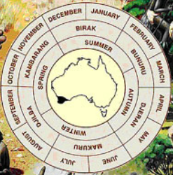
Example of possible layout TO MERGE WITH INFO ABOVE

