Kaya Bora

[Hello or welcome] [Meeting Place]

The Meeting Place
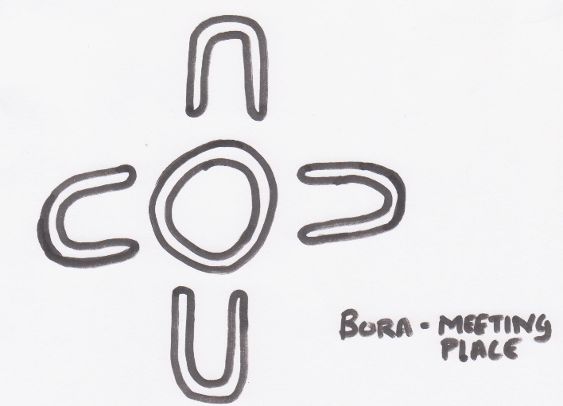
This ‘Meeting Place’ is for guests at Wharncliffe Mill to enjoy spending time together. It enables people to connect with the local landscape and traditional culture.
Cultural and environmental presentations, performances, social gatherings and group meetings can be held in this natural bush amphitheatre.
It is also a place for people to relax and enjoy being amidst nature. During winter, groups may choose to light a fire in the designated fire pit (when fire restrictions are not in place), though we ask that you ensure fires are fully extinguished when unattended.
Please respect the ‘Meeting Place’. Ensure children are well supervised and litter is not thrown into the fire or left in this special place.
This is a place to reflect on nature and culture.

Meeting or coming together – a traditional perspective
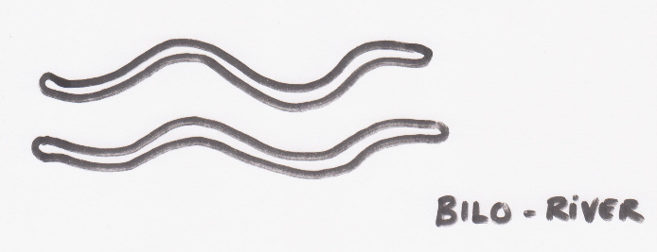
Traditionally most Aboriginal people moved through Country for hunting and gathering, though often came together for meetings and ceremonies. They moved within their traditional boundaries which for the Wardandi people, is framed by the Preston River, following along the escarpment, and down the Blackwood River to Augusta.
Wardandi people camped in Mia Mia’s - thatched shelters built out of natural bush materials, near their meeting place. The meeting times and places were dictated by the seasons and were for trading rocks, medicines, information and knowledge.

The local Aboriginal people – The Wardandi
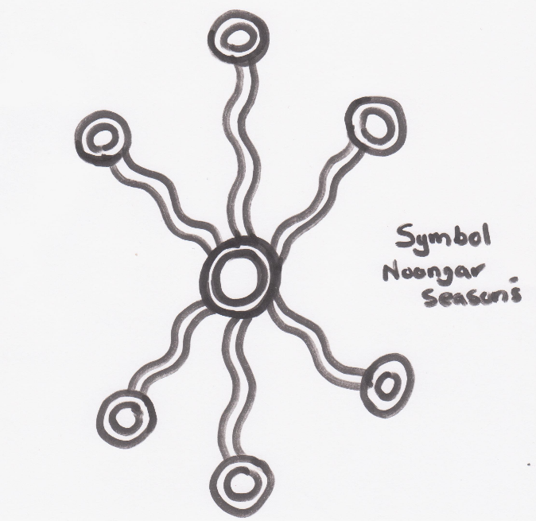
The Wardandi (forest people by the sea) are one of the Noongar tribes, and are the Traditional Owners of the South West Cape to Cape region. The region’s wide variety of native foods, wonderful beaches, forests and cave systems are traditional pathways to the dreaming for the Wardandi cultural custodians.
“Caring for country’ is integral to our culture and our future, and by respecting ‘Country’ visitors show their respect and contribute to our environmental sustainability.”
Living by the six seasons, the Wardandi people hunted and gathered from the land and sea. They would move along the coastal areas during the warmer months, and then back along the wetlands river systems and lakes over the cooler months. They would hunt for traditional foods such as kangaroo, wallaby emu, ducks, birds, fish, squid, octopus, crab, marron, abalone, and large variety of bush vegetables and fruits.

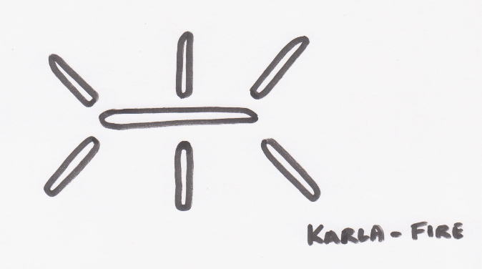
The significance of karla (fire) to the Wardandi people
Fire is an important part of Aboriginal culture, it represents family and kinship. Traditionally fire is used for cooking food, warmth, hunting, ceremonies (welcome to country, cleansing the spirits, burials) and land management.
Aboriginal people periodically set fire to the bush in Autumn - using mosaic circle burning, to make way for regeneration and allow the ash produced to work as a natural fertiliser. Controlled burns are still carried out today, based on the the traditional knowledge that if the leaf litter and understory vegetation is not burned periodically, highly destructive bushfires are inevitable.
Traditional fire lighting using only materials found in the natural environment is a skill that takes quite some practice, and is done using a fire stick from the Balga Tree.

