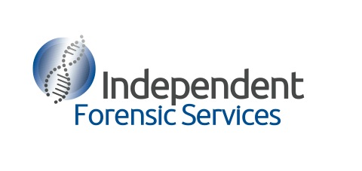

Forensic Science Expertise from the Crime Scene to Court

About Us

Our forensic biology experts each have over 10 years experience in operational forensic laboratories, (including the Forensic Science Service in the United Kingdom, Australian Federal Police, and the New South wales Police Force) and are experts in human biological material (including Blood, Saliva, Semen), Bloodstain Pattern Analysis as well as DNA analysis and interpretation.

Services

Independent Forensic Services has expertise in the following areas:
- Forensic Biology (including biological fluid detection techniques
- Bloodstain Pattern Analysis
- Damage Analysis
- DNA Analysis and Interpretation

We have the ability to:
- Conduct an independent review of the work conducted by the State or Federal Laboratories
- Assess if all appropriate examinations have been conducted
- Provide an expert opinion in relation to the significance of the evidence
- Assist in providing appropriate lines of questioning for expert witnesses
- Appear in court as an expert witness
- Perform laboratory based examinations or re-­‐examinations items for biological evidence.
- Conduct bespoke training on forensic biology, DNA analysis and interpretation and forensic science

We will provide high quality and timely advice that is honest and transparent and any resulting reports will be presented in a form readily understood by non-scientific audiences.
Independent Forensic Services has implemented a quality framework and is structured to provide the same internal technical review processes required by accrediting bodies such as NATA and we are continually working to expand our services and ensure our work is of the highest quality.
We believe our experience from the crime scene to the court and our quality framework offers our clients one of the most comprehensive independent forensic services available in the area of forensic biology and DNA analysis.

Who Uses Us?

Our services are utilised across the legal and law enforcement communities, some of the organisations that we have completed work for include:
- Private law firms
- Legal Aid
- Aboriginal Legal Aid
- Universities

Contact Us

Phone: +61 478 789 804
Email: enquiries@independentforensicservices.com.au
Web: www.independentforensicservices.com.au
Mail: PO Box 2466 North Parramatta NSW Australia 1750

