The Telstra spectrum is an important branding asset, it is used to place the focus on something (such as text or a picture) at the point (or in the “v” if inverted).
For example, here is how Telstra.com looks for the holidays:
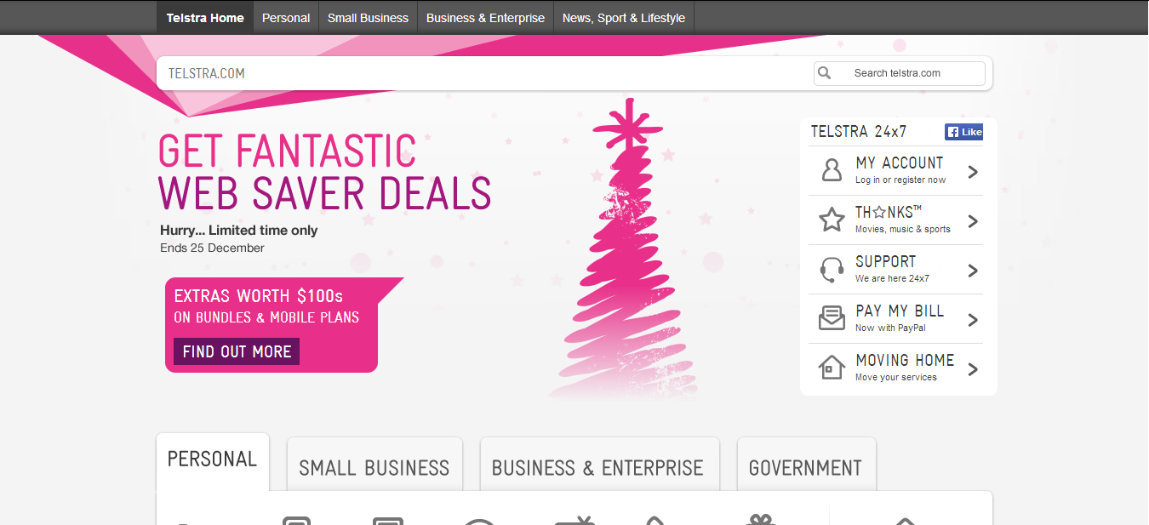

The following PSD files are available from Telstra in multiple color schemes (blue, red, green, purple, etc.)
The first two rows are for full pages, like a web site. The rest are for ads/banners.
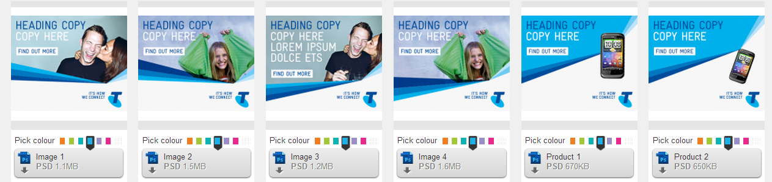
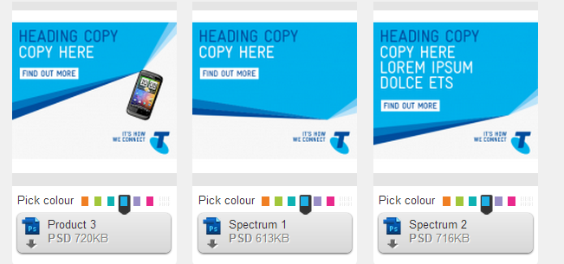
These are all for banner or side-bar advertisements … included FYI
