KEEPS Rx – Prescription Discount Brief
Who is KEEPS America?
KEEPS America distributes prepaid debit cards to clients of law firms on which they receive Social Security disability benefits or law suit settlement funds.
What is KEEPS Rx?
KEEPS Rx is a prescription discount card that entitles KEEPS’ cardholders to savings of up to 85% on their prescription medications at over 60,000 participating pharmacies. It is one of several value added products/services that we offer to our cardholder network. The prescription discount card is absolutely free to obtain and to use.
Where can consumers obtains KEEPS Rx?
A buckslip containing the KEEPS Rx card will be mailed in the same envelope that contains the KEEPS prepaid debit card as a separate, stand-alone marketing piece. This same buckslip will sometimes also be mailed by the law firms previous to a client opting to use the prepaid debit card – therefore, no mention to the KEEPS Card should be made.
Cardholders will also be able to print the card from the KEEPS Rewards website as well.
How does KEEPS Rx work?
Clients take the prescription discount card to a participating pharmacy and provide it to the pharmacist. When fulfilling the prescription, the pharmacist enters the Bin #, Group ID and Member ID into their software. The software checks if the client’s prescription is offered at a better price through our prescription discount card. If so, the discount will be applied. No matter what the client gets the best price – whether it is through the discount card or not.
What needs to be on the card?
Include on the card must be:
- “Prescription Discount Card”
- KEEPS Rx logo
- Healthtrans logo preceded by “Power by..”
- KEEPS Partner logo (on co-branded version)
- “Discount Program. Not Insurance.”
- Customer Service Phone Number (for consumers)
- Pharmacy Helpline (for pharmacists)
- Group ID/Member ID/Rx Bin Number
- URL (custom URLs for co-branded cards)
What should not be in the artwork (card or buckslip)?
- Logos of participating pharmacies
- Mention of “For Pharmacy Locations and Pricing”
Example One
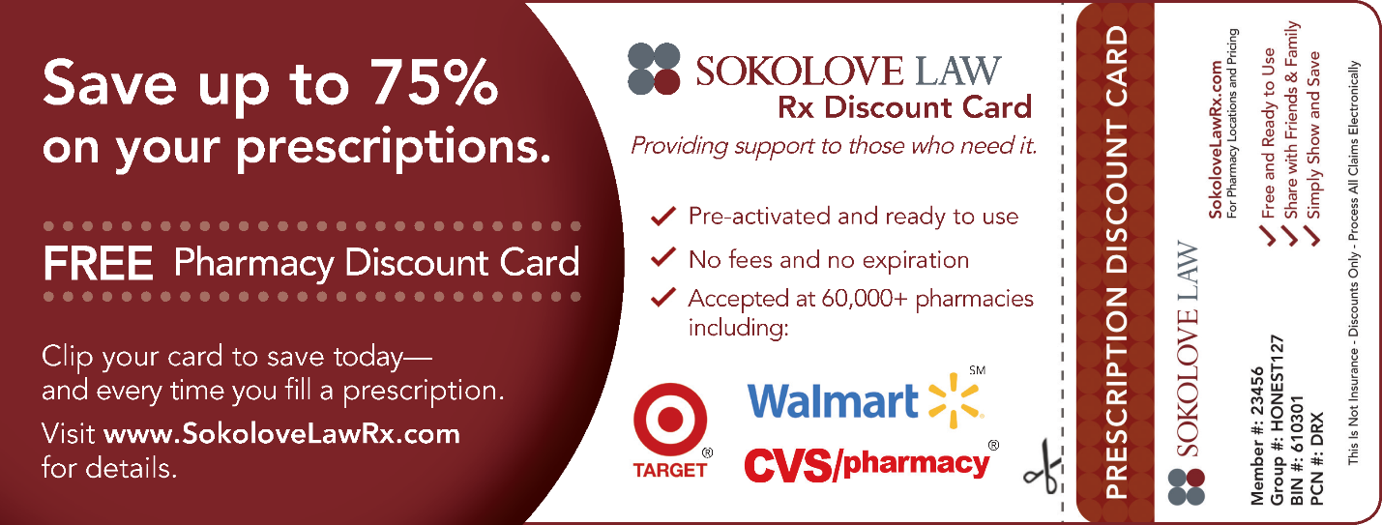
Good
- Easy tear-off of the card from the buckslip
- Clear, concise description of card benefits and how to use it (both on buckslip and on the card itself)
Bad
- Includes pharmacy logos
- Does not include partner logos
Example Two
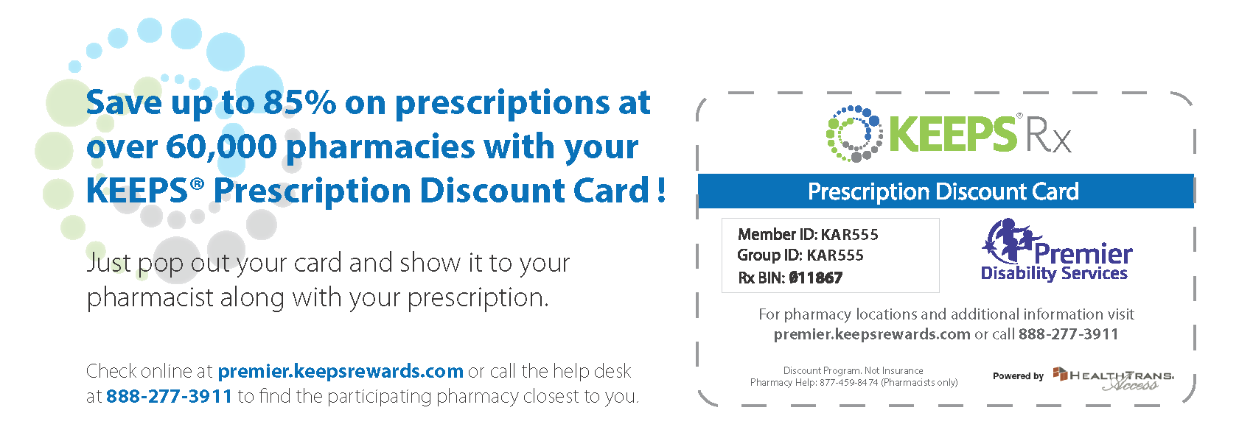
Good
- Includes correct logos, disclaimer language, phone numbers, URLs and Group ID/Member ID/Rx BIN
- Good amount of white space
Bad
- Copy is too long on buckslip
- Does not explain how to fulfill in concise manner
- Hard to cut out card

