
Union Marine Management Services Pte Ltd

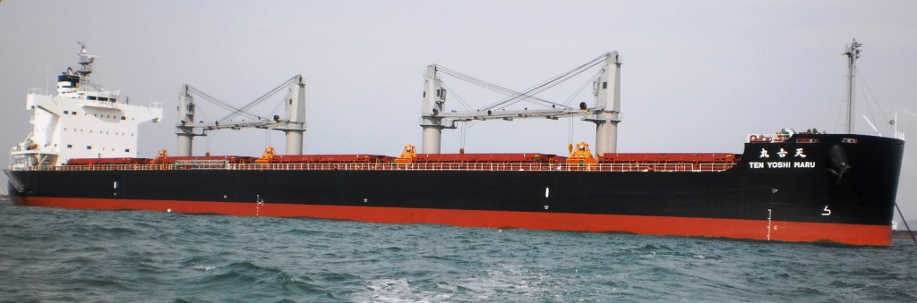
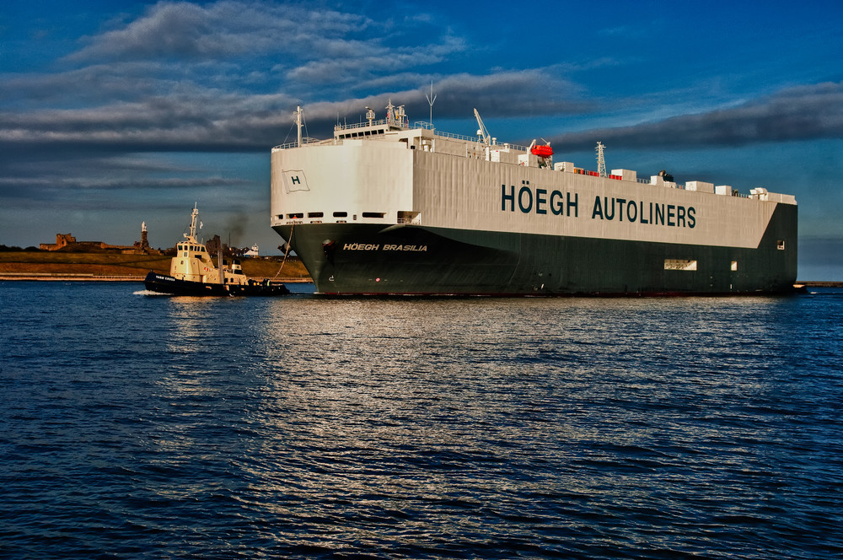
About us:
Union Marine Management Services Pte. Ltd, established in Singapore in 2012 as a Ship Management company with a clear objective to provide quality service to the Ship Owners while maintaining a fine balance and harmony between cost, efficient operation and giving a humane touch to the Ship Management.
With this philosophy, Union Marine Management Services Pte. Ltd was formed and was chosen as a dependable ally by Tsuneishi Group who have trusted us for the upkeep and safe operation of their ships for majority of their existing fleet and all new building vessels.
We have a vision – to contribute to the ship management business its lost pride and glory by running Clean, Safe and Happy Ships ethically.
Company is headed by Mr. Vinay Gupta who has more than 20 years of sea and shore based experience in various positions in the Shipping industry with majority of time spent ashore in key management position. UMMS is his brainchild and a reflection of his youthful and energetic persona. Like minded professionals were chosen right from the inception who have become the corner stones of the organization to build a strong yet dynamic entity.


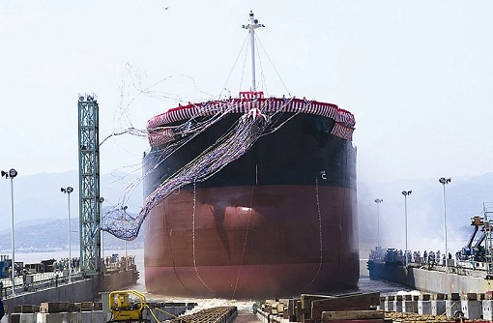
A ship being launched at Tsuneishi Shipyard

Services Offered:

- Ship Management

- Technical Solutions
An array of technical solutions for the shipping world
• Technical Consultancy
• New Building Supervision
• Pre-Purchase Surveys
• On-Site Supervision
• Dry Docking
• Condition Surveys
• Port Captaincy

Vision Statement:
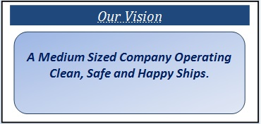
Mission Statement:
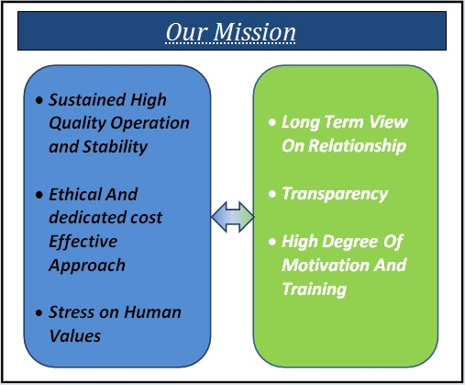

Milestones :
- Interim DOC audit conducted by Class DNV on 28th March’2012
- First vessel Hoegh Brasilia took over under management on 20th April’2012
- Fifth vessel Tenshou Maru taken over on 12th June’2012
- Tenth vessel Ten Yu Maru took over on 12th October’2012
- Fifteenth vessel Ten Yoshi Maru took over on 8th April’2013
- Eighteenth vessel was taken over on 8th June’2013.
- Training institute in Manila started on 8th November’2013
- Branch office in India opened from 4th December’2013
- Presently operating 16 Bulk carriers and 2 Car Carriers
- Another car carrier to be taken over in January.

Commitment:
- The company believes that good training, motivation and emphasis on human values are essential for long term success. Consequently, the company is committed to providing an ideal working environment both in its offices and on ships.

Strength:
- The company derives its strength from its highly skilled professionals who are among the best in the industry and share a common zeal to maintain uncompromised standards of safety, quality and efficiency.

- Honesty, trust, integrity and diligence are some of the qualities which are core to the principles of the company. Such traditional values and an in-depth knowledge of modern marine technologies blends here to produce a unique company that is focused in developing and sustaining prosperous partnerships with ship owners, office members, ship-staff and marine support service companies.

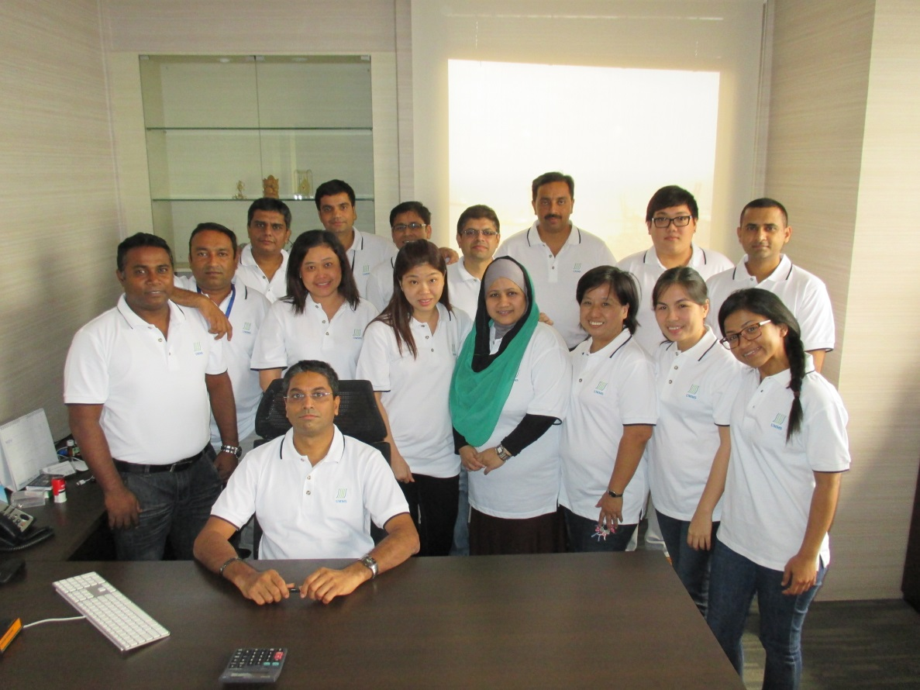

Our team in Singapore

Initiatives
- Started own in house training institute in Manila to train our staff and keep them abreast of new developments in shipping industry.
- ECDIS installation started on board in order to ensure smooth transition to paperless navigation with proper training to ship staff in our training center.
- Commenced Internet facility on board all our vessels. 20 mb data being given free to each crew every month.
- Special emphasis on crew welfare with supply of fitness and entertainment equipment on board.
- Assistance like free telephone cards, internet cards, cash donation provided to staff in case of a natural calamity in home country.

Photographs for the brochure:

- Ship’s photographs
- Crew photographs
- Training center in Manila

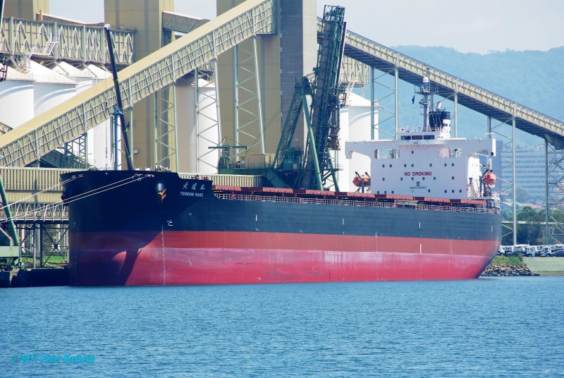

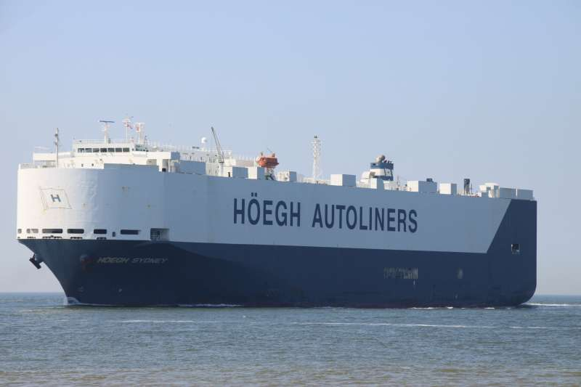

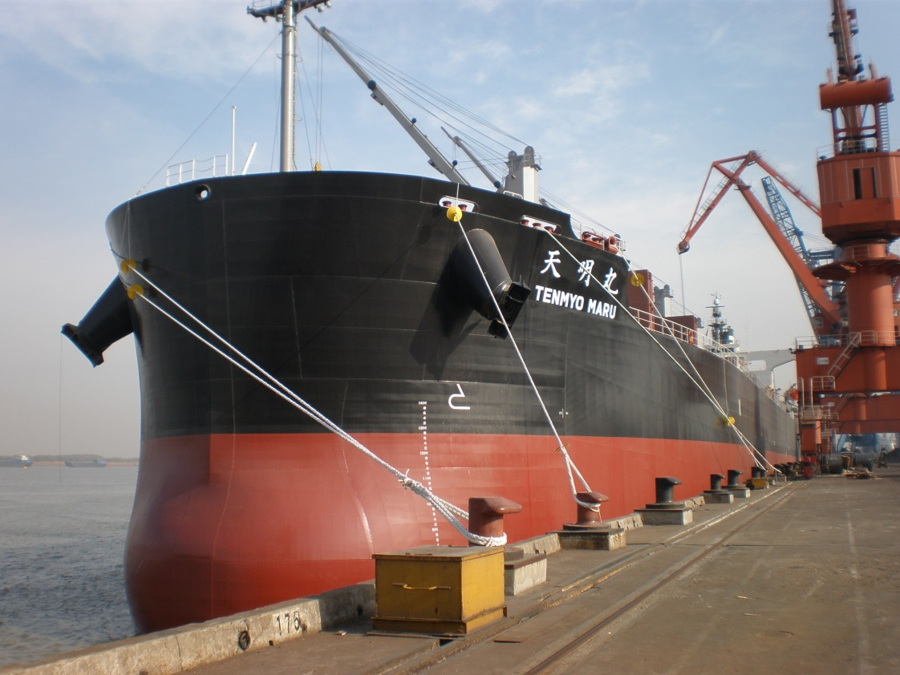

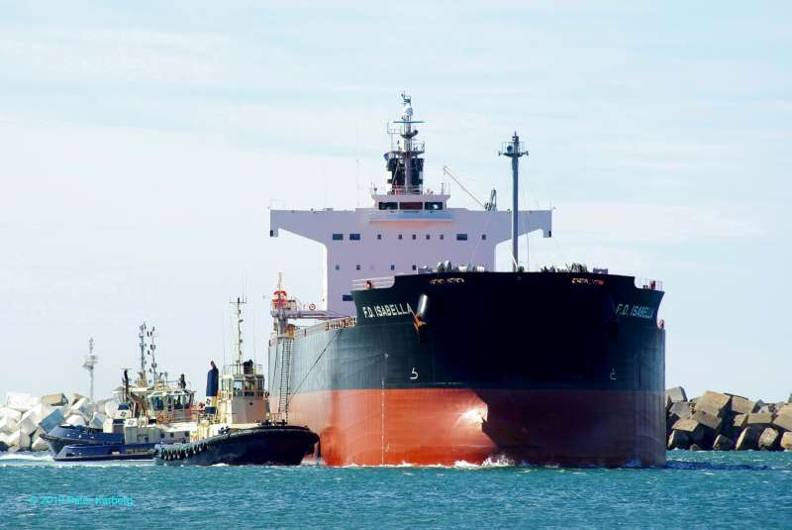

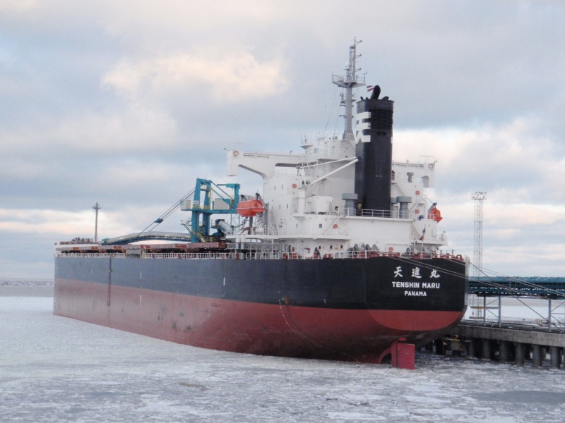

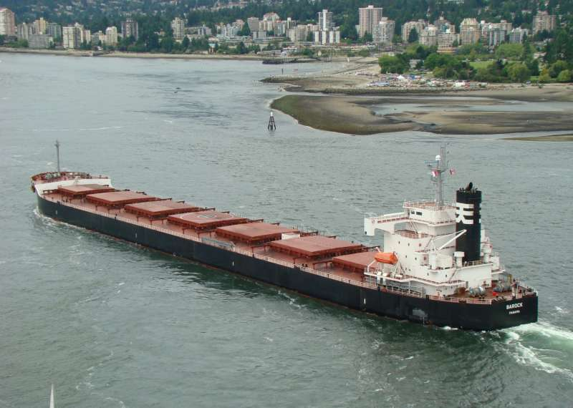

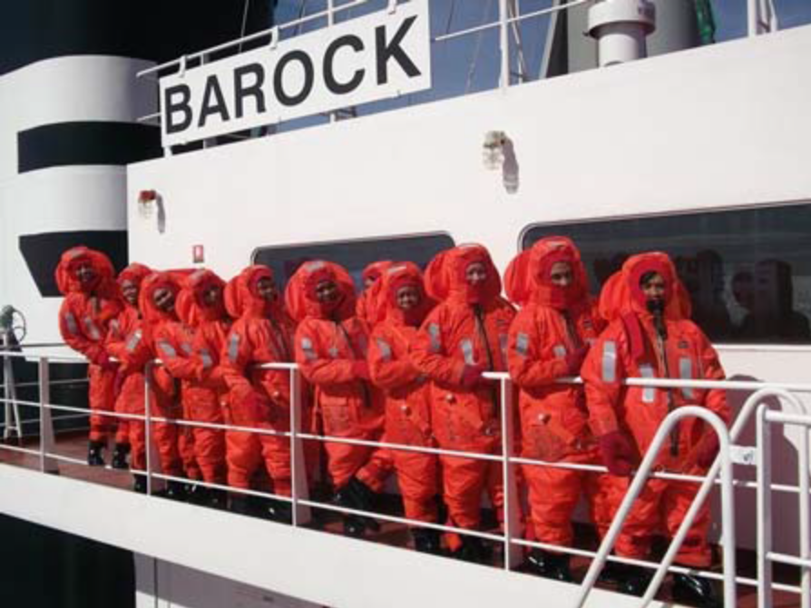

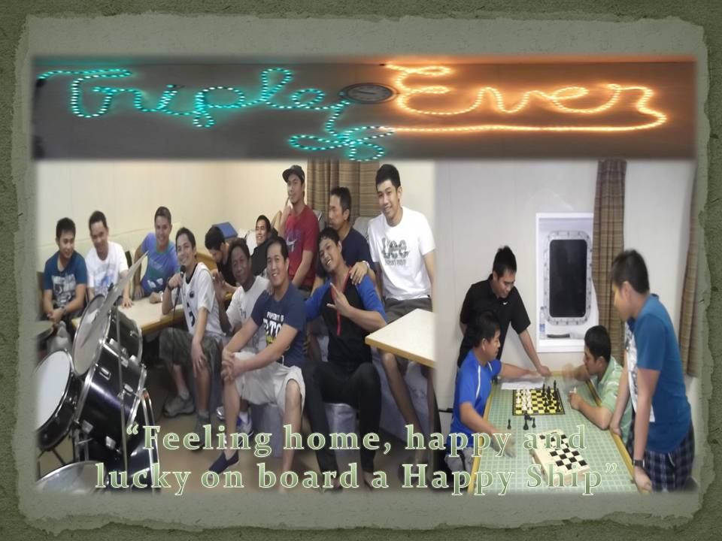

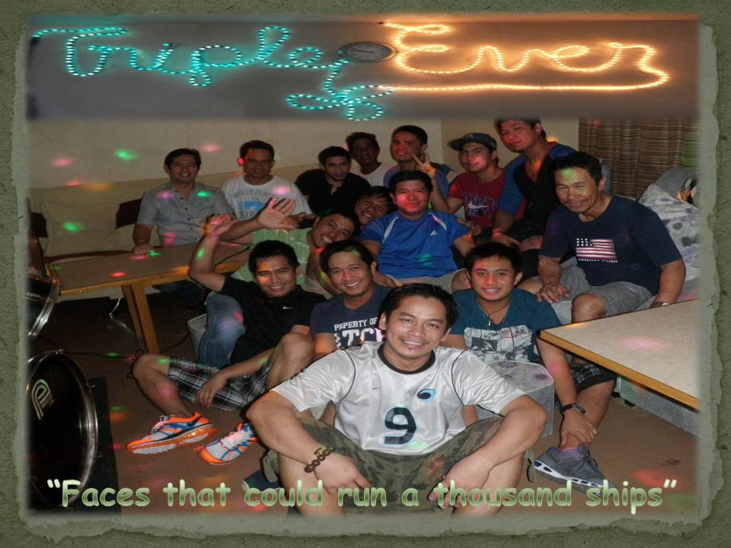

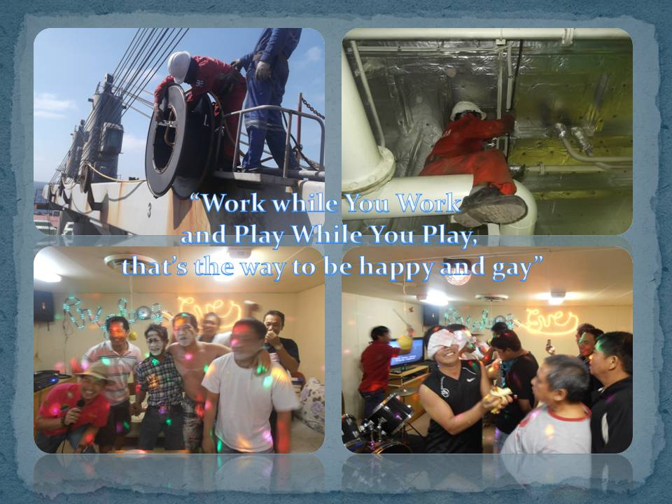
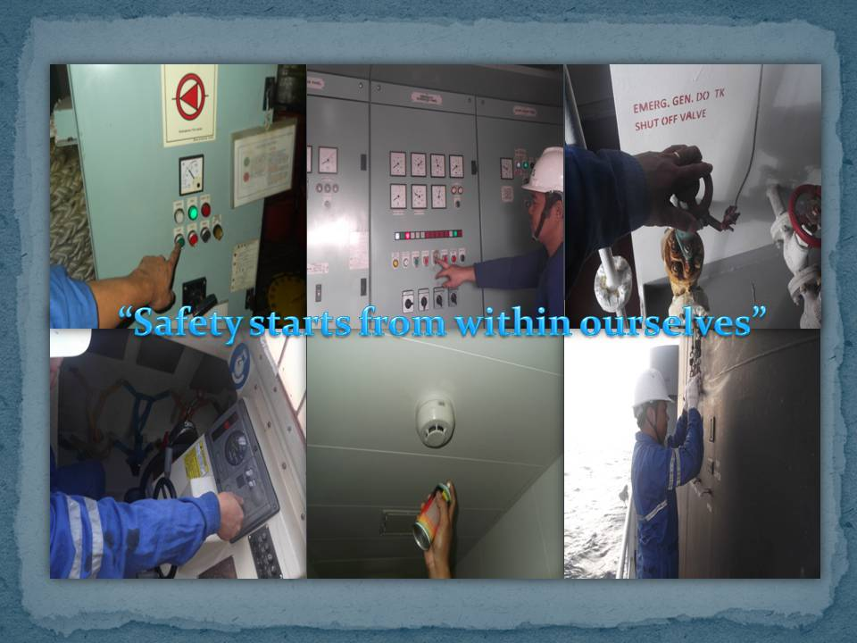

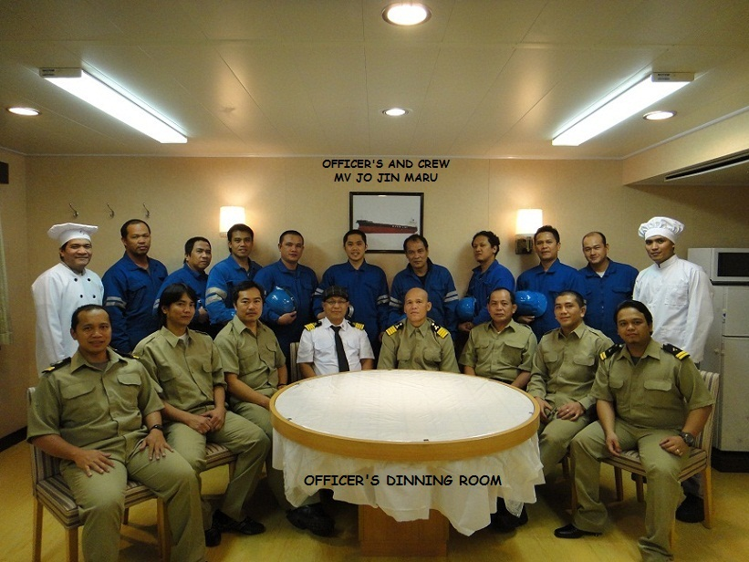
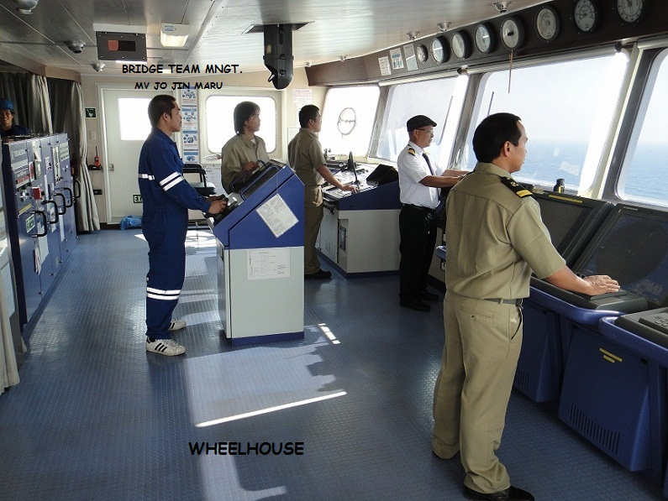

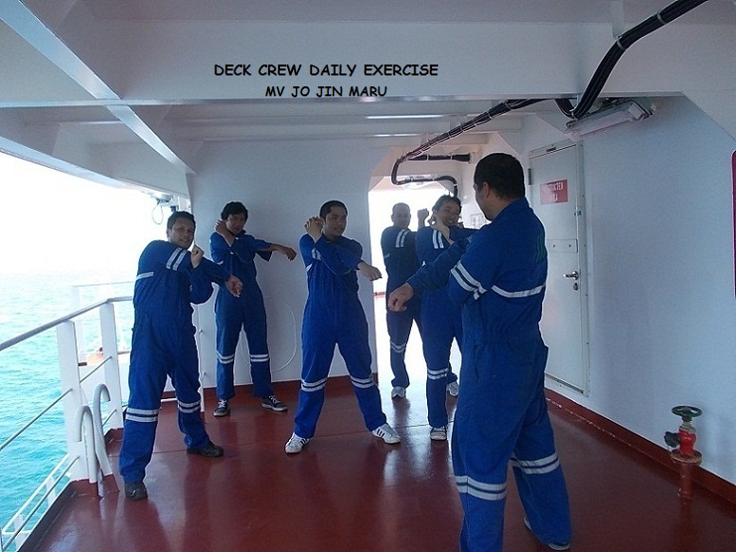
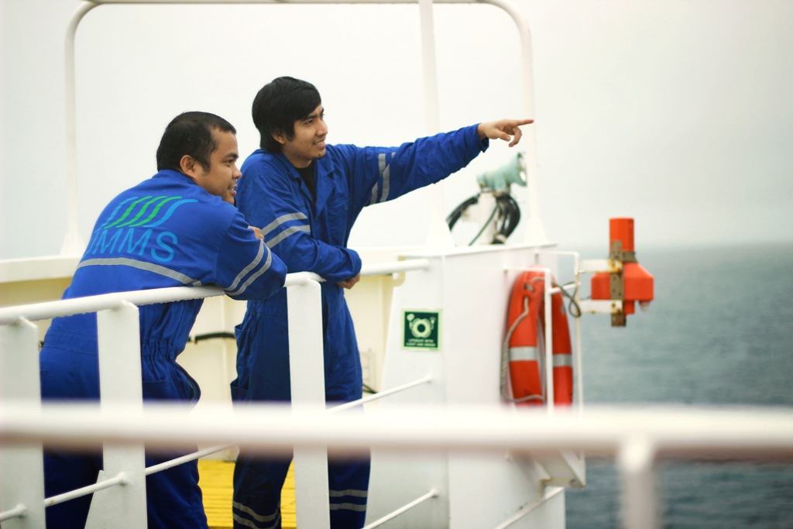

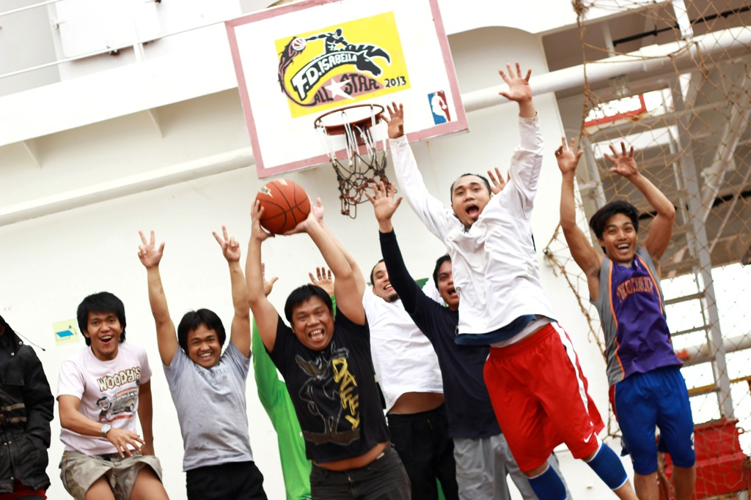

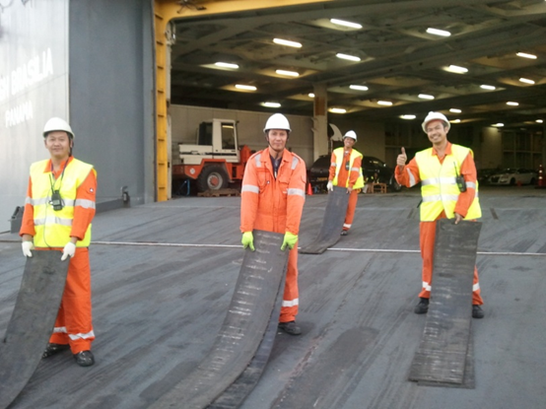

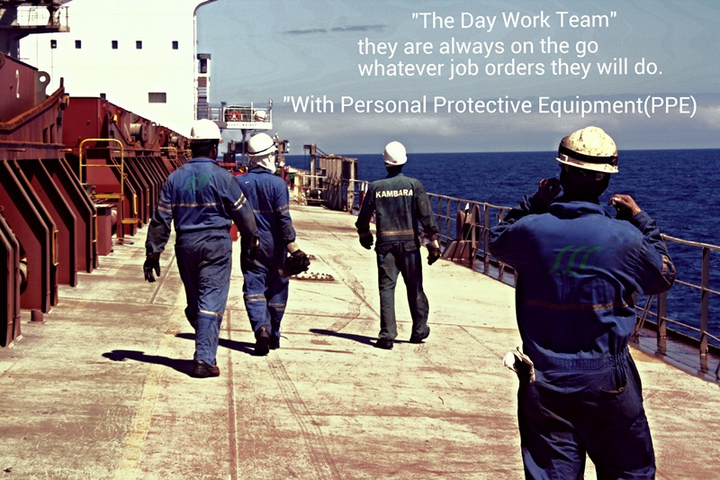

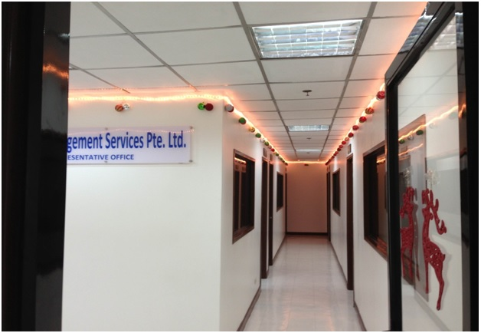
Training institute in Manila

