The three logos below are the ones I like the best so far. I don’t have to have a check mark for the icon, but I do need something that has to do with results, or rules coming together, or logic, or pieces of the puzzle coming together. Something to signify many rules becoming true and then when all the rules have been met, the trade is taken. I thought a blueprint might signify some kind of “plan”. Also a kind of check list, or a series of smaller check marks with one large one following showing that “all the rules have been met”. Something like that. I don’t know. I’m open to suggestions.
I do like “Trading Plans and Strategies” for the tag line under Trade The Plan or Trade-The-Plan rather than “Turn Your Ideas Into Rule Based Trading Plans and Strategies” I think I’ll use the latter as a kind of headline for my website.

For the one below, the check mark is too “Nike”. I dunno. I like the blue print feel to it. Maybe use a square instead of a cirlce? Try using “Trading Plans and Strategies” for the tage line, and use some kind of list with smaller check marks to the left side of the icon with a large check mark next to them on the right side of the icon…??? I wish I were more creative. I just want something really nice. This does look pretty nice, though.

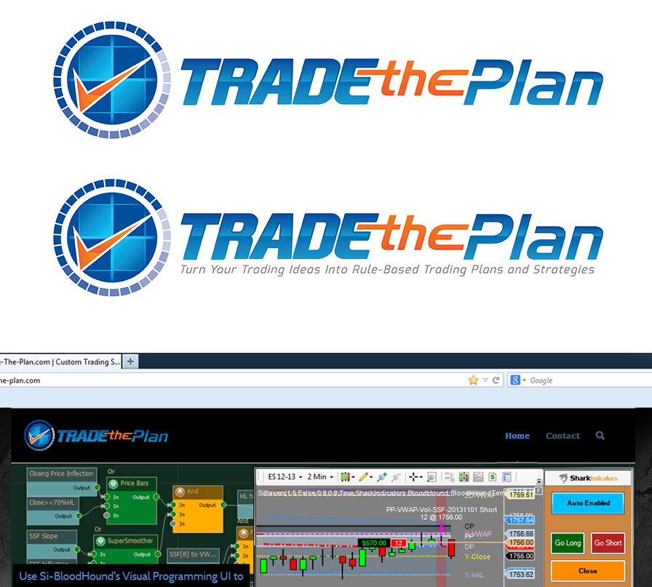
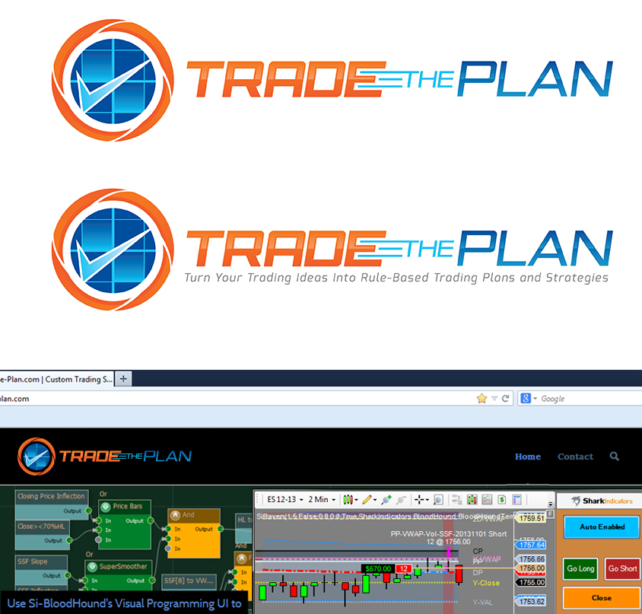
I was thinking of something like the first icon below, with a kind of clipboard or a faint blue checkered spreadsheet (giving a kind of blueprint feel) with “Trading Plan” as the heading with a 5 or 6 point checklist with one big checkmark coming up and out of the plan signifying all the rules have been met. And then have “Trade The Plan” next to it with “Trading Plans and Strategies” underneath in a little smaller text. I like the design of this checkmark. Not sure about the color, though. And I like the 3d design, if that’s not too difficult.


I don’t like the colors of this one. And the icon is not exactly what I’m looking for. It doesn’t really say anything about Trading Plans or strategies. It’s just a bar chart. I’m looking for something more specific.


Below are just a few icons I found on shutterstock.com.





And the ones below were just some logos of some of the companies in the same kind of industry as I. Most are not very good, but these seem to be somewhat decent. Just for ideas...




An example of the work that I do for people

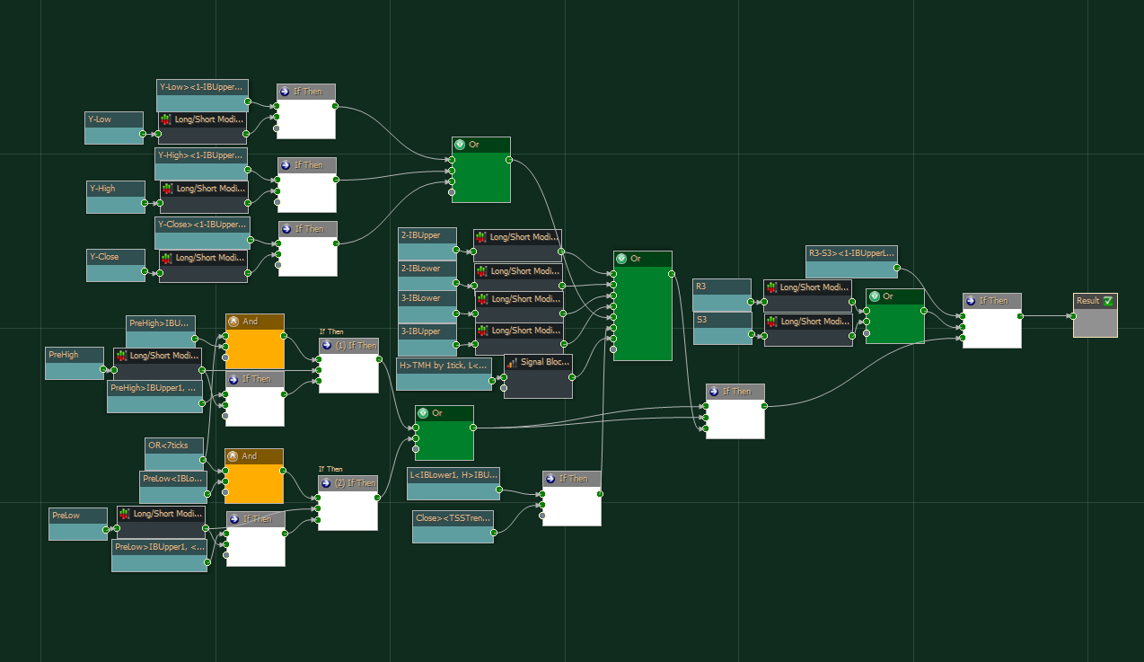

Just an example of some of what the logic templates produce on the chart. The green vertical line is the signal line
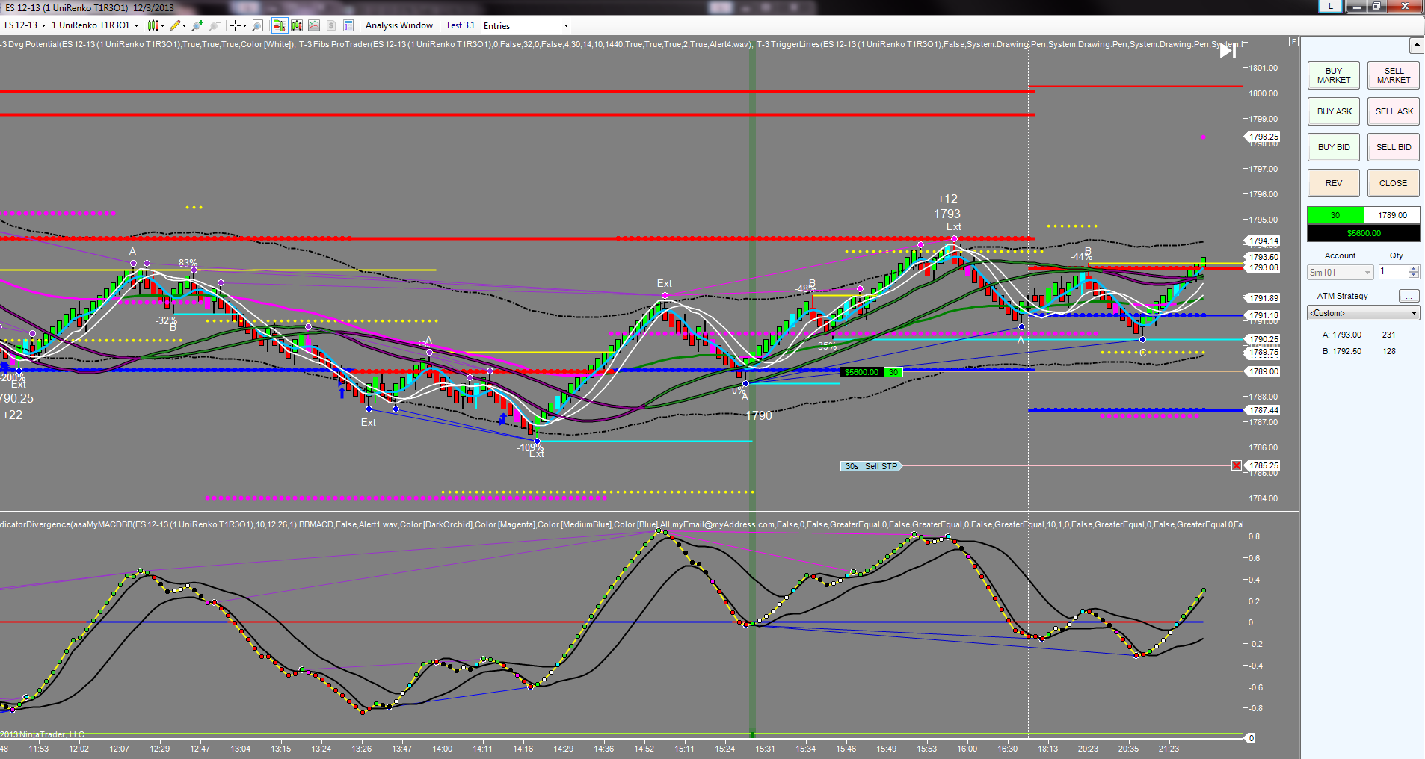

Another example:
