Brief.
The aim is to create a logo for this new holiday home finding property business.
“The eventual aim is to create a BRAND that is synonymous with buying a home abroad. First thing people think of when they start to consider taking on a place in the Sun. Originally will focus on UK buyers looking in Mallorca. However, the brand would need to work internationally. As over time you would aim to represent UK buyers in whatever countries they are looking to buy – yet in addition other nationalities in assisting their holiday home purchase e.g. Swedish/German/Chinese etc.”

The company name
Byrd & Boone. Holiday Home Hunters.
Why?
It is a tie in with some famous World Explorers – a playful link between what they did and what we aim to do. It is also gives the company a feeling of heritage and experience. Stature.
Explorers famously braved treacherous conditions, discovering news parts of the World for everyone else to just enjoy the benefits of. They did the hard work, so we didn’t have to!
Mr Richard E. Byrd and Mr Daniel Boone; two men with an insatiable thirst for adventure

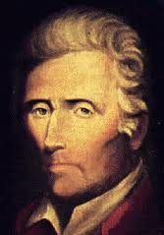 BYRD 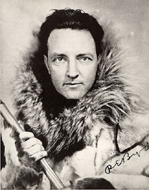 Boone

Some extra important details
- Who is your target audience? 40+ well off couples and families looking for a second home or relocating abroad. Singles. Alternative lifestyle (working from home).
- Who are your closest competitors? Existing search agents (most of which do not really advertise, just wait for word of mouth for people to come to them). Or estate agents on the island.
- What type of product or service do you offer? Complete support for the buyers of holiday homes from start to finish. Representing them in every aspect of it.
- What is your unique selling point? A combination of Property market experience, local knowledge combined with knowing how to serve your customers to a high standard. Using technology to answer the needs of foreign home buyers.

THE OUTPUTS

Company name: Byrd & Boone
Tag line: Holiday Home Hunters
Slogan: The smart way to buy abroad

Open to ideas but ideally the Brand title, tag line and Logo would be incorporated into one design (also available to be used as separate components
- I would like a neat professional presentation of Byrd & Boone. Holiday Home Hunters. The smart way to buy abroad (using the recommended fonts below)
- Then in addition we need a powerful energetic logo that encapsulates what it is all about. This could well just be the B&B. Below I am including a lot of graphics to give you an idea. But I see the logo encompassing the travel theme – perhaps with one of the compasses mentioned below and using that colour palette
I envisage tweaking this regularly over the week, and finishing within that 7 days.

INSPIRATION:
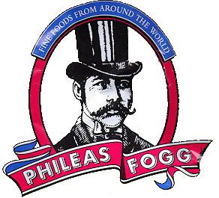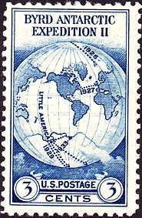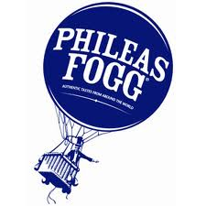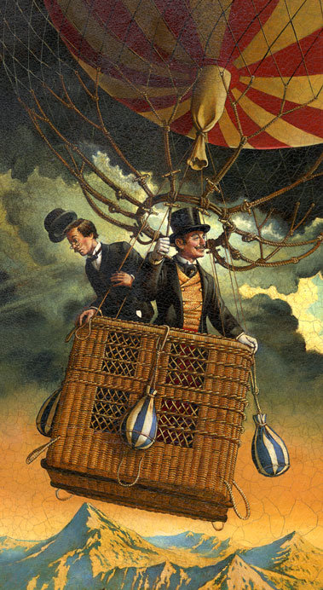

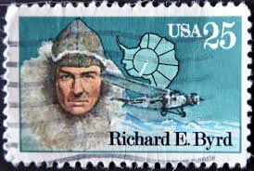

COLOURS – I am interested in either simple black and white – or to use the following colour palette. I will leave this to your professional judgement:

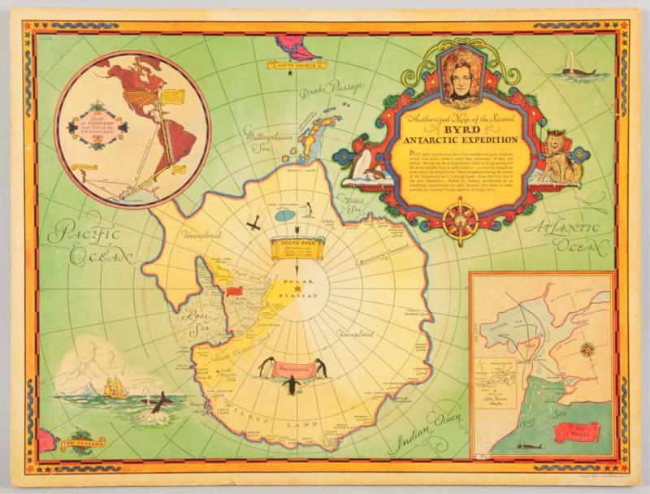

IN terms of the logo we thought including a telescope or a compass like this:

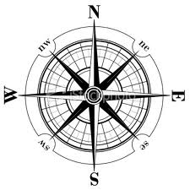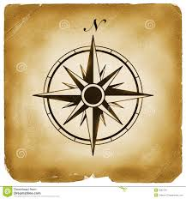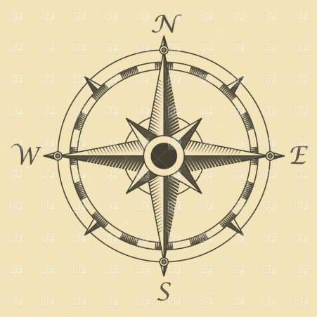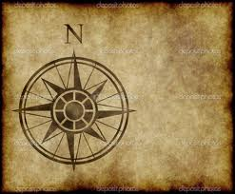
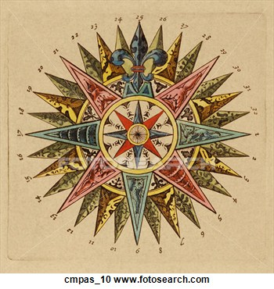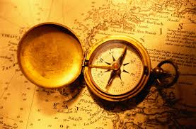
Some nice logo ideas:

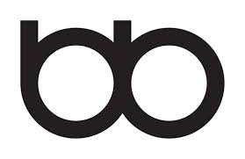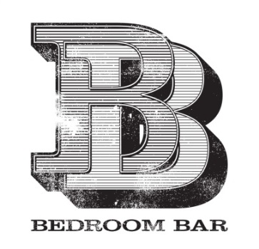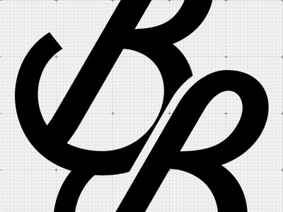

FINALLY SOME POSSIBLE FONTS FOR THE FIRST OUTPUT (the professional presentation of the full company title)

Byrd & Boone
Holiday Home Hunters

At Byrd & Boone we recognise that…

Byrd & Boone
Holiday Home Hunters

At Byrd & Boone we recognise that…

Byrd & Boone
Holiday Home Hunters

