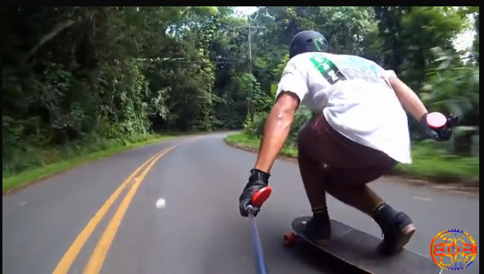

Social media banner
This should be a chagble banner. Here we should show banners of the iSAW Extreme, the PRO-mount accessories and more
Full size video sxreen.
Top banner + video screen should bes een without scrolling
Place iSAW logo infront of the ‘action camera’logo

