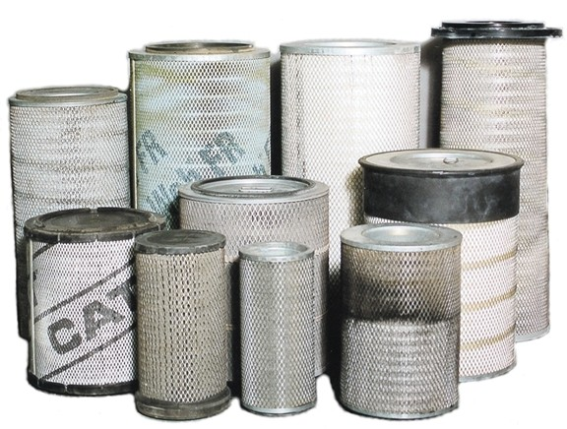

FILTER CLEANING SERVICES

Dave Gregory
Managing Director
Address: PO Box 243, Singleton NSW, 2330
ABN: 93150486454
Email: dave@afcs.com.au
Website: www.afcs.com.au

Ph; 0499770081

Australian Filter Cleaning Service Pty Ltd

• Recycle
• Re-use
• Reduce landfill impact
• Save you 40 – 60 % off new filter by recycling your filters
• Reduces operating expenses
• Increase carbon credits
• Reduce Inventory
Australian Filter Cleaning Services
• Uses no water or chemicals
• Uses clean air to blow and vacuum
• Inspects every filter for integrity
• Track filter cleaning cycles
• Vacuum tests every filter
• Caterpillar compliant process
• Provides filter test reports

“We can come to you” to clean your filters! You get “your” filter returned!
We're confident in our company and in our product. We are sure that you will be, too. Contact us saving the environment and start saving money by using recycled filters.
Contact us today

Phone: 0499770081
Email: Info@afcs.com.au

