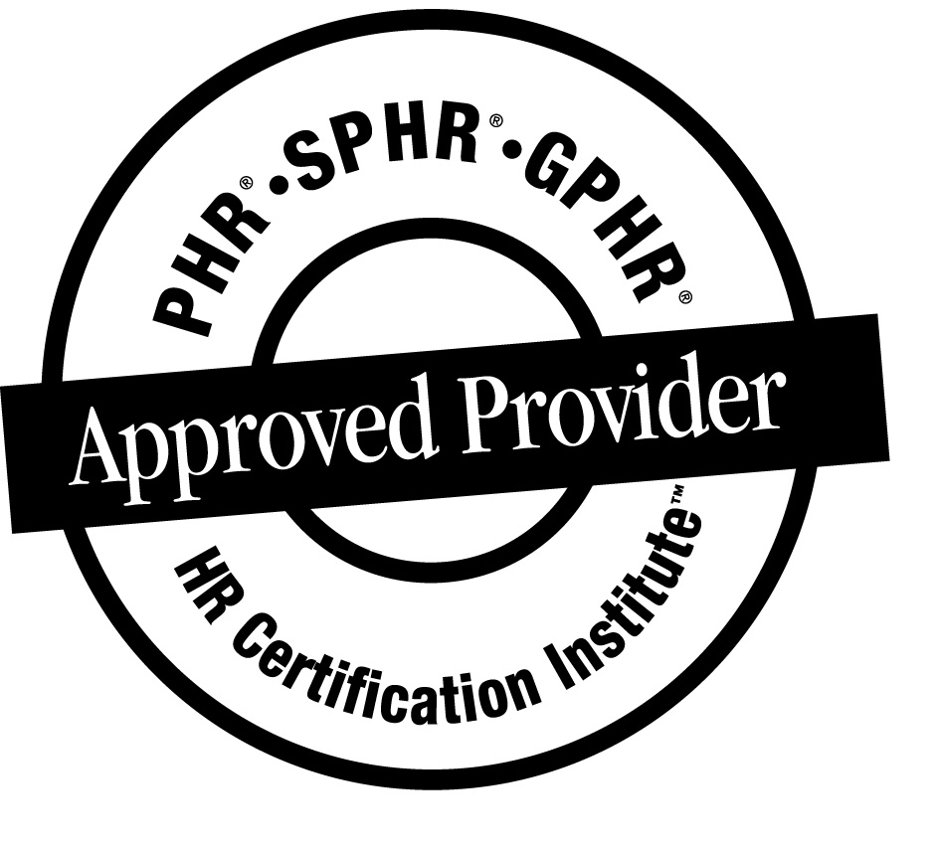
Clear Law Institute

Human Resources Webinars
Live and On-Demand

Upcoming sessions include:
Generic Photo of someone on a Web Conference
- Detecting Lies and Deception in Employee Investigations
- Writing Investigative Reports
- Employee Benefits for Same-Sex Partners
- Social Media and Employment Law
- New Affirmative Action Regulations
- Criminal Background Checks
- Legal Risks of Telecommuting
- And More!

Table of Contents
Social Media and Employment Law* (Jan. 6) 3
Top 10 Employment Cases of 2013 (Jan. 14) 4
Employee Benefits for Same-Sex Partners* (Jan. 15) 5
New OFCCP Affirmative Action Regulations * (Jan. 16) 6
Employee Dress and Appearance Standards* (Jan. 16) 7
Detecting Lies & Deception in Investigations* (Jan. 21-23) 8
Legal Risks of Telecommuting (Jan. 22) 10
Mental Illness and the ADA (Jan. 23) 11
Criminal Background Checks* (Jan. 28) 12
Immigration Compliance (Jan. 29) 13
Writing Employee Investigation Reports* (Jan. 30) 14
New Regulations for 2014 in California (Jan. 31) 15
Frequently Asked Questions 16

* These webinars are also available on-demand for immediate viewing

Social Media and Employment Law  January 6, 2014, 2 to 3:15 PM EST  In this interactive webinar, you will learn how to prevent and respond to employee misuse of social media. Among other things, you will learn:  - How to avoid violating state and federal laws, including the National Labor Relations Act, when addressing employee misuse of social media  - How to handle employees who criticize co-workers, bosses, or customers online  - How to prevent employees from disclosing trade secrets online  - How to combat your employees’ beliefs that what they do online is private  Attend live and/or view recording for 3 months after webinar  Price (Money-Back Guarantee)  $249 per person  Register and learn more at http://www.clearlawinstitute.com/xxxxx | 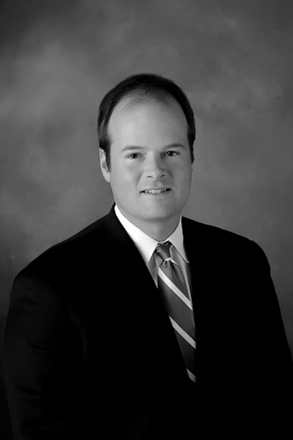  Jonathan Yarbrough is a partner in the national labor and employment law firm Constangy, Brooks & Smith, LLP.

Top 10 Employment Cases  of 2013  January 14, 2014, 2 to 3:15 PM EST  Which 2013 employment law court decisions really matter to you? Which cases are going to alter how you do business? In this entertaining and engaging session, you will learn:  - About the ten most important court decisions from 2013 and how they might impact your organization.  - The steps you should take now to review and modify existing policies and procedures  Attend live and/or view recording for 3 months after webinar  Price Per Attendee (Money-Back Guarantee)  $249 per person  Register and learn more at http://www.clearlawinstitute.com/xxxxx |   Louis R. Lessig is a partner with the firm Brown & Connery, LLP. His practice concentrates in labor and employment counseling.

Employee Benefits for Same-Sex Partners  January 15, 2014, 2 to 3:15 PM EST  Employers must immediately ensure that their benefits plans take into account:  - The Supreme Court’s decision striking down the Defense of Marriage Act (DOMA), and  - The IRS’s decision to recognize all same-sex marriages for tax purposes.  In this interactive webinar, attorney Todd Solomon will discuss the impact of these rulings and the steps employers should take now to ensure that they are in compliance with all applicable laws. You will learn about:  - Employers’ options and obligations relating to employee health, retirement, and other benefits for same-sex couples  - Changes in federal and state tax treatment of employer-provided benefits for same-sex couples  - State law recognition of same-sex relationships and recent developments  - Best practices and tips for offering benefits to same-sex couples  Attend live and/or view recording for 3 months after webinar  Price (Money-Back Guarantee)  $249 per person  Register and learn more at http://www.clearlawinstitute.com/xxxxx |   Todd Solomon is a partner in the employee benefits practice group of McDermott Will & Emery LLP in its Chicago office. Todd is the author of Domestic Partner Benefits- An Employer’s Guide. He frequently speaks on benefits issues related to domestic partnerships and same-sex marriages.

New OFCCP Affirmative Action Regulations for Federal Contractors  January 16, 2014, 1 to 2:15 PM EST  The OFCCP recently published Final Rules relating to the treatment of persons with disabilities and veterans in affirmative action plans. For the first time, federal contractors must establish a “utilization goal” for individuals with a disability and an “annual hiring benchmark” for protected veterans. Join us as we dissect the new Rules, outline the new requirements, and discuss such items as:  - New Requirements & Obligations  - Differences Between Final & Proposed Regulations  - Recordkeeping Procedures  - Planning for Implementation  - Practical Considerations  Attend live and/or view recording for 3 months after webinar  Price (Money-Back Guarantee)  $249 per person  Register and learn more at http://www.clearlawinstitute.com/xxxxx |     Angelique Groza Lyons and Cara Crotty are Partners at Constangy, Brooks & Smith LLC. Ms. Lyons and Ms. Crotty represent employers in all types of employment law matters. They also help federal contractors develop affirmative action plans and represent them during audits.

Employee Dress and Appearance Standards  January 16, 2014, 3 to 4:15 PM EST  First there was the shift from business attire to business casual. Now employers are faced with everything from tattoos, to piercings, to dreadlocks, and beyond.  Many employers do not realize that their dress and appearance standards could lead to claims of race, sex, disability, or religious discrimination, unfair labor practice charges, or violations of other state and federal laws.  In this interactive webinar, you will learn practical and legal issues associated with employee dress and appearance standards. You will also learn a commonsense approach to resolving such issues in the workplace.  Attend live and/or view recording for 3 months after webinar  Price Per Attendee (Money-Back Guarantee)  $249 per person  Register and learn more at http://www.clearlawinstitute.com/xxxxx | Jonathan Yarbrough is a partner in the national labor and employment law firm Constangy, Brooks & Smith, LLP.
Detecting Lies and Deception in Employee Investigations  3-Part Webinar Series  January 21-23, 2014, 1 to 2:15 PM EST  Former US Department of Justice attorney Michael Johnson leads three webinars that challenge common beliefs about how to interview witnesses and spot deception in internal investigations.  1. Spotting Cues to Deception in Employee Investigations  Tuesday, Jan. 21 | 1:00 to 2:15 pm ET  You will learn, among other things:  - How to strategically approach “he said/she said” cases or cases where there are no eyewitnesses  - Which verbal and physical cues to deception have been scientifically validated and which are based on myth  - Guidance from a U.S. government agency on how to make credibility determinations in employee misconduct cases  2. Investigative Interviewing: Advanced Techniques  Wednesday Jan. 22 | 1 to 2:15 pm ET  You will learn, among other things:  - How to use the “Funnel Method” to gather all relevant information from each witness  - How to use a “journalist” as opposed to a “police officer” interview style to get the person to talk  - Advanced questioning techniques developed in Europe that make it easier to differentiate between truthful and deceptive responses  Content Analysis of Witness Statements Thursday, Jan. 23 | 1 to 2:15 pm ET  You will learn, among other things:  - How to use “Statement Validity Assessment” to distinguish between statements that are based on memory of actual events versus false statements  - How the manner in which a witness tells a story provides clues of truthfulness  - Techniques for examining word choice and changes in word choice that may signal deception  Attend live and/or view recording for 3 months after webinar  Price Per Attendee  $179 per webinar ($447 for all 3)  (Money-Back Guarantee)  Register and learn more at http://www.clearlawinstitute.com/xxxx | 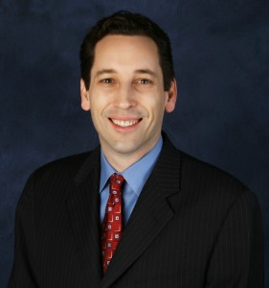  Michael Johnson, CEO of Clear Law Institute, is a former U.S. Department of Justice attorney. Michael has trained thousands of professionals how to investigate employee misconduct and write investigative reports. He has provided investigations training to organizations such as the EEOC, Google, and the United Nations. He is a graduate of Duke University and Harvard Law School.  Continued on next page  Michael Johnson, CEO of Clear Law Institute, is a former U.S. Department of Justice attorney. Michael has trained thousands of professionals how to investigate employee misconduct and write investigative reports. He has provided investigations training to organizations such as the EEOC, Google, and the United Nations. He is a graduate of Duke University and Harvard Law School.

Legal Risks of Telecommuting  January 22, 2014, 3 to 4:15 PM EST  During this session, we’ll answer questions including:  - What are the legal risks involved in “telecommuting” and employees working from home?  - How do you protect safety sensitive information when employees are working outside the office?  - How do you keep up with “hours worked” for those who are not exempt under the Fair Labor Standards Act?  - How do you monitor performance for those who work from home?  - What is OSHA’s latest position with regard to “telecommuting” arrangements?  - What things should you consider in a telecommuting agreement?  Attend live and/or view recording for 3 months after webinar  Price Per Attendee (Money-Back Guarantee)  $249 per person  Register and learn more at http://www.clearlawinstitute.com/xxxxx |   Susan Fahey Desmond has been representing management in all areas of labor and employment law since her graduation from the University of Tennessee in 1985. She is a partner with Jackson Lewis, a national labor and employment law firm with 54 offices across the country.

Mental Illness and the ADA  January 23, 2014, 3 to 4:15 PM EST  Attend live and/or view recording for 3 months after webinar  Price Per Attendee (Money-Back Guarantee)  $249 per person  Register and learn more at http://www.clearlawinstitute.com/xxxxx | 
Criminal Background Checks in the Hiring Process: Complying with New Changes in the Law  January 28, 2014, 2 to 3:15 PM EST  Changes in state laws and new guidance from federal agencies have left employers uncertain about considering applicants’ criminal history in the hiring process. In this interactive webinar, you will learn:  - How to navigate between the Fair Credit Reporting Act, new EEOC guidance, and new OFCCP guidance  - How to avoid negligent hiring lawsuits from hiring someone with a criminal background  - How to comply with state and local “Ban the Box” laws that impact employers’ ability to ask about and consider applicants’ criminal history  Attend live and/or view recording for 3 months after webinar  Price Per Attendee (Money-Back Guarantee)  $249 per person  Register and learn more at http://www.clearlawinstitute.com/xxxxx |   An attorney based in New Jersey, Ms. Frisch counsels senior management and HR professionals in multi-state labor and employment law issues, including discrimination, wrongful termination, wage and hour compliance, privacy and ADA/FMLA, and Title VII.
Immigration Compliance  January 29, 2014, 1 to 2:15 PM EST  Attend live and/or view recording for 3 months after webinar  Price Per Attendee (Money-Back Guarantee)  $249 per person  Register and learn more at http://www.clearlawinstitute.com/xxxxx | 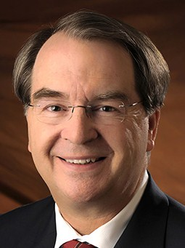  
Writing Employee Investigation Reports  January 30, 2014, 1 to 2:15 PM EST  Former U.S. Department of Justice attorney Michael Johnson provides practical guidance for writing investigation reports in this interactive webinar. You will learn how to efficiently write reports that are clear, concise, and legally defensible.  Among other things, you will learn:  - Legal considerations of what to include, and not include, in the report  - How to break up the report writing process into six discrete steps  - How to overcome “writer’s block”  - The rules for clear and concise writing  Attend live and/or view recording for 3 months after webinar  Price Per Attendee (Money-Back Guarantee)  $249 per person  Register and learn more at http://www.clearlawinstitute.com/xxxxx | Michael Johnson, CEO of Clear Law Institute, is a former U.S. Department of Justice attorney. Michael has trained thousands of professionals how to investigate employee misconduct and write investigative reports. He has provided investigations training to organizations such as the EEOC, Google, and the United Nations.

New Regulations for 2014 in California  January 31, 2014, 2 to 3:15 PM EST  Attend live and/or view recording for 3 months after webinar  Price Per Attendee (Money-Back Guarantee)  $249 per person  Register and learn more at http://www.clearlawinstitute.com/xxxxx | 

Frequently Asked Questions
about Clear Law’s Webinars

Continuing Education Credit
Each webinar has been approved for 1.25 hours of general recertification credit hours toward PHR, SPHR, and GPHR recertification through the HR Certification Institute. The use of this seal is not an endorsement by the HR Certification Institute of the quality of these programs.

Are the webinars interesting and helpful?
Clear Law Institute only selects presenters who are both informative and engaging. All of our previous webinars have been rated at least 4.0 on a 5.0 scale.

Do you offer a money-back guarantee?
Yes. If not completely satisfied with the training, we will refund your money in full.

Are the webinars recorded?
Each webinar is recorded and available for you to view for 90 days afterwards.

