Examples of colors and fonts:

TRANSFORMATIONAL DREAMS
Dying to Live
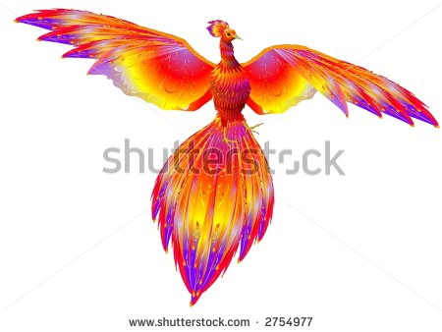

Understanding the Language of the Unconscious

Cinzel Font – the same as on my website
OR
TRANSFORMATIONAL DREAMS
Dying to Live
Understanding the Language of Dreams

IMPRINT MT SHADOW FONT
