

PERSONAL(ITY) VIBE

Tailored for:


Personal Vibe is the basis of what makes up organizational vibe. The culture of any organization or group of people is built one person and one relationship at a time.
is the uncanny, invisible energy
that emerges from the combination of
      - clarity,
      - competency and
      - chemistry
leading to noteworthy results!

Vibe tends to “trickle down” from the top starting with the leader.

THE QUADRANT of CHANGE
Change Doesn’t Work Like This…

CHANGE MOVEMENT

- People do not move from Comfortable to Productive
- People do not move from Disconnected to Productive

Change Works Like This. . .
- For change to be permanent, one must go thru the _____________ , the Land of Disillusionment
- This requires a change in One’s Communication Style

THE FOUR PERSONALITY STYLES

PERSONALITY THEORY COMPARISON CHART
The chart below represents the names for the Personality Styles as they compare to our model and descriptions:

the PERFORMER  Social Style: “Expressive”  DiSC: “Influence”  Galen: “Sanguine”  Smalley & Trent: “Otter” | the PRODUCER  Social Styles: “Driver”  DiSC: Dominant  Galen: “Choleric”  Smalley & Trent: “Lion”
the HARMONIZER  Social Styles: “Amiable”  DiSC: “Steadiness”  Galen: “Phlegmatic”  Smalley & Trent: “Golden Retriever” | the ARRANGER  Social Styles: “Analytical”  DiSC: “Conscientiousness”  Galen: “Melancholy”  Smalley & Trent: “Beaver”

PERSONALITY STYLE IDENTIFICATION CLUES
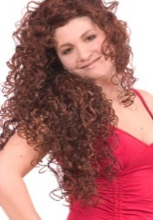 The Performer
Fast Paced - Initiator
Relational Focus
Performers tend to:
- Be loud with open ______________________
- Dress in _______________________ colors.
- Be cheerful and ____________________.
- Tell stories!
- Have a good sense of __________________.
- Use ________________ ________________ (even as adults).

The Producer
Producers tend to:
- ______________ or put their hands on their ____________.
- Be bold and ________________.
- Be __________________ - Oriented.
- Wear _______________ color clothing.
- Be ____ ____________ (of everyone and everything that they do)!
- Exude confidence

Fast Paced - Initiator
TASK FOCUS

 The Arranger
Arrangers tend to:
- Be __________________ and thoughtful.
- Be serious and _______________________.
- Possess an orderly way to approach everything.
- Be ____________________ (hair and dress alike)
- Possess ___________________ tendencies.
- Be ____________________ - Prone.

Slow-Paced - Responder
TASK FOCUS

The Harmonizer
Relational Focus
Slow-Paced - Responder
Harmonizers tend to:
- Be warm and ________________________.
- ___________ and peaceful.
- Like ________________ clothes.
- Like rest and __________________.
- Be soft spoken and shy.

Performer’s Strengths & Weaknesses
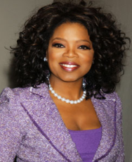
A Performer’s Weaknesses
(Need for Maturity) include:
- They are messy and _______________________.
- They __________________ need attention.
- They tend to be an organization’s Drama ____________and Papas!
A Performer’s Strengths (Maturity) include:
- They are fun, _______________ and entertaining.
- They are naturally __________________.
- They make ____________ EASILY!

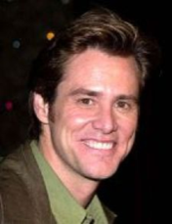

Producer’s Strengths & Weaknesses
A Producer’s Strengths (Maturity) include:
- They are natural _____________________.
- They get things ______________!
- They are decisive and easy to ______________.
- They are ________________.
A Producer’s Weaknesses
(Need for Maturity) include:
- They are overly ______________ & demanding.
- They are ___________________.
- They can be _______________.



Arranger’s Strengths & Weaknesses

An Arranger’s Weaknesses (Need for Maturity) include:
- They tend to be ___________________.
- They can be _______________ sensitive.
They can be ___________________.
- They can tend towards being moody & _____________.
An Arranger’s Strengths (Maturity) include:
- They possess strong _______________ skills.
- They are detail oriented with a commitment to _____________________.
- They are __________________.
- They are artistic.

Harmonizer’s Strengths & Weaknesses
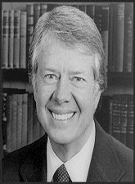
A Harmonizer’s Weaknesses (Need for Maturity) include:
- They get _______________ easily run over.
- They tend to be non-________________ to decisions.
- They are the most ___________- __________ of the Personality Styles.

A Harmonizer’s Strengths (Maturity) include:
- They are the ______________________
- They are non-confrontational.
- They are nice and _______________.
- They are pleasant and ___________________.
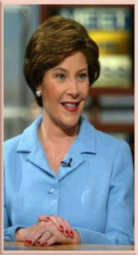
The Listening Exercise
How to Feed A Soul
T
The Emotional Needs of a Performer
A Performer is driven by the need for
___________________, ________________________,
___________________ and ______________________________.
The Inspiration word of a Performer is ________________________________.

The Emotional Needs of a Producer
A Producer is driven by the need for: ______________________, ______________________, __________________________________ & ____________________________.
The Inspiration word of a Producer is _________________________________.

The Emotional Needs of an Arranger
An Arranger is driven by the need for: _____________________, _______________________, ______________________________ and _______________________________.
The Inspiration word of an Arranger is _________________________________.

The Emotional Needs of a Harmonizer
A Harmonizer is driven by the need for: ______________________, _____________________, _______________________________ and ______________________________.
The Inspiration word of a Harmonizer is ______________________________.

HOW TO MAKE IT WORK: BEING VERSATILE

Fast-Paced Initiator

Task Focus
Relationship Focus
Slow-Paced Responder

