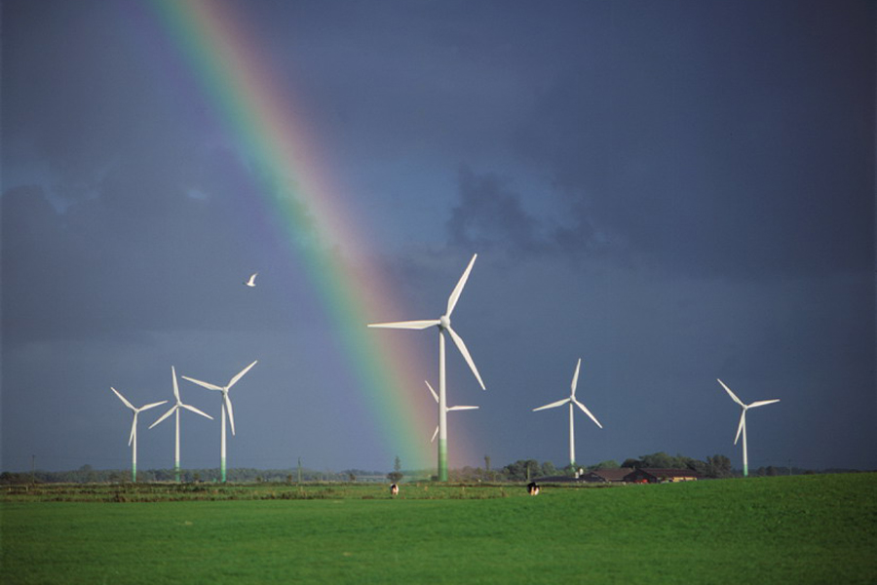

Sherra Zulerons & John Barros
905.407.7118 647.963.6906
szulerons@share-a-watt.com jbarros@share-a-watt.com

info@share-a-watt.com
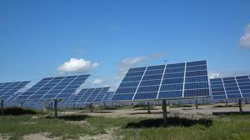
Share-A-Watt Community Power Services
Share-A-Watt Community Power Services Inc. is a Canadian company which provides renewable energy project oversight and managerial services to groups and communities who want to develop, build, own and / or operate a renewable energy facility.
Share-A-Watt principals Sherra Zulerons and John Barros are well seasoned renewable energy project developers who possess over 30 years of successful experience in commercial energy project development and delivery.
Who is Share-A-Watt?
- We’re not an engineering firm or an environmental assessment company;
- We’re not an equipment manufacturer/supplier or a financier;

- We’ve spent decades hiring and managing these services and suppliers in the development of thousands of megawatts of renewable power.
- We are pure play independent project developers who want to share our expertise with communities.

“We believe that smaller scale, community supported distributed generation is the best way for renewables to penetrate current electrical systems; however smaller MW sized projects often struggle to get out of the gate, let alone see commercial operation.

We therefore want to share “big developer” knowledge, insight and advantages with smaller groups and communities who want to own renewable generation”.

What do we deliver?
Through our combined achievement of over 500 megawatts of operational renewable energy projects John and Sherra have cultivated a long and impressive list of industry relationships; yet in order to ensure minimum risk and maximum revenue for our clients Share-a-Watt is completely agnostic when it comes to generation type, equipment, supplier or financier.

Share-A-Watt determines the most feasible renewable energy solution for your site and for the power purchase opportunities available to you - be it large scale wind turbines, ground mount or commercial roof-top solar, biomass or a combination co-gen system.
We design, develop, permit and deliver a build ready project.
- If renewable projects aren’t your core business

- Share-A-Watt can provide the guidance and support you need to build one.
Sharing our knowledge and experience

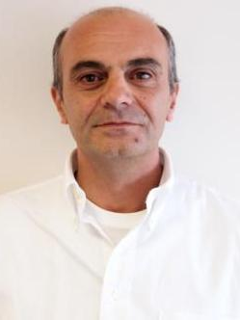
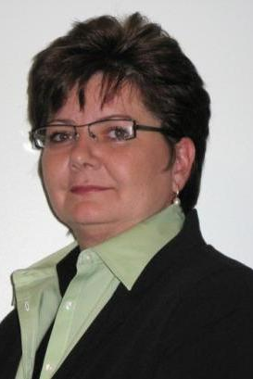
As successful project developers for major corporations Sherra and John have developed extensive industry, regulatory and finance relationships.
While maintaining highly successful careers they have now decided to share their expertise with groups who want to develop and build their own renewable power projects.

Share-A-Watt’s combined experience:

Projects and Pipelines:
- Led origination, permitting, micro-siting, and engineering of some of Canada’s most profitable wind farms
  - 189MW Prince Wind Farm (Crown Land in Sault Ste Marie, ON – Brookfield Power)
  - 166MW Comber Wind Farm (Comber, ON – Brookfield Power
  - 50.6MW Gosfield Wind Farms (Leamington, ON – Brookfield Power)
  - 46MW Oldman Wind Farm (Pincher Creek, AB – Mainstream Renewable Power)
- Initiated, coordinated and/or managed over 11,000 megawatts worth of renewable project pipelines across North America.
- Managed successful project development and RFP submissions – securing 1,023MW contracts.
- Won a FRP for 200MW of wind power; the project was later sold to Enbridge.
- Led a team developing 100MW of community solar power projects in Ontario.
Technical Capabilities:
- Initiated and directed high quality energy resource assessment campaigns for over 6,000MW.
- Identified and secured approximately 800MW of prime transmission capacity in Ontario.
- Implemented first SODAR and avian RADAR campaigns in Canada.
- GIS siting software mastery including Arc, AutoCAD, Idrisi, Map Info, Map factory, Earth Resource Mapper, WinPro etc.
Stakeholder and Permitting Skills:
- Originated, designed and implemented five Community Energy Cooperatives (60+ members each) for investment in renewable energy projects in Ontario.
- Coordinated all studies, consultation and authored the first combined federal/provincial Environmental Assessment Report, Plan of Development (POD) and Environmental Management Plan (EMP) for a Crown Land Wind Project in Ontario.
- Designed and implemented first post-construction monitoring protocols for wind farms in Ontario.
Corporate Experience:
- During 13 years in the business Sherra has originated and operated three successful renewable energy companies as Canadian subsidiaries under larger corporations: Superior Wind Energy Inc. (Brookfield); Airtricity Canada (Airtricity); and Canada Mainstream Renewable Power (Mainstream Renewable Power).

Detailed Project Development Service Offerings

PROJECT EVALUATION
- Evaluation involves the development of an effective Project Plan and a thorough assessment of project goals, challenges, and needs.
- Clearly define client's overall investment goals, pre-development, planning, investigations and SWOT analysis.
- Develop conceptual budget, master development schedule and scope definition, and delivery of an overall Project Plan that meets the investment goals

DESIGN ENGINEERING and PERMITTING
- Confirm all project assumptions, identify project requirements, and assemble appropriate project team, design efficiency, management and optimization of all project components.
- Conduct all studies, submit and obtain regulatory buy-in, approvals and permit delivery.
- Design and lead stakeholder engagement plan, ensuring project support.

PROCUREMENT
- Source and conduct RFP process on behalf of the project for equipment, civil and electrical contractors, engineering and environmental services, etc.
- Manage all contract design and negotiations in concert with project owner.
FINANCE and ENERGY CONTRACTS
- Source investments as required (cooperatives, private or public funding).
- Financial modelling required for investments and submission of project to contract procurement process (RFP, Feed-in-tariff, net metering or private consumption)
- Financial close
BUILD
- Design and implement construction management plan, source, qualify and solicit construction buy-out, quality control, manage the change order request process.
- Manage submittal/shop drawing process, real time and transparent project progress reporting, and a timely and efficient start-up, commissioning certification and turnover process.

We would be pleased to discuss your renewable project ideas
and
design a plan of development for you

