Chalet Fiak
Chalet Fiak is a traditional chalet situated on a quaint street in Morzines old town- it is just 1 minute from the village centre. It's all location, location, location with this chalet meaning easy access to all the ski lifts, shops, restaurants and bars - the perfect chalet for a spot of apres-ski!

The free bus stop is conveniently less than 100m away - here you can catch the free buses to any of the major cable cars & ski lifts either Morzine, Prodains (for Avoriaz), Nyon, Ardent (for Les Linderets and Avoriaz.

It can be catered or self-catered as we want to suit all budgets and make sure everyone has the holiday they want. Chalet Fiak is perfect for groups of friends and families.
Accommodation:
Chalet Fiak is a 4 bedroom chalet with 3 bathrooms, traditionally styled and unbeatable in location. The log fire brings a warm and cosy ambience, the perfect place to come home to!

Chalet Layout

Ground Floor
- Bedroom 1 - sleeps 4 (Double/twin and bunks) with en-suite bathroom (bath, shower, sink & toilet).
- Garage with board/ski storage.
First Floor
- Open plan lounge, kitchen and dining area
- Shower room with sink & toilet.
Second Floor
- Bedroom 2 sleeps 4 (twin/double & bunk),
- Bedroom 3 -Sleeps 2 (twin/double)
- Bedroom 4 -Sleeps 2 (twin/double)
- Shower room with sink & toilet
The chalet also has the following features:
- Flat screen TV, Apple Mac mini media centre with hundreds of films, Nintendo wii, books and board games.
- Rome snowboards & Apo ski test centre
- Use of inhouse HD GO PRO video camera
- GHD’s and hair dryer
- Board and ski tuning facilities
- Log fire
- Parking spaces
- Organising of lift passes ready for arrival (no extra cost), transfers, lessons and equipment hire
- Childrens facilities (cots, high chairs etc)
Facilities:
bar, barbecue, boot dryers, computer, cot/highchair, games console, garden, home cinema, iPod docking station, laundry facilities, open fireplace, pets allowed, private parking (open), satellite/cable TV, ski workbench

Resort name: Morzine
Ski area: Portes du Soleil
Country: France
Amenities: adventure park, bars and restaurants, beauticians, bob luge, bowling, bus station, bus stop, canoeing, canyoning, cash withdrawal facility, childcare, cinema, climbing wall, cross country skiing, cycling, devil carts, doctor, dog sled rides, fantasicable, fishing, fitness centre, free shuttle bus, freelance catering, golf, gym, gym classes, hairdressers, half pipe, high altitude restaurants, high ropes course, hiking, horse driven sleigh rides, horse riding, huski dogs, ice climbing wall, ice diving, ice driving, ice rink, lake, massage, mini golf, mountain biking, mountaineering, night skiing, night sledging, nightclub, off piste guiding, paragliding, parapenting, pilates classes, rafting, segway, segways, ski jouring, ski school, ski touring, skidoo safaris, skiing, skiing/snowboarding, sledging pistes, snow kiting, snow mobiling, snowboard school, snowshoe walking, spa, supermarket, swimming pool (indoor), swimming pool (outdoor), tennis, torch lit descents, tourist office, via ferrata

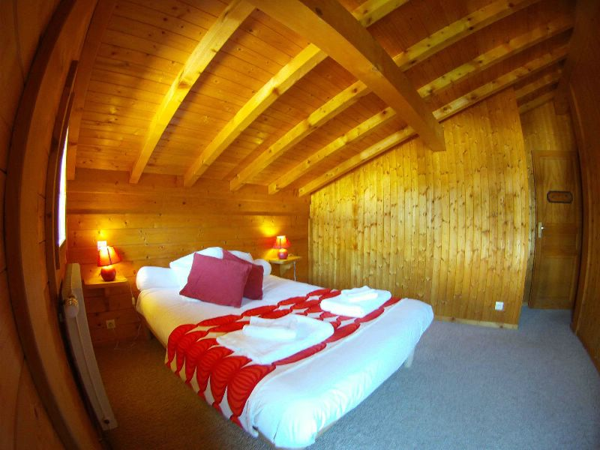
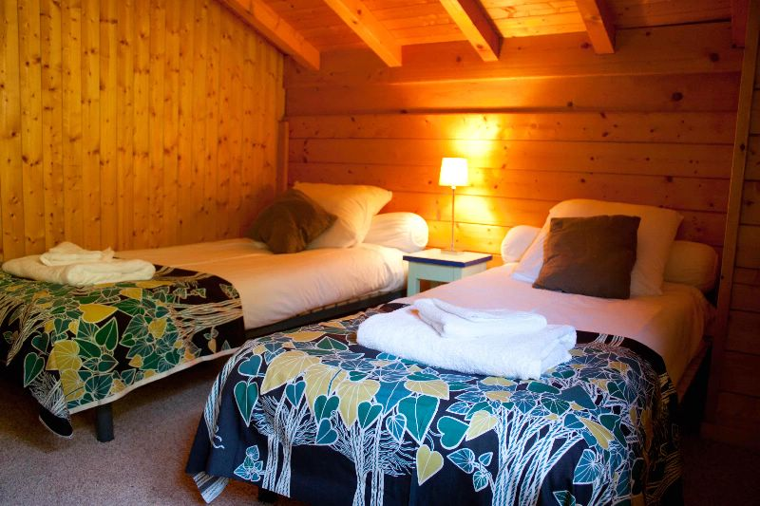
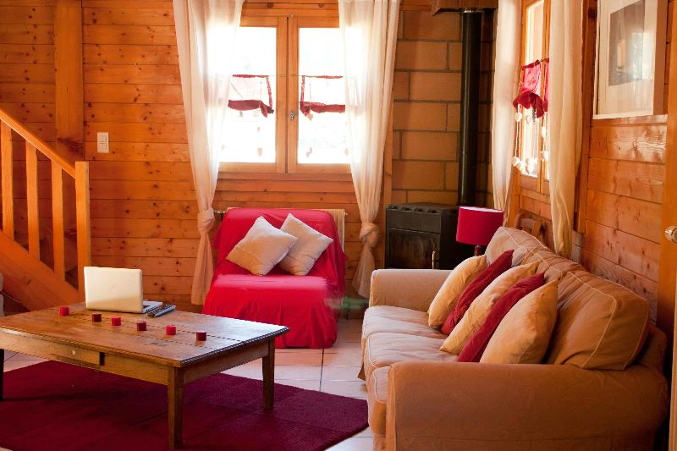
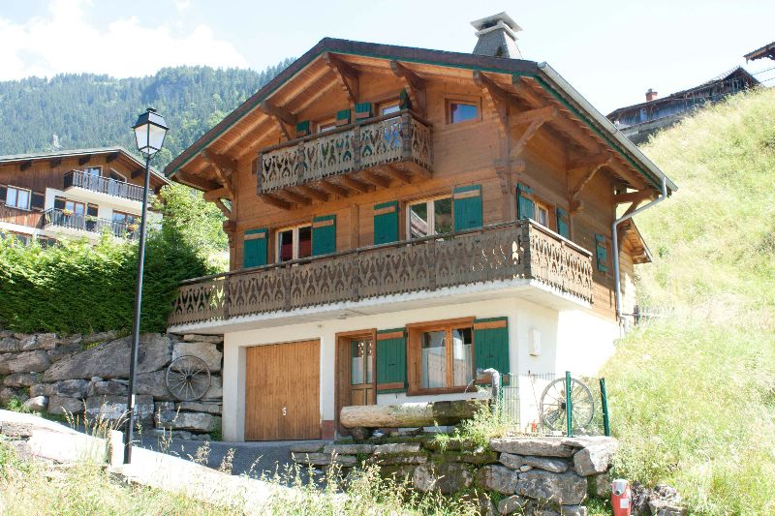
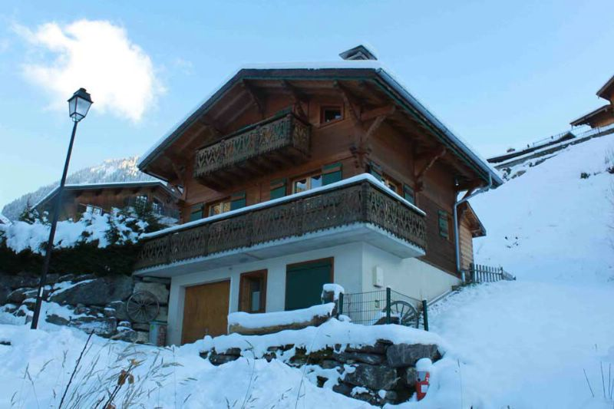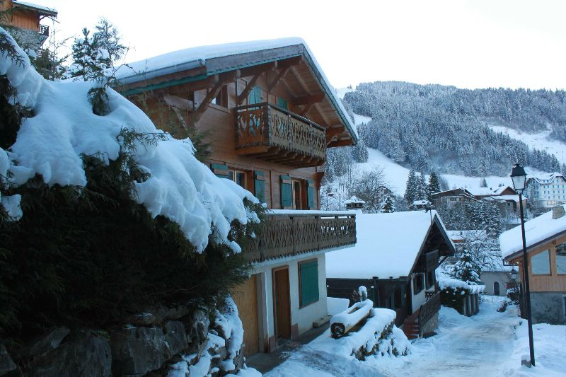

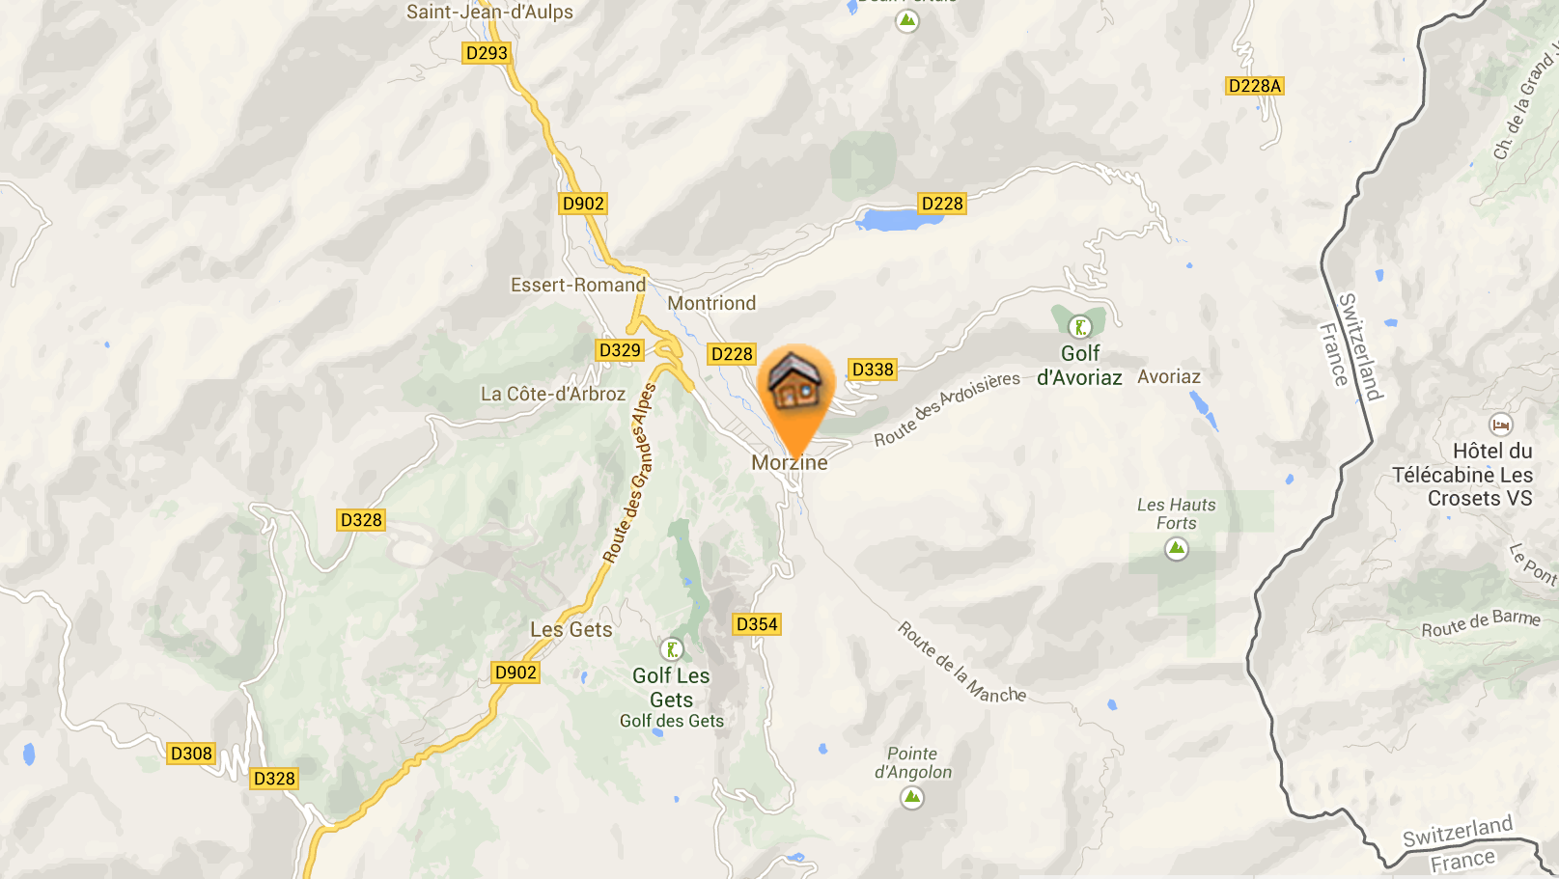

CONTACT

+ 44 7871561847

or email

chalet.fiak@outlook.com

