1. Vendors List their products on the Green Merchant Direct Website.
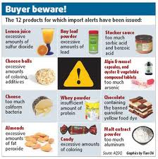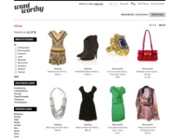
2. Green Merchant Direct Markets vendors product to a large group of buyers who are looking for Green natural eco friendly products. through our sales team, email campaigns, Social Media, ext.


3. Buyers place orders for the vendors products for their businesses and institutions, and pay Green Merchant Direct.


4. Vendors ship the product direct from there warehouses insuring the best prices and freshest products.
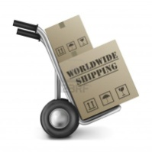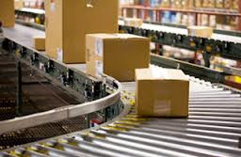

5. Customers receive products and are very happy.
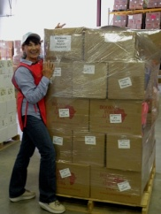

6. Green Merchant pays vendor for products received.


