LOGIN PAGE
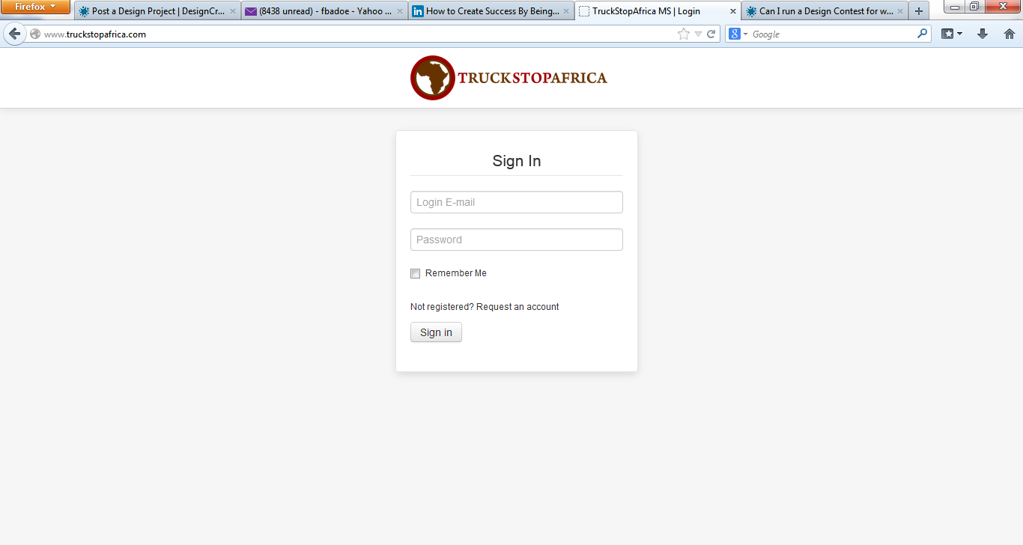

DASHBOARD
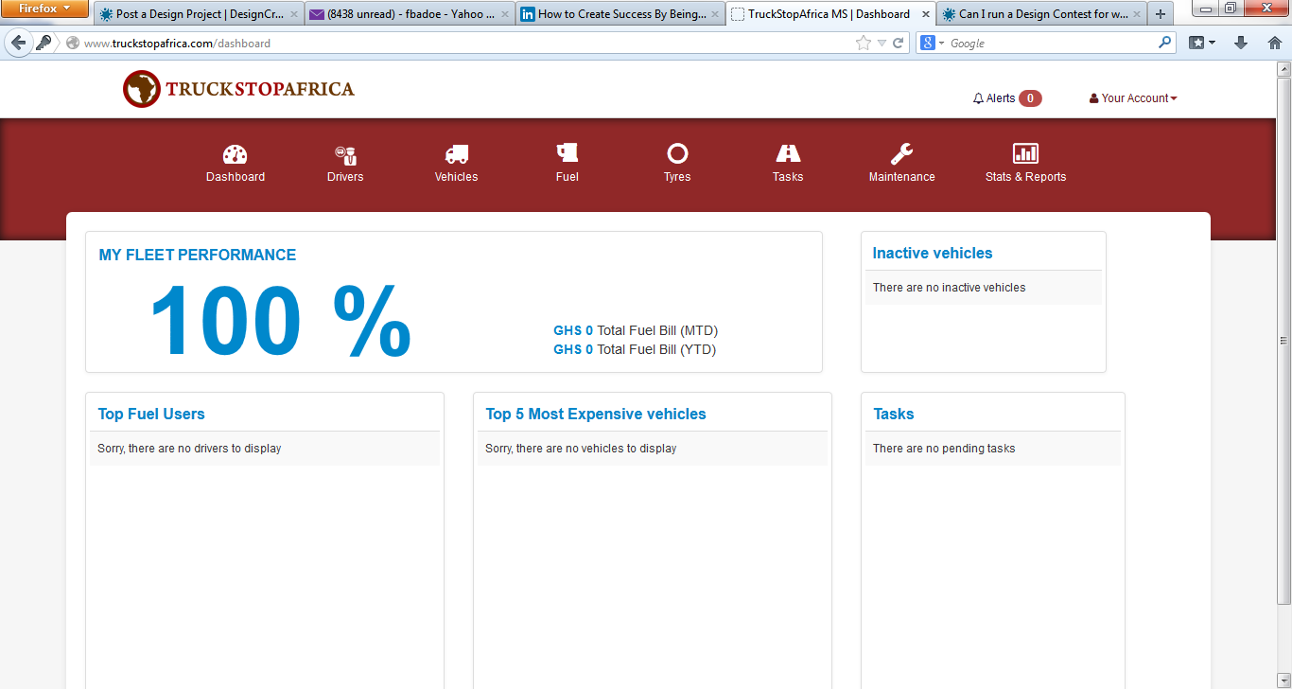

DRIVERS SECTION
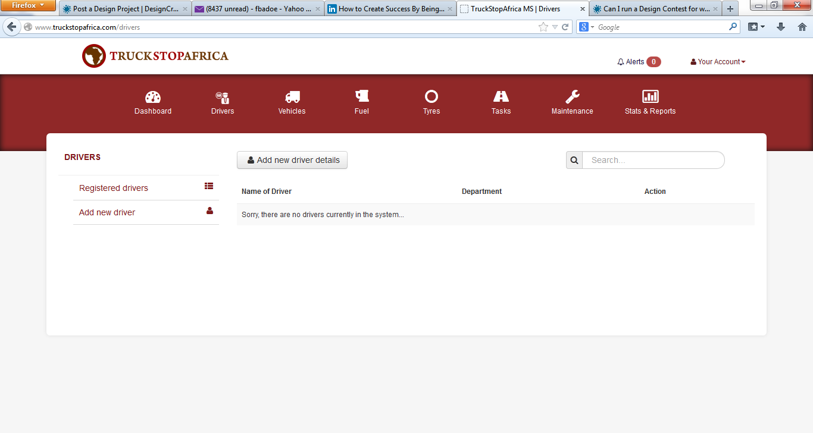

The vehicle, fuel, tyre, tasks and maintenance page are all very similar to this page. The only difference is what is listed.

I find the entire design dull and lacks punch. It would be great to see what you can add to it.

