DL flyer 210mm x 95mm portrait 4 colour double sided. 3mm bleed and crop marks (refer attached print guidelines) output file as word and PDF in high resolution. Font: Tahoma
Front page:


203 VICTORIA STREET, NORTH MELBOURNE

Position “live, breathe, love…” as our tagline
live, breathe, love…

New Yoga Studio opening 23 November
First class free in opening week *
*Opening week 23 Nov – 29 Nov inclusive
To book your free class go online to register and book, like us on Facebook The Yoga Place - Melbourne and tell your friends.
View other opening specials at theyogaplace.com.au

Emphasis: new yoga studio opening and first class free

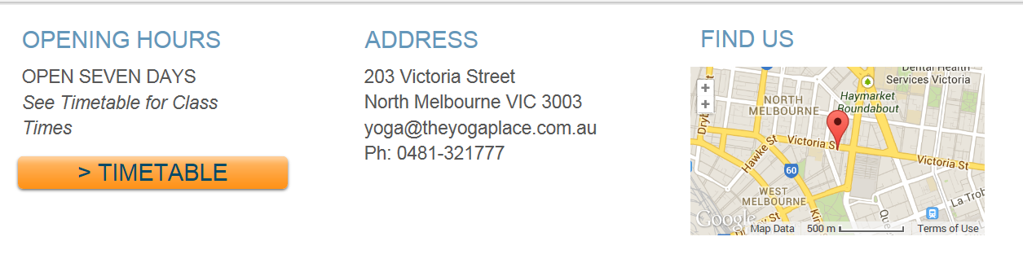
Delete timetable button

Include website address theyogaplace.com.au and facebook logo
Reverse side:
Include The Yoga Place logo and address
A generously sized natural studio in North Melbourne, providing dynamic flow vinyasa and restorative yoga for all levels from newbies to experienced, with a collection of the best teachers.
Embark on a journey to happiness within yourself – be healthy in your body and mind.
Science is finally proving what yogis have known all along.... yoga is good for you!
A tranquil space to de stress, build strength and healing in our bodies through our own tapas (internal heat).

Include website address theyogaplace.com.au and facebook logo
Delete timetable
Class Times
Sat | Sun | Mon | Tue | Wed | Thu | Fri
9:00 AM | 9:00 AM | 6.30AM | 6.30AM | 6.30AM | 6.30AM | 6.30AM
10.30 AM | 10.30 AM | 9.30AM | 9.30AM | 9.30AM | 9.30AM | 9.30AM
4PM | 4PM | 12.30PM | 12.30PM | 12.30PM | 12.30PM | 12.30PM
 |  | 5.30PM | 5.30PM | 5.30PM | 5.30PM | 5.30PM
 |  | 7PM | 7PM | 7PM | 7PM | 7PM

