Brief for Castlecorp Branding
What we need:
- Updated logo and look ‘n’ feel
- Stationery including letterheads, with comps, envelopes, business cards

New logo/colour scheme:
  - We don’t mind the actual logo, although we are open to suggestions of changes, but the current colour scheme is too feminine.
  - Must be professional – we are a professional commercial real estate agency targeting business owners, investors and tenants.
  - Easy to read: for signboards, text will need to be seen from a car potentially 20-50 metres away
  - No fading in/out (makes signage look old)
  - Different to our competitors (see below)

Current Logo:
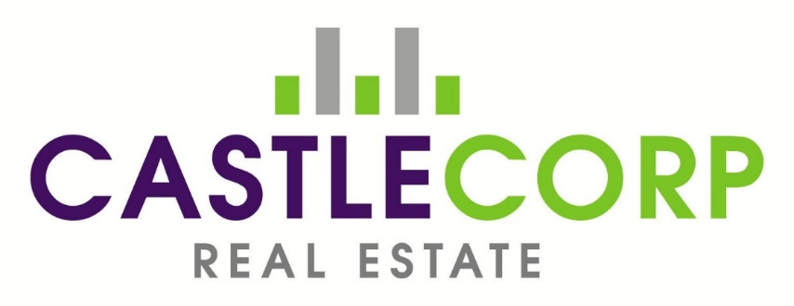
Current Signboards:
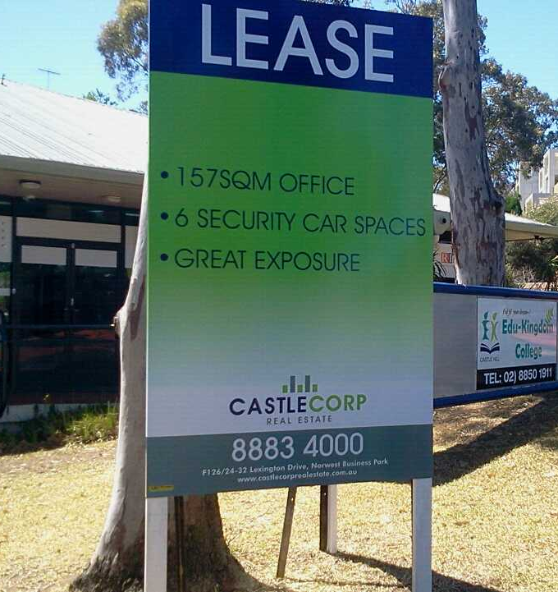

www.castlecorprealestate.com.au

Current brochures:
A4 brochures:
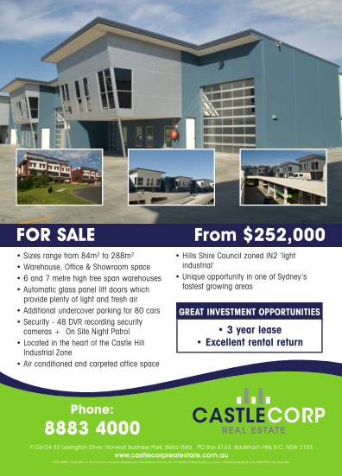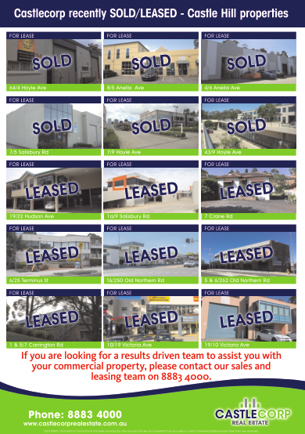
DL brochures:
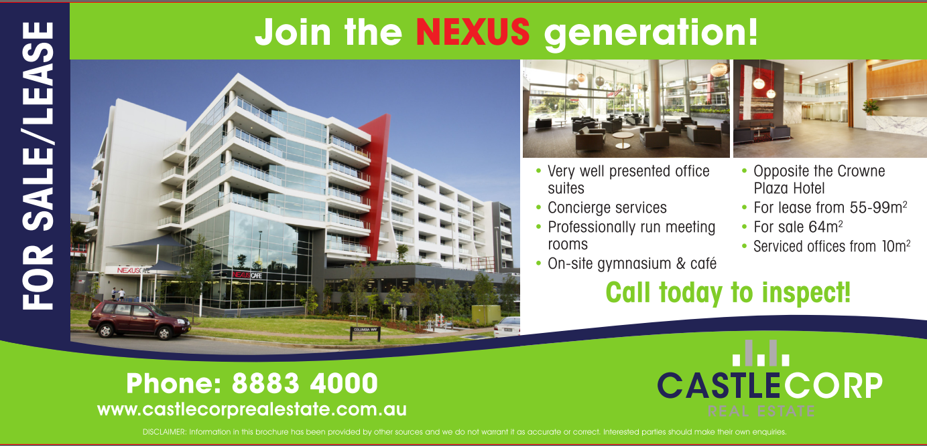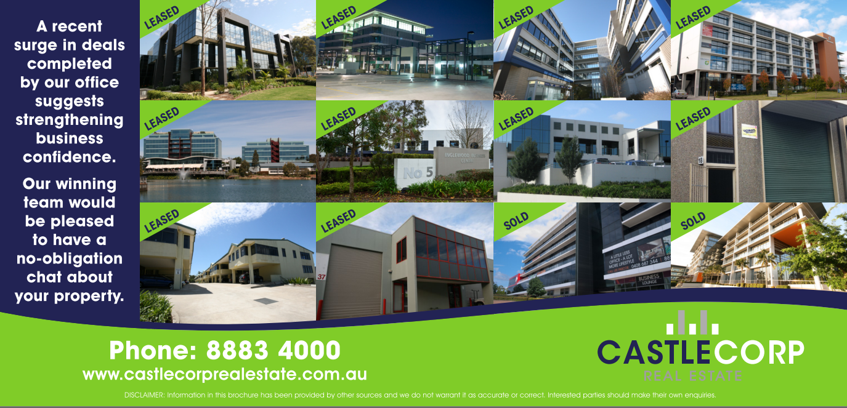

COMPETITORS:
Norwest Commercial - www.norwestcommercial.com.au

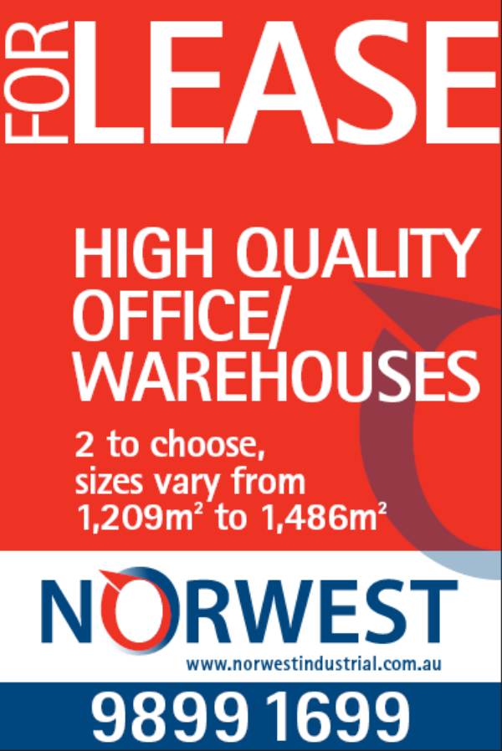

Coutts Commercial - www.coutts.com.au

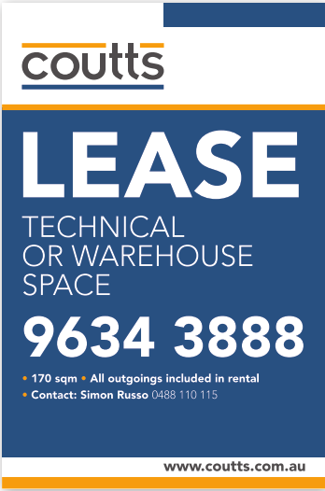

Hills Commercial – www.hillscommercial.com.au

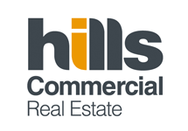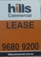

PRD Nationwide - www.prdnationwide.com.au
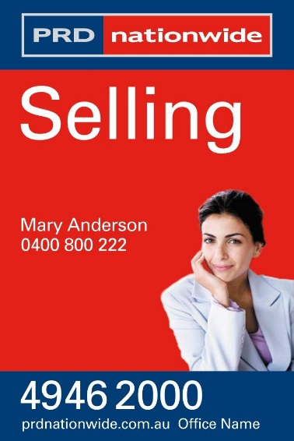

Taylor Nicholas - www.taylornicholas.com.au
