LOGO DESIGN FOR GOLF ACADEMY
(Please read before beginning)
Concept:
We would like a very professional looking logo to represent our golf company. We are called: Complete Player Golf. Our slogan is: PLAY TO YOUR POTENTIAL.
We will use this logo to create a video animation for the introduction to our videos so a creative design that allows some sort of professional animation would be highly regarded. We would like a golf ball in the logo made up of puzzle pieces. In the centre will be a puzzle piece of a different colour (to represent it now being complete).
This logo will need to be available in various formats as it will be used on: our website, logo animation, business cards, printed materials and clothing.

Design:
Creativity in the layout is welcomed as long as the basic concepts are met. The logo must be clear and a high resolution for high pixel screens. The layout could follow one of the following formats:
- The business name can be on the right hand side of the ball with the slogan below.
- The business name and slogan could be underneath the ball
- The writing and slogan could be wrapped around the outside of the ball
- A design without the slogan can be made and compared to the original.

Fonts that look professional are preferred. The name and slogan can be all capitals or just the first letter of each word? You can either: Have a golf ball made up of puzzle pieces with the one in the centre highlighted OR use an artistic golf ball with only one puzzle piece in the middle. (like the hexagonal golf ball below on the right)


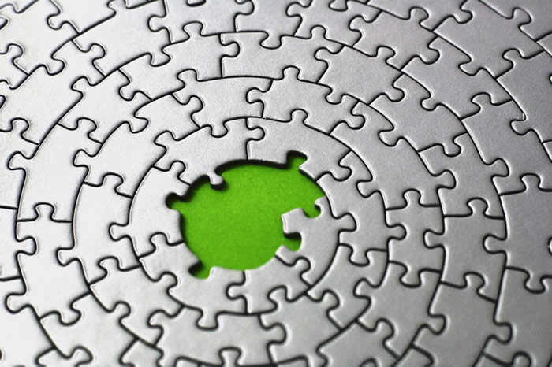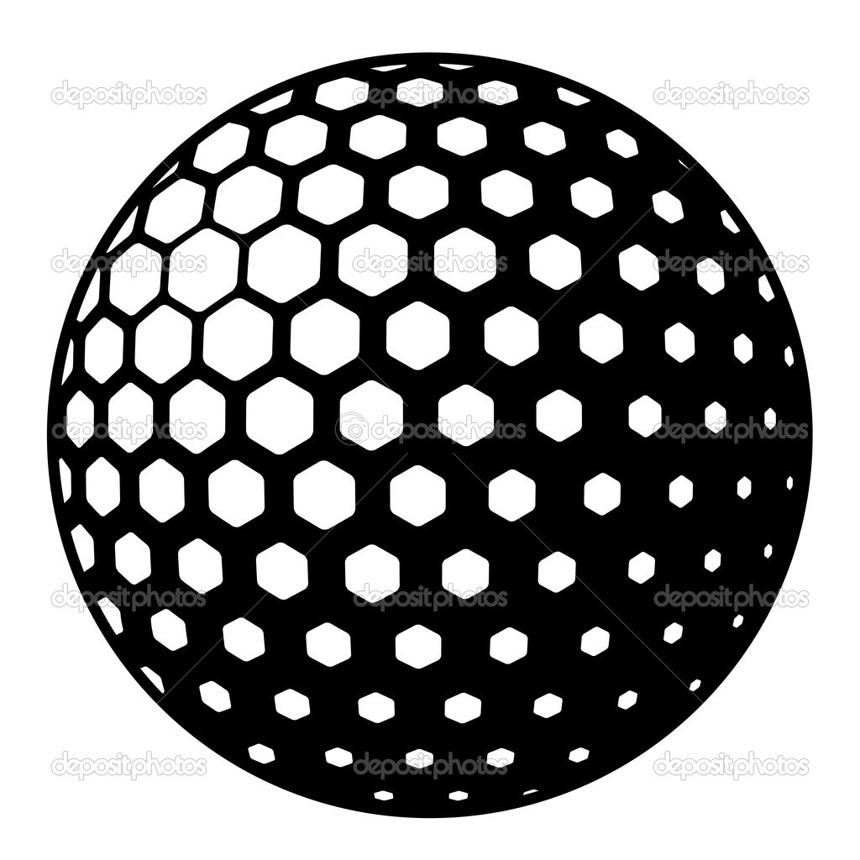

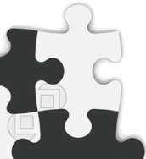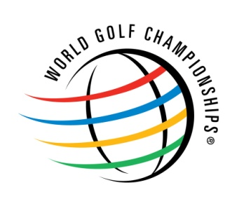

An example of the puzzle piece structure of the golf ball with a highlighted piece in the centre. The shape of the coloured puzzle piece (above on the right in white) is our preference for the centre puzzle piece. We like the ball style and large puzzle piece structure of the blue ball above. (Colours of the ball could be matt gold, black or white) Use the white puzzle piece in the centre. The logo on the right is an example of a conceptual golf ball that is 3-D in appearance. A puzzle piece that looks 3-D could be in the centre?

Colours:
The colour choice is important to our image and the look of our company. We would like a more masculine, classy colour design. We want a very professional, high quality and upmarket company image. We like a “matt finish” on colours like: gold, dark green and dark grey or black. This is our first preference. Other colours could include (non matt varieties) or other shades of green or white.

The background could be matt black (with different shades) the writing dark green and the ball could be gold. Please use your superior colour coordination skills and trial other combinations to see what looks best The centre puzzle piece could be a different colour to highlight that it was the missing piece?

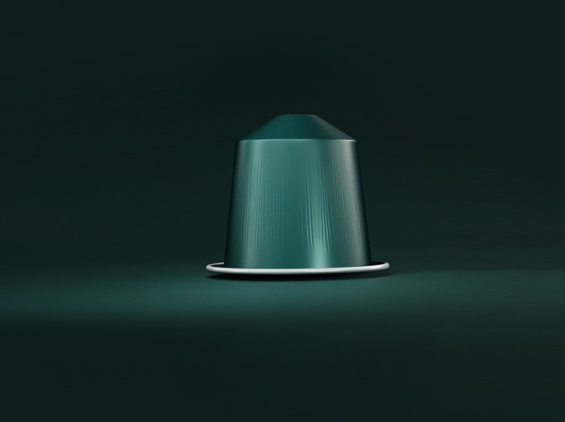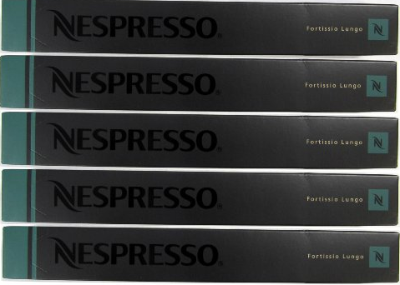
The coffee capsule colours represent the shades of colours we like. Notice the matt gold, black and green combinations.



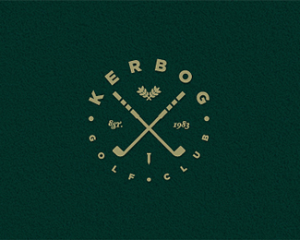

Some examples of colour shades we like. A few shades either side of these colours would be interesting also...

Requirements:
The winning designer will be required to supply the following:
- Copyright and ownership of the logo
- Digital and print ready format for use of the logo online and for various printing/marketing projects such as: Adobe Illustrator (AI), Bitmap (BMP), EPS, GIF, JPEG, PDF, PNG, PSD & TIFF etc.
- The Fonts and hexadecimal colour codes used in the logo.

Thank you for reading; we are excited to work with you and to help you produce a winning logo!

