Type AG Website Ideas

Things to note about the rings I want are these. Sometimes simple is more eye catching than complicated. These rings need to be ‘sexy’, yet badass/cryptic/edgy. I think New age Medieval is a decent context for design. I definitely want to separate myself from every single other ring company around by making rings that ‘pop’ and aren’t skulls. Totally played out. Every time I see skull rings, I think ‘oh gee, yet another skull ring’ and look away. This line needs to be distinct. I put some notes on these rings so you can follow what I am thinking.

-: http://www.gothiccrossjewelry.com/categories/Rings/ - few ok rings, too much death/skulls
-This guy is decent, bit over complicated. Some of his stuff has really nice sleek lines. http://www.tribalhollywood.com/StoreFront.bok

Silver Rings
-http://www.bikerringshop.com/servlet/the-364/Dragon-Tattoo-Ring/Detail- I like the wrap around concept on this ring. Though I think we should sometimes have the wrap around separated, so that the ring is somewhat one size fits all. Also, the design itself, I like because it has distinct curves, the details aren’t overwhelming, and the shiny part stands out beautifully and is also very distinct.
-http://www.bikerringshop.com/servlet/the-383/punk-ring/Detail, I’m a bit over the skull rings, but what stands out quite a bit is the head of this skull. Notice how much it stands out and makes you think, ‘those are cool curves’.
-

-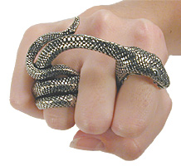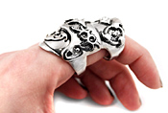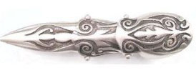
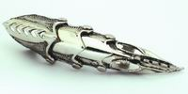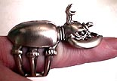
-These pictures are an awesome example of creativity. I will want something different like this down the line.
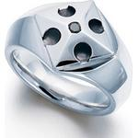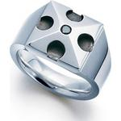
-I love the ‘cleanness’ of this ring. Design is decent. If you can mix that with a gothic twist, it would be absolutely perfect. I think I like more simplicity like this, but not always. Detail is hard to duplicate on any CAD program, so you have to be careful . But if you can make a more detail oriented ring stand out, more power to you.
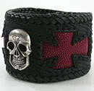
-Interesting. I think leather/silver might be a new thing coming on. Maybe we can get something like this going a bit later.
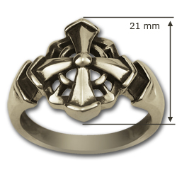
-The design itself is ok. I don’t care about the design so much as the curves. It’s very ‘clean’ and eye catching.
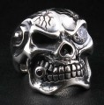
I don’t want to concentrate on skull rings because they’re very played out, but I might want one for the collection, but later. This one looks different than most others. It stands out. It’s not overcomplicated. An idea for my skeleton ring would be a metal/slabs/screws type of skeleton head.
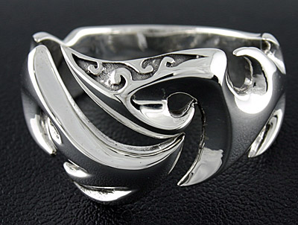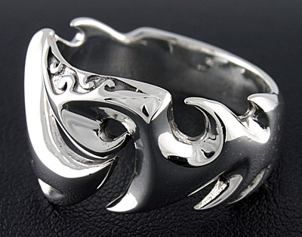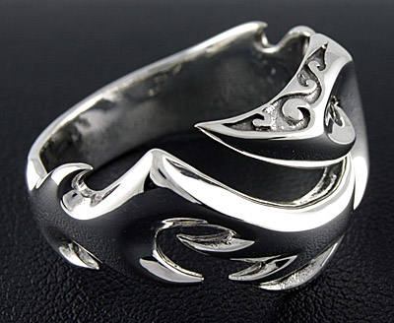
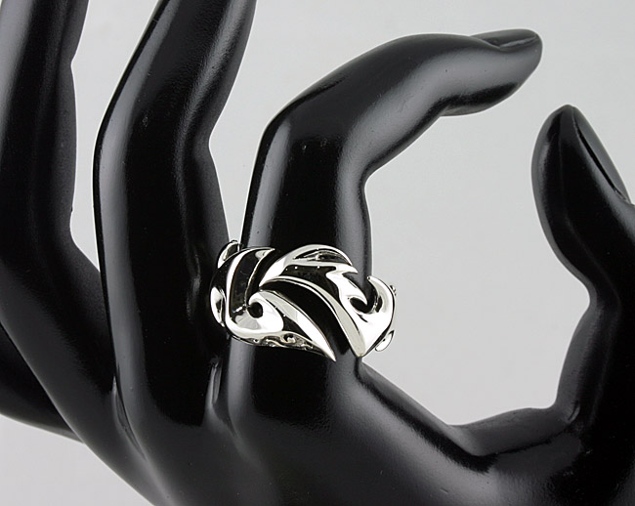
This is my favorite ring of all my examples. The thing to notice about this ring is that it ABSOLUTELY stands out. The lines are so sexy, you have to take a second look. This is called a Spartan ring. The lines on this are AWESOME. My company is called ‘Type AG’ (AG is the chemical name for silver). One idea in this ring context would be a ring with the writing ‘Type AG’. Maybe ‘Type’ would be the wrap around underside and the ‘AG’ would be what everyone sees. Hardly necessary, but an idea.
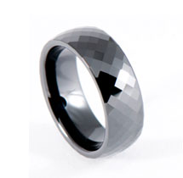
-Pretty simple, luxury lookin, and catches your eye. Looks good like that or add a hint of cryptic/badass to it. Not all rings are going to need tons of creativity.

