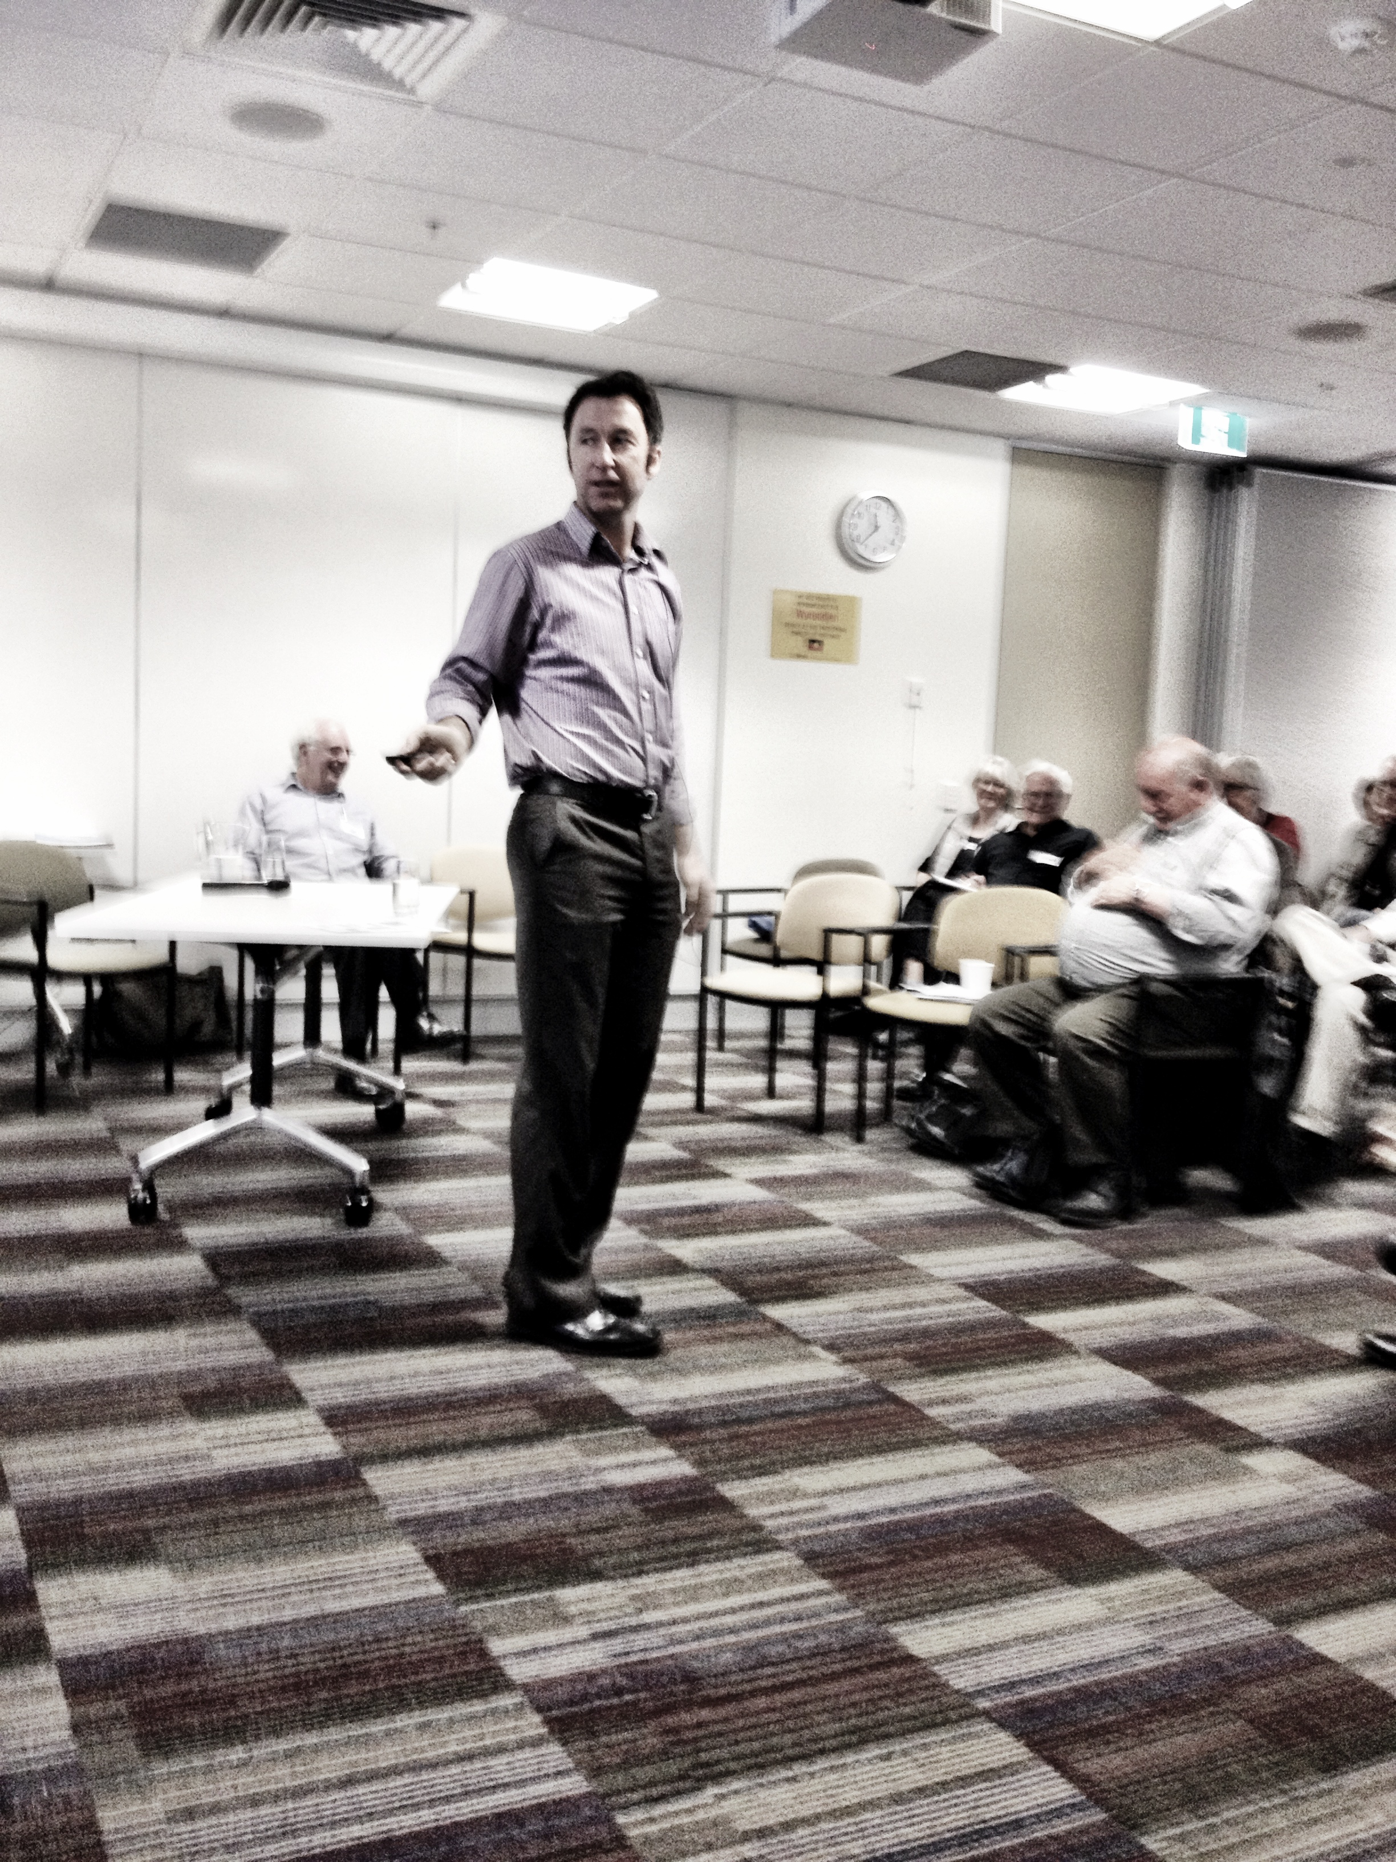
“I feel much more confident in role as a Mandatory Reporter after attending this training – Thanks!”

“The training was really well-structured and professional.
Matt’s delivery made it easy to follow and understand how to apply what we learnt in practice”

This 4-hour workshop format course has been created for professionals that are designated as mandatory reporters under the Children, Youth and Families Act (2005), primarily teachers and medical staff.
Everyone’s efforts in this field must be aimed at preventing harm to children through any form of abuse, be that physical, sexual or neglect. Through training, we provide a greater chance of children arriving at the best possible outcome from what is usually a very scary and traumatic point in time.
We have included a range of topics in our course which will be of benefit to those professionals that bear the responsibility of being mandatory reporters. It helps to understand the scope and definition of child abuse in Australia and around the world, and to know how very far reaching the consequences of abuse are to the victims and their families. We cover off on modes of abuse and the motivations of the offenders that commit these crimes.
Police and government responses to allegations of child abuse can range from confusing, discouraging and illogical for those unfamiliar with their systems. This course will attempt to de-mystify the processes followed by agencies investigating child abuse.
APIAS trained Mandatory Reporters will have the skills and knowledge to:
- Recognise the signs of a child that may be experiencing abuse or be at risk of abuse
- Be able to confidently initiate and respond to discussions with children regarding abuse and have practised techniques to enable effective communication with children
- Be familiar with the process followed by DHS and Victoria Police when handling disclosures
- Be confident in enacting their responsibilities as mandatory reporters under the Children, Youth and Families Act
- Have a basic understanding of what leads to offending and where in that process external factors can intervene

Learning Outcomes

Matt Brown
Director - Facilitator

Melbourne, Australia
P: +61 411 354 341
E: apiastraining@gmail.com
www.apiastraining.com.au



APIAS Training

Program Overview

APIAS Training – Mandatory Reporter’s Course
Insert List Here

• List your services or products here.

• List your services or products here.

• List your services or products here.

• List your services or products here.

• List your services or products here.

• List your services or products here.

• List your services or products here.

• List your services or products here.

