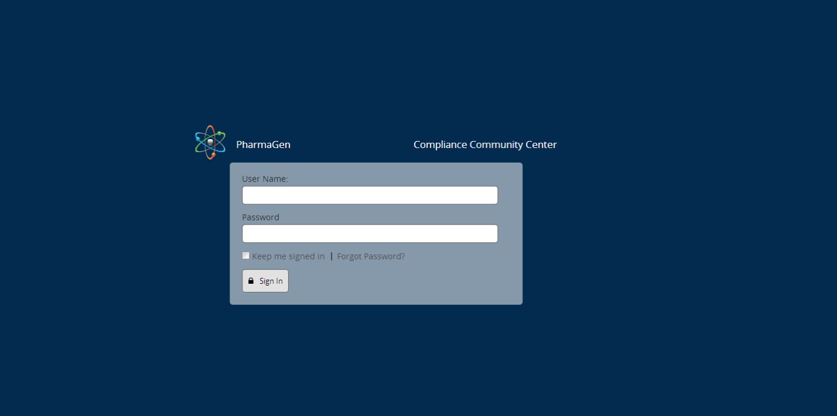

Login page –
“PharmaGen” is a fictitious pharmaceutical company client. We see their logo sitting about the login area as shown, but the CCC logo displayed below the login area.
Please propose a logo for the application Community Compliance Center
Also – please suggest color scheme and button treatments please..

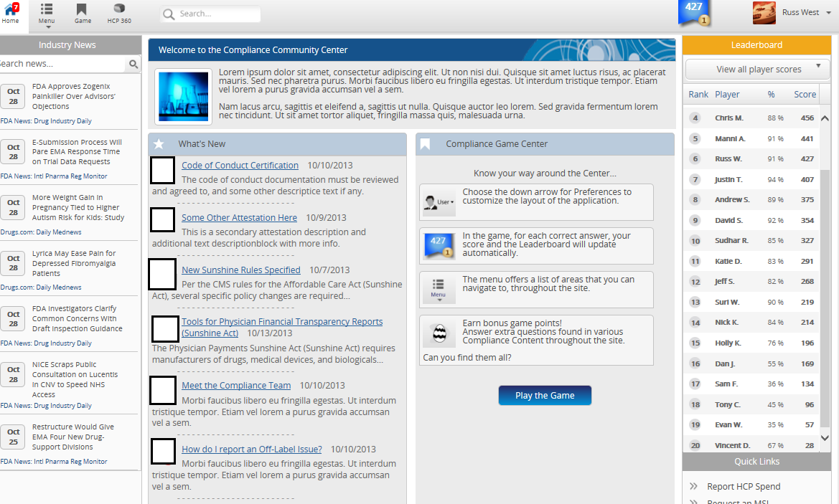
Home page –
Please suggest specific color scheme and treatment ideas. This application is both touch and mouse-click friendly, so all treatments should keep both paradigms in mind. Please include these specific items:
- Color families by area/control – Title bar primary and accent colors, Type face(s), Headline text, Title text, body text, button treatment
Whited-out boxes are placeholders for content-area-specific icons. The content areas are:
- Compliance News
- Compliance Blog
- FAQ’s
- Document Library
- Relevant Links
- Reports
- Forms
Please propose industry-appropriate icons for each of these content areas

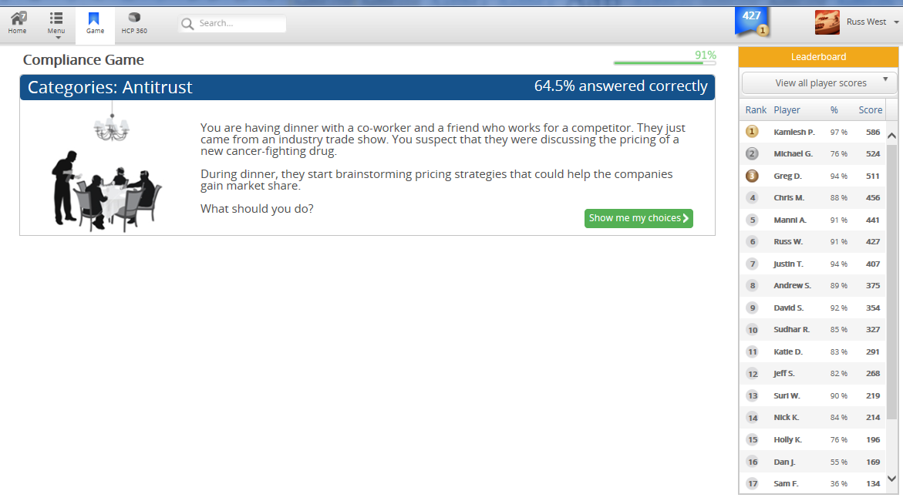
Compliance Game –
This is the initial state of each question in the game.
Please propose color and treatment ideas.

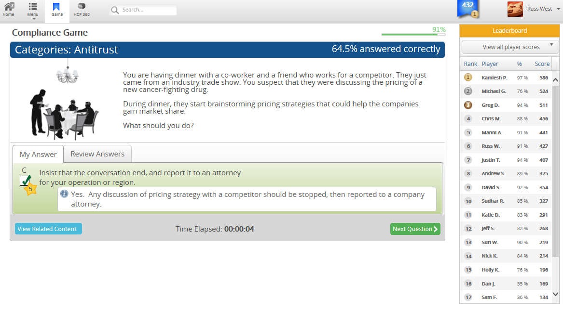
Compliance Game –
This is the final state of a game question, after it has been answered (correctly, in this case). Please propose/refine the treatment shown here.

