FireLess2

Dynamic forecasting of the risk of forest fires
An innovative system for dynamic forecasting of the risk of forest fires allows authorities to plan their standby services more effectively.
Today, in order to forecast forest fires, it is usually the case that the moisture of the combustible material is indirectly derived from the area’s meteorological data. However, as different soil types and forest types react differently to changes in humidity, the calculations do not always correspond to the local conditions. For this reason, EnvEve has developed FireLess2 in partnership with WSL researchers.
FireLess2 determines the moisture of forest litter and humus locally. A set of sensors on and in the forest floor is wirelessly connected to a solar-powered mini control center that continually transmits the measurement data to the monitoring authority’s computers. Taking the current meteorological data into account, these can then provide a precise picture of the risk situation.
Over the course of two years FireLess2 has been extensively tested by EnvEve engineers and WSL researchers. The solution and sensors have been tuned and engineered until they have been proved reliable on accuracy and reliability. Many field tests showed correlation between the system’s estimate and the actual moisture of the combustible material to be, in some respects, considerably stronger with FireLess2 than with the conventional method. In particular, the measurements in humus and in needle litter delivered highly precise results. With regard to leaf litter, the correlation was within normal limits. However, Fireless2 was able to show trends (i. e. decreasing or increasing moisture) more quickly.

FireLess2 Modules
FireLess2 is composed of 3 main modules:
- Sentries
- Gateway
- Cloud Software

SENTRIES: Wireless Smart Sensors, detecting temperature & humidity of litter as well as humidity of humus. Battery powered.

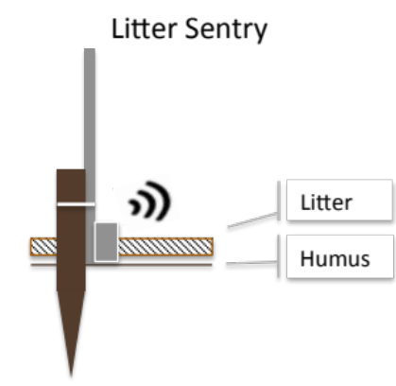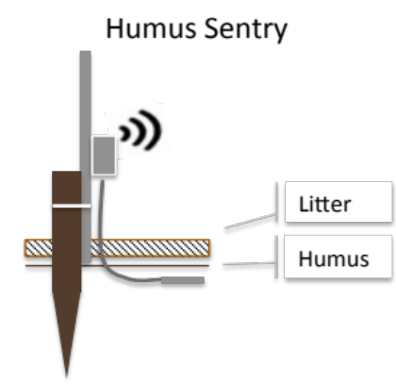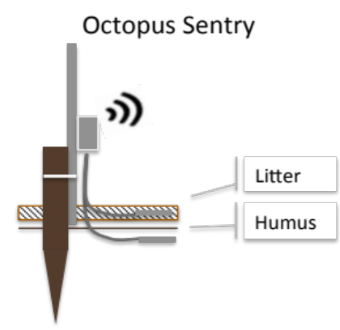

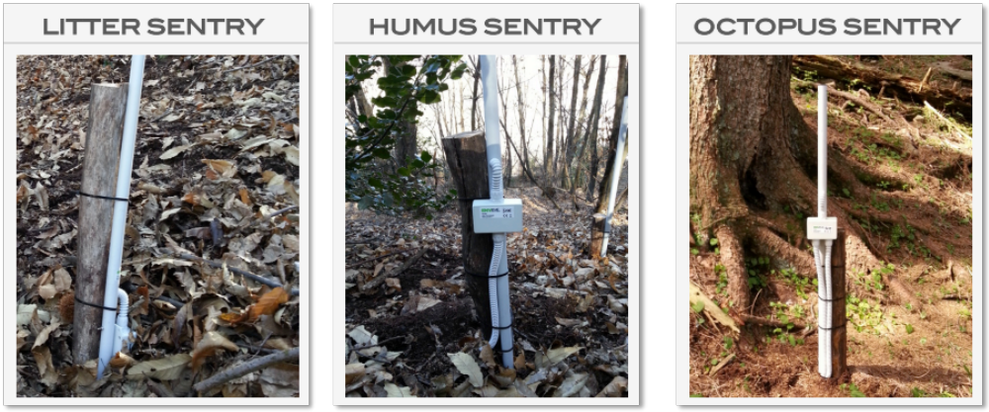

GATEWAY: Gathers the sensor signals and transmits them to the CLOUD by means of GPRS / GSM. Solar powered.

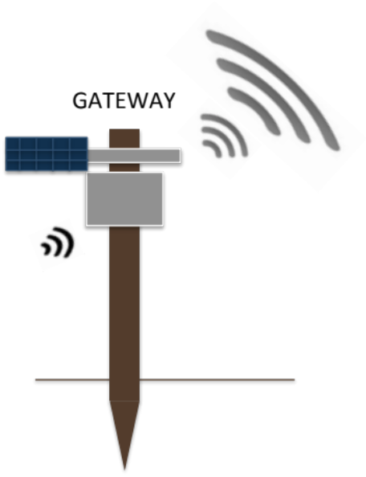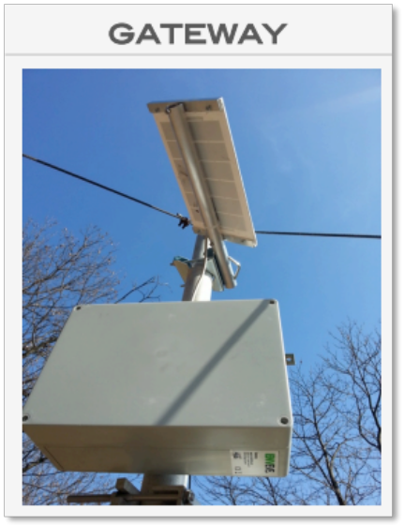

CLOUD SOFTWARE: Gathers the data sent from all the Gateways, store them, georeferentiates them, allows to easily access to them through browser and creates graphics and analytics (soon available).

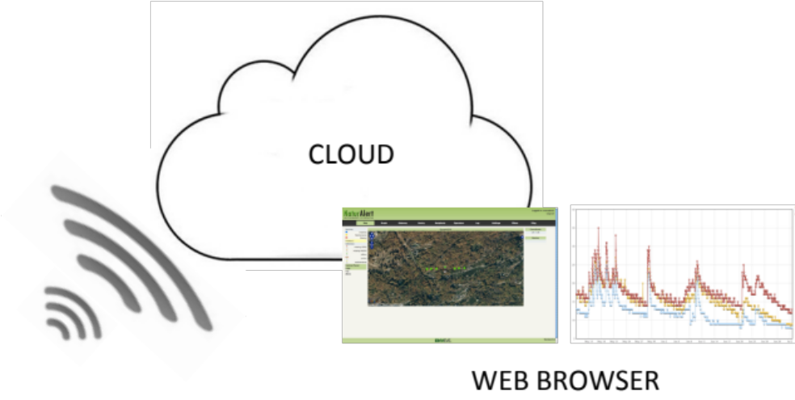

Types of FireLess2 Stations
Given the kind of vegetation EnvEve has developed the following FireLess2 Stations Types:

FireLess2 Broadleaf
3 Litter Sentries
3 Humus Sentries
1 Gateway

FireLess2 Conifer
3 Octopus Sentries
1 Gateway

Optional FireLess2 Modules
Combo Gateway: often FireLess2 requires to be installed in remote area with little mobile network availability. In these situations the Combo Gateway significantly improves the data collection reliability.

Smart Meteo Station: FireLess2 can be equipped with more wireless sensors to locally collect and correlate meteo data.

Advanced interface with analytics: under development it will be available on 2014.

FireLess2 function schema

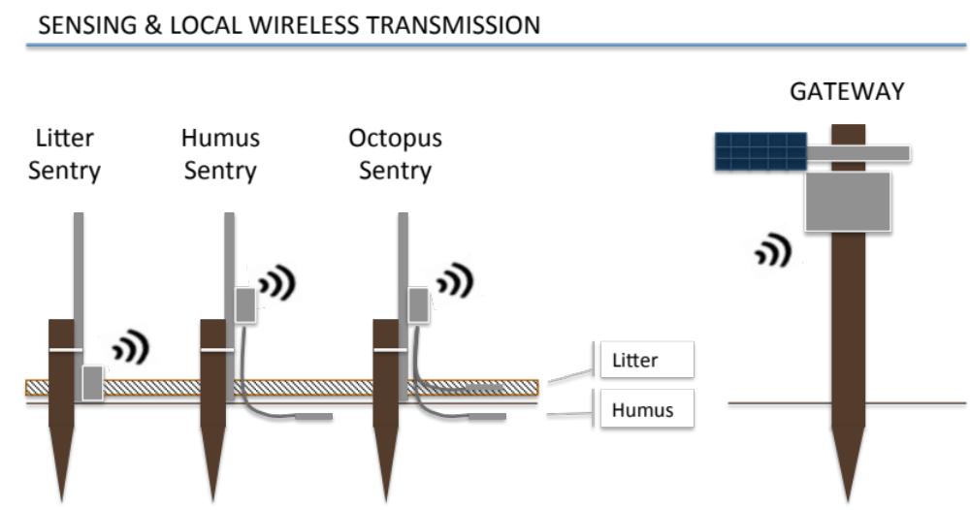
1. Data are automatically collected by the Sentries
2. Data are wirelessly transmitted to a local Gateway

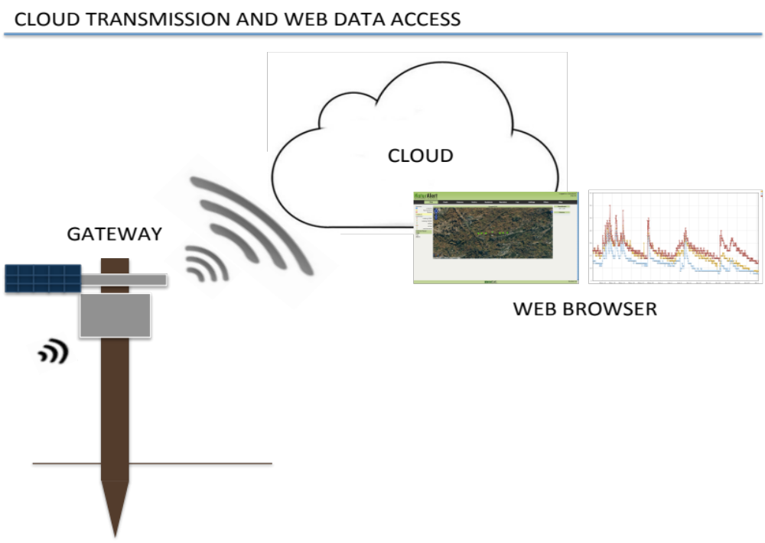

Technical Details
3. Data are automatically forwarded to the CLOUD by the Gateway
4. Data are accessible from internet using a regular browser
Local Wireless Communication (bewteen sensores and gateway): RF 433 MHz on proprietary highly perfomant protocol specially designed for very low power outdoor communication.
Local communication range: 100m - 5km depending on orography and vegetation.
Sentries very low power: 5-10 years operation time with a single battery.
Sentries Ruggedized: sentries package designed to resist harsh conditions, shocks and temperatures in the range -40° to 90° (Celsius).
Gateway very low power: unlimited operation time with a little solar panel. The gateway is also equipped with a secondary battery allowing a 2 months operation time in case of total solar panel obscuration (for instance in case it will be covered by snow). The efficient software will often enable the gateway to obtain a positive power cycle even with a solar panel under indirect solar radiation.
Gateway ruggedized: despite the advanced and sophisticated technology, EnvEve gateway has proven to resist harsh conditions, heavy rains, ice and temperature range -40° to 90° (Celsius) [primary battery will be damaged below -25° but the gateway will continue to operate relying on the secondary battery).
Out-of-filed Wireless Communication: 2 gateways versions are available, GSM and GPRS. While the Combo Gateway uses both. The GSM communication uses a proprietary protocol specially designed to deal with low outdoor GSM signal.
Power suppy: The gateway can store up to 13 days of data. In case of lack of signal they will be stored and sent as soon as the gateway will find the GSM signal.

