HARBOR HOPE CAT RESCUE
P.O. Box 2693 Gig Harbor, WA 98335 * 253-858-6205 petsavers@aol.com

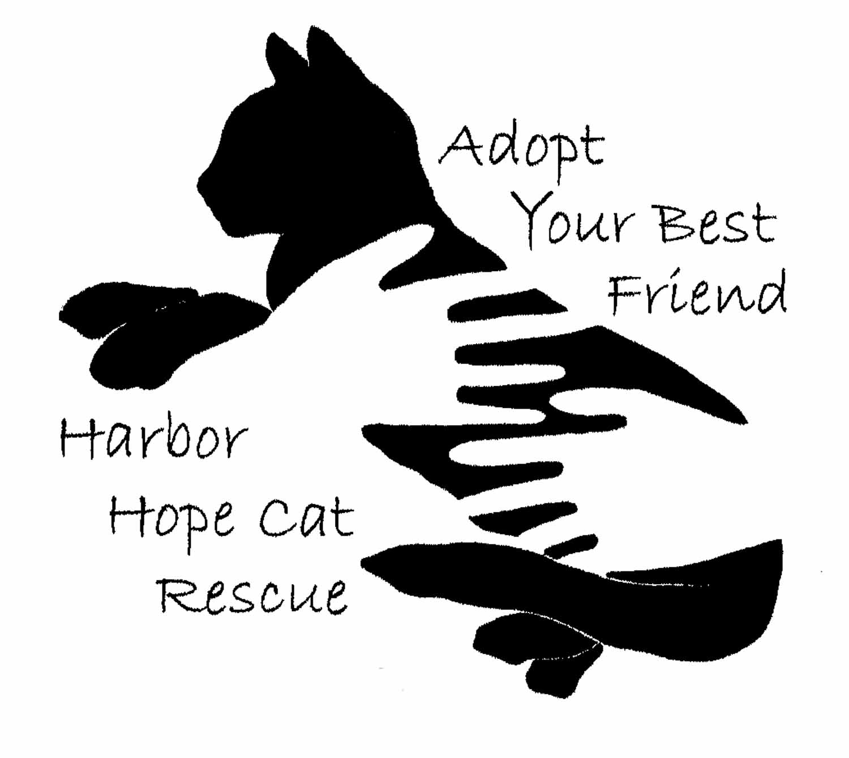
Harbor Hope Cat Rescue is a non-profit effort dedicated to the rescue, rehabilitation and placement of abandoned, ill, injured and special-needs animals.

All cats are tested for FeLV (leukemia) and FIV (feline infectious virus). They are spayed or neutered, vaccinated, microchipped, treated for parasites and given individual medical care as needed. They are kept separate from other cats for at least 21 days to rule out any possible virus transmission and to build trust and their sense of security. They are then integrated with others depending on disposition, age and dietary needs.

Because our rescue efforts focus mainly on the ill and/or injured and special-needs cats, we are sometimes faced with the difficult decision of euthanasia. It's never easy to make this decision, but for some terminally ill or severely injured cats, particularly feral ones who are suffering, it is the kindest act that they will ever know from humans. It's a sad fact, but one that we are trying to change through community education and spay/neuter. We are committed to giving each and every cat thorough diagnostics and treatment. It is necessary to try to limit our number of rescue residents so that we can remain able to provide the time and finances needed for the often extensive medical care and rehabilitation.

We relocate feral cats from unsafe areas, so we are always in need of secure homes for them such as a barn where they are fed, sheltered and monitored. All ferals are altered, vaccinated and given complete medical care, including dental treatment. We provide information on incorporating feral cats as an integral part of a healthy environment.

Potential adopters are screened by application process, and an adoption donation is requested. All adoptions are lifetime guaranteed in that if the new family is ever unable to keep the cat, he/she is to be returned to Harbor Hope.

