Mini Jets
(2-6 years)
- Develops amazing self confidence
- Builds spatial awareness
- Builds strength, coordination and flexibility
- Improves the vestibular system – important for brain learning
- Loads of Fun for kids to explore their bodies amazing capabilities

The Mini Jets Program is designed to give children 2-6 years of age the best start in life. At Jets we use gymnastics to teach children how to move their bodies in a huge variety of ways including running, jumping, rolling, swinging, balancing, landing, hopping, cartwheeling, spinning, and so much more.
Mini Jets incorporates all of our wonderful gymnastics apparatus such as ropes, rings, trampolines, balance beam, bars and also uses our huge sprung floor area with loads of soft shapes which encourage learning. Each Mini Jets class combines themes with gymnastics skills and concepts such as colours, numbers, shapes etc, which helps students maximise their learning opportunities.
Give your child the best start in life - Book NOW for a Free Mini Jets Try Out Class

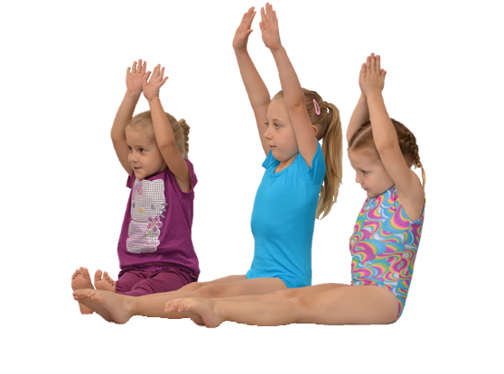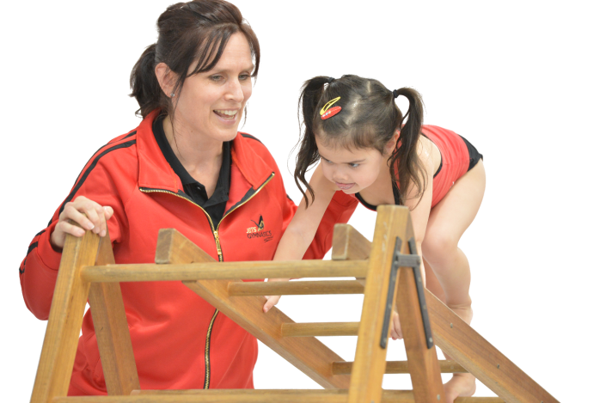

“Gymnastics educates children’s bodies”
Qualified Instructors | Great Facilities | Safe | Fun
2012 WAG Club of the Year

Fun Gym
(5-8 years)
- Loads of Fun and Excitement
- Develops amazing self confidence
- Builds spatial awareness
- Builds strength, coordination & flexibility
- Skills include forward & backward rolls, cartwheels & handstands

Our Fun Gym program is the introductory level to the wonderful sport of gymnastics. Designed for Children 5-8 years of age this is a one hour class which provides the basics and foundations of the sport in a fun, safe and challenging environment.
Gymnastics provides the foundation of all movement, providing opportunities for participants to run, swing, jump, balance, roll, skip, somersault, bounce, hop and flip. It requires strength, power, flexibility, agility, courage, determination, skill and finesse. Little wonder why it is so highly regarded by leading sports coaches and educationalists. Coaches all use set lesson plans which provides for maximum safety and learning opportunities and aims to engage all students.
The program though is not just about having fun, it aims to provide all students with a range of gymnastics based shapes and skills including safe landings, forward and backward rolling, swinging and balancing as well as commencing work on handstands and cartwheels.
Classes involve a 15 minute warm up followed by 3 x 15 minute rotations with students doing all apparatus in the gym over a 2 week period. Students 7yrs of age and older are encouraged to move from the Fun Gym program into a 2 hour Stars class (generally after 6-12 months in Fun Gym).
Get started at Jets Now - Book a Free Fun Gym Try Out Class

“Gymnastics educates children’s bodies”

Qualified Instructors | Great Facilities | Safe | Fun
2012 WAG Club of the Year

Rockets
(5-7 years)
- Uses our own unique Levels System
- Skills include handstands, cartwheels, walkovers, pullovers, back & front drops
- Students commence work on flips and somersaults
- Creates amazing self confidence
- Is challenging, SAFE & progressive

Our Rockets & Stars program is designed to provide specific challenges for all students, allowing them to develop a range of gymnastic skills beyond the basic level. Key basic skills are mastered (including rolls, swings and balancing) and enhanced with a continued emphasis on the physical development of each child including their strength, flexibility and coordination.
Skills developed include rolls, cartwheels, handstands, walkovers, pullovers, back & front drops. Students also commence work on flips and somersaults. Jets has a specially designed Levels system aimed to help the students continue to progress from white level through to black level with a whole range of safe and progressive skills and drills.
This is a 2 hour/week class however students may elect to do 2 classes per week. The class also incorporates a range of strength and flexibility development to assist participants to achieve the next level of skills.
Book NOW for a Free Rockets Try Out Class

“Gymnastics educates children’s bodies”
Qualified Instructors | Great Facilities | Safe | Fun
2012 WAG Club of the Year

Stars
(7-10 years)
- Uses our own unique Levels System
- Skills include handstands, cartwheels, walkovers, pullovers, back & front drops
- Students commence work on flips and somersaults
- Creates amazing self confidence
- Is challenging, SAFE & progressive

Our Rockets & Stars program is designed to provide specific challenges for all students, allowing them to develop a range of gymnastic skills beyond the basic level. Key basic skills are mastered (including rolls, swings and balancing) and enhanced with a continued emphasis on the physical development of each child including their strength, flexibility and coordination.
Skills developed include rolls, cartwheels, handstands, walkovers, pullovers, back & front drops. Students also commence work on flips and somersaults. Jets has a specially designed Levels system aimed to help the students continue to progress from white level through to black level with a whole range of safe and progressive skills and drills.
This is a 2 hour/week class however students may elect to do 2 classes per week. The class also incorporates a range of strength and flexibility development to assist participants to achieve the next level of skills.
Book NOW for a Free Stars Try Out Class

“Gymnastics educates children’s bodies”
Qualified Instructors | Great Facilities | Safe | Fun
2012 WAG Club of the Year

Gymstar
(10-16 years)

- Uses our own unique Levels System
- Keeps children focused on progressing
- Skills include roundoffs, handsprings, flips & somersaults
- Creates amazing self confidence
- Is challenging, SAFE & progressive

Gym Star is a Levels based class for 10-16 year olds. Advancing on from the Stars program the Gym Star program provides opportunities for gymnasts to learn more advanced skills.
Jets has a specially designed Levels system aimed to help the students continue to progress from white level through to black level with a whole range of safe and progressive skills and drills. The early levels develop skills such as rolls, cartwheels, handstands, walkovers, pullovers, back & front drops, students then develop more advanced skills such as roundoffs, flips, somersaults, handsprings, flysprings, kips, giants and more.
This is a 2 hour/week class. Students may elect to do 2 classes per week. The class also incorporates a range of strength and flexibility development to assist participants to achieve the next level of skills.
Book NOW for a Free Gym Star Try Out Class

“Gymnastics educates children’s bodies”
Qualified Instructors | Great Facilities | Safe | Fun
2012 WAG Club of the Year

Tumbling & Trampoline
(5-16 years)

- Fly through the air
- Develop great aerial skills
- Is Challenging, SAFE & Progressive
- Skills include roundoffs, handsprings, flips & somersaults

The Tumbling & Trampoline program is specifically designed to teach acrobatic skills to all participants in a safe and progressive environment. The program is divided into Beginner, Intermediate and Advanced Classes with students working through our specially designed levels system.
Students learn lots of basic tumbling & trampolining skills, jumping and twisting as well as developing strength, coordination, spatial awareness and flexibility. When these skills are mastered students progress on to learning flips, somersaults and associated activities.
Every Jets centre boasts an Olympic sized sprung floor, 2 competition size trampolines and a huge 12m long tumbling trampoline. Students in the classes use all trampolines to learn various skills with classes tailored towards individual needs and skill levels.
Classes are combined boys and girls and involve a warm up followed by rotations which include trampoline, tumble trampoline, floor, vault and conditioning. Classes involve 1-1½ hours training per week although participants can attend additional sessions if they desire.
Book NOW for a Free Tumbling & Trampoline Try Out Class

“Gymnastics educates children’s bodies”
Qualified Instructors | Great Facilities | Safe | Fun
2012 WAG Club of the Year

Squad
(5-18yrs)
- Achieve amazing skills
- Builds confidence & character
- Aspire to be your absolute best
- Creates strong healthy bodies
- Challenges every student to their maximum

The Jets Gymnastics Squad Program is designed to give girls aged 5+yrs the opportunity to excel in the sport of gymnastics. Girls aged 5-9yrs are encouraged to develop their skill base and quickly progress through the beginner levels of gymnastics before moving into the competitive system.
Entry to our squad program is by selection only and places are limited. Children first start in our squad development program. This program is specifically designed by Jets to advance gymnasts through to the higher levels of the sport. Girls also focus on significant strength & flexibility development which assists in the development of high level gymnastics skills.
Jets conducts a squad program for girls using the State Levels system in all of our centres. Girls usually train 3 sessions per week with a focus on developing competitive level gymnastics skills and routines on all apparatus (Vault, Bars, Beam & Floor).
Jets is also the only private club in Australia which has developed its own High Performance Centre (at our Diamond Creek Venue). In this venue Jets has programs for National & International Level Gymnasts who aspire to the highest levels of our sport. Previous athletes at Jets include Liz Wong (Sydney Olympics Squad Member), Lizzy Garder (Victorian Champion and dual Winter Olympian), Stephanie Moorhouse (Bronze Medalist 2003 World Championships & 2004 Athen’s Olympian) & Georgia Bonora (2008 Bejiing & 2012 London Olympian)
Assessments are done by our Head Squad Coach on request.

“Gymnastics educates children’s bodies”
Qualified Instructors | Great Facilities | Safe | Fun
2012 WAG Club of the Year

Birthday Parties
(1-12yrs)
- Loads & loads of fun
- 1½ hours of Games, Free Time & FUN
- Catering options available
- No mess to clean up
- Special Bungee Jumping for the Birthday Child

Every Saturday afternoon and Sunday Jets opens its doors so that kids can celebrate their birthday with the most fun ever! Our parties last for 2 hours - with one and a half hours of fun filled activities in the gym and the last half hour in our party room.
Gym activities include organised games tailored for all age groups & loads of free time to explore our amazing facilities including trampolines, ropes, rings, balance beams, soft shapes, bars and our huge sprung floor area.
To finish the party the birthday child gets to FLY in our amazing bungees – what better way to celebrate your birthday.
Our Eltham & Gisborne facilities offer fully catered parties on both Saturdays and Sundays so you can sit back and relax - no more stress when organising your child's birthday - let us do all the work. We even supply you with invitations.
Our Shepparton & Bendigo venues both offer fabulous facilities for your child's party - there is so much equipment for them to play on as well as wonderful games organised by qualified instructors.

Call us now to book your child's next Birthday Party.

“Gymnastics educates children’s bodies”
Qualified Instructors | Great Facilities | Safe | Fun
2012 WAG Club of the Year

School Holiday Program
(5-12yrs)
- Highly engaging and energetic program
- Wonderful staff
- Open everyday in the school holidays
- Loads of activities to suit everyone
- They will never want to go home !!!!

Every School Holidays Jets conducts its own Full Day Care program for primary school aged children (5-12 years). The program is high on energy and excitement and combines gymnastics activities (every day) with other activities such as movie making, crafts, cooking, jumping castles, free play, games, bungee’s and various theme days.
The program runs from 8.00am-6.00pm every day of the holidays, parents can simply drop their children off and pick them up safe in the knowledge that they will have so much fun. We are big on keeping the kids active, so there is no chance your child will be bored or sitting down all day.
Places are limited – book early to avoid disappointment

“Gymnastics educates children’s bodies”

Qualified Instructors | Great Facilities | Safe | Fun
2012 WAG Club of the Year

Free Play
(0-5yrs)

- 0-5 Year Olds
- Parent Supervised
- Great way to explore and play in the gym
- Only $5 per child

Free Play is a parent supervised session for pre-school aged children. Children are free to explore our wonderful gymnastics centre and use all the traditional gymnastics equipment such as balance beams, trampolines, rings, ropes, sprung floor and bars. We also have a huge range of special climbing equipment for children to develop upper body strength and a range of soft shapes.
Bring all of your friends and enjoy a great time at Jets
Please note free play is strictly Pre-School children only
For more information on our Free Play Program including, dates, times and availability check out our facebook pages or ring your local Jets Gymnastics venue.

“Gymnastics educates children’s bodies”
Qualified Instructors | Great Facilities | Safe | Fun
2012 WAG Club of the Year

Centre’s

Eltham & Diamond Creek
Eltham
Phone - 03 9439 6571 | eltham@jetsgym.com.au
12 Brisbane Street, Eltham, Victoria

Diamond Creek
Phone - 03 9438 8940 | diamondcreek@jetsgym.com.au
Address: Community Bank Stadium, Main Hurstbridge Road, Diamond Creek

1300 JETS GYM (5387 496)

Bendigo
03 5444 1119 | bendigo@jetsgym.com.au
Address: 41 Hattam St, Golden Square
1300 JETS GYM (5387 496)

Gisborne
03 5428 8255 | gisborne@jetsgym.com.au
200 Hamilton Rd, New Gisborne
1300 JETS GYM (5387 496)

Shepparton
03 5825 4228 | shepparton@jetsgym.com.au
Recreational Reserve Midland Hwy Mooroopna
1300 JETS GYM (5387 496)

