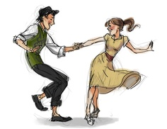
First Class FREE TO TRY!

Learn to
Swing
Dance



Beginners Lindy Hop
& Charleston Classes

Every Wednesday (6-7 pm)

@ 95 Lavinia Avenue, Near Runnymede Subway
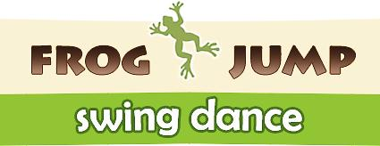
No Partner Required
$10
per Class

FrogJumpDance.COM

