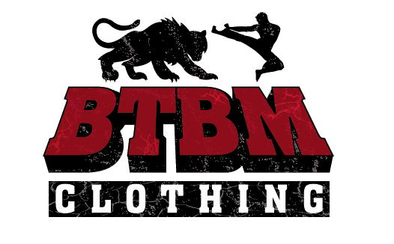 Born To Be Man T Shirt Design

To create 3 T Shirt designs for Born To Be Man (BTBM) brand. Refer to the logo for the feel of our brand.

T Shirt Design 1 (Brand)

Design 1 will be brand name. This is simple. This will mean the words “BTBM” or “Born To Be Man” to be conceptualized on a T Shirt. Feel free to experiment with fonts that resonate well with our “manliness” image. Feel should not be too serious, but not too cartoonish either.

Please note, words should also look well on both light and dark backgrounds.

Example:

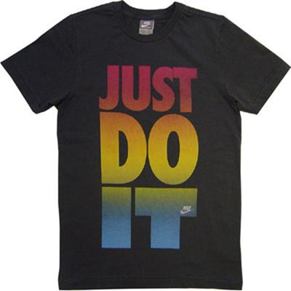

T Shirt Design 2 (Picture)

Design 2 will be Pictorial. Please design a T Shirt with an image/picture/visual on it. If the “BTBM” brand can be included without jeopardizing design, please consider as well.

Key elements of this image:
- Manly
- Bold
- Not too complicated
- Eye-catching

Examples:
Do’s
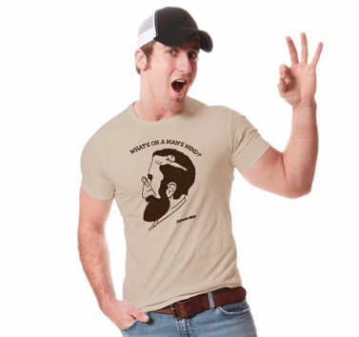
Don’ts:
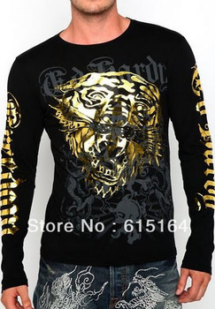

T Shirt Design 3 (Message)

Design 3 should be message based. Picture/image along with the message can be considered if it is packaged well.

Content of the message and picture (if image included):
- RIdiculously manly
- Short and to the point
- Image must be related to the message (if any)

Examples:

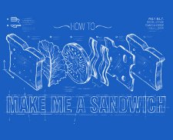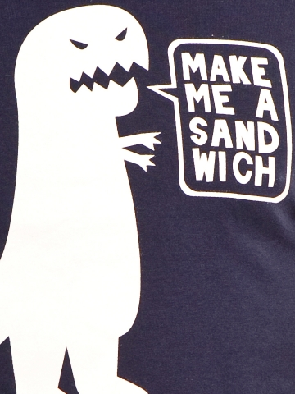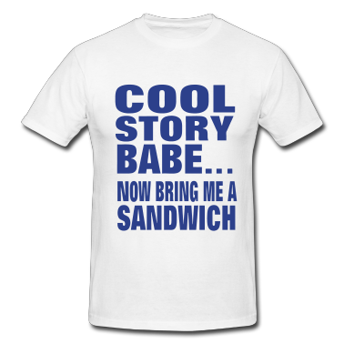

Slogans to put on T Shirt. These slogans can be taken word for word, but we welcome your slogan ideas as well (following the general feel)

- “Make Me A Sandwich”
- “Content: 100% Man”
- “Steak & Whiskey”
- “Everybody Wants A Lumberjack”
- “Women & Horses & Power & War”
- “Remember the Alamo!”
- “Keeping It Real”
- “What a Man Wants” (Picture of boobs or other things traditionally desired by men can be added here)
- “I Came. I Saw. I Conquered” (Picture of a hot girl holding a game console controller and a plate of ribs, wearing a bikini)
- “F**k Play Dough” (image of a toddler/infant playing with steel & fire)

Note: If you feel images are necessary to enhance the feel of the T Shirt, please go ahead. Also, the slogans can be tweaked. For example, “Steak & Whiskey” could be tweaked to be something like a Nutritional Information Panel saying 50% Steak & 50% Whiskey or something along those lines. Use your creativity.

Additional Information:

Target Audience:

• Young males from 15 – 30 years old

• Internet Savvy

• Possess disposable income

• Preferably have access to credit cards for purchase

Message Objectives:

• Shouting to the audience that we are an unashamedly male-orientated brand

• Buy our products, and you will be seen as a man

Do’s & Don’ts:

• DO – be willing to have a design that is “OUT THERE” to establish a personality

• DO – be shamelessly masculine

• DO – be classy at the same time

• DON’T – Try to please everyone. We are aiming for a niche

• DON’T – Be feminine at all. NO PINK

• DON’T – Overcomplicate the designs

Note: Kindly copy paste the below sentence into the comments section as proof of receiving the brief.

“I have read this brief and will do my utmost to contribute to the growth of manliness”

