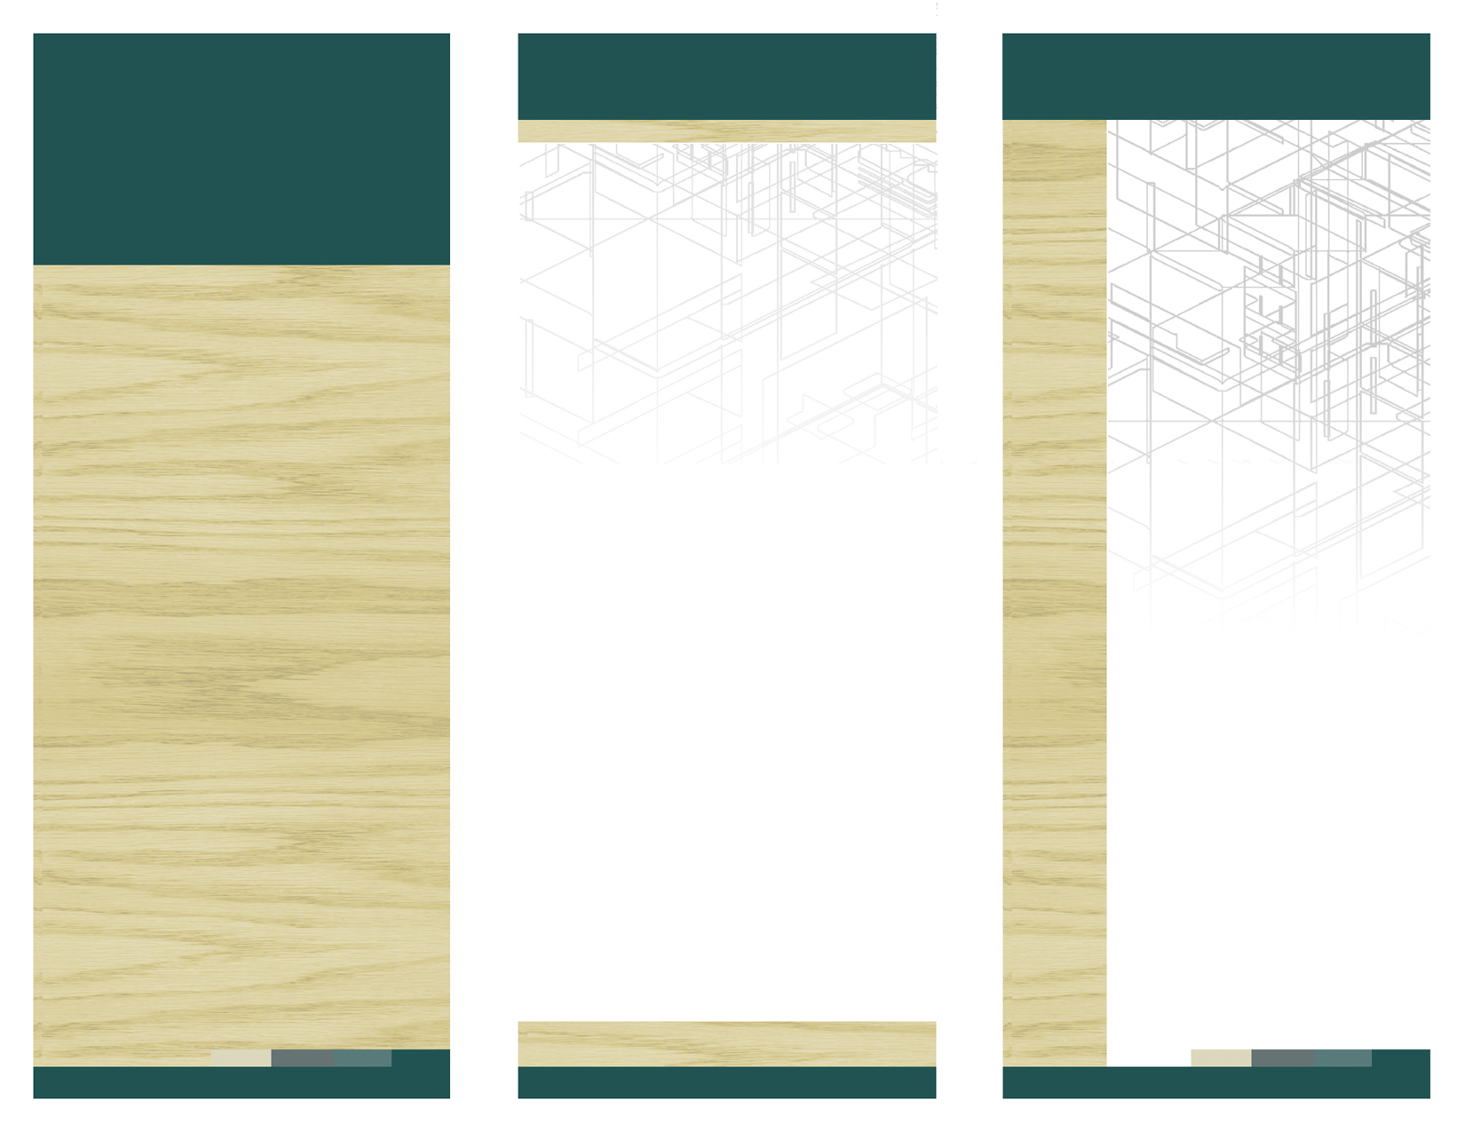
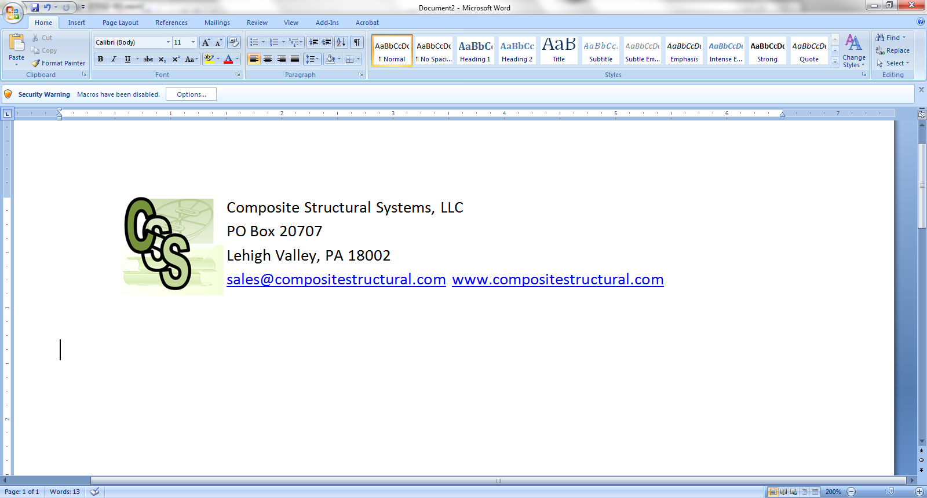

REBUILD SAFER
STRONGER
BETTER

PO Box 20707, Lehigh Valley, PA 18002-0090
T. 610.813.2170 │ F. 610.365.1491
Email: sales@Compositestructural.com
www.compositestructural.com
WHO WE ARE
Following the devastation of Hurricane Sandy, countless homes along the Northeast Coastline were dislodged from their piling foundations. Some of the pilings were completely destroyed while others subsided. Composite Structural Systems, LLC (CSS) was established by a team of Engineers, Designers and Material Specialists that witnessed the destructive aftermath personally. This highly skilled team provided engineering services to home owners along the coast at the initial stage of the aftermath recovery efforts. During this time, the CSS team identified a need for an improved solution.
Traditional options available on the market presented problems for the recovery of homes on pilings that needed to be repaired or raised. Options provided to homeowners had drawbacks. The traditional method includes lifting and moving the home away from the pilings, then drive new pilings, and then move the home back. This alternative presented several problems, such as cost and where to place the house during the reinstallation of the pilings. Simply put there is no room for this option in most cases.
As a result, CSS developed a system which allows the house to be raised without actually moving the home, the Collars installed, and the house reset on the Collars without the expense of moving the house or driving new pilings. This option can be installed in a matter of days with limited space and at a lower construction cost. Please see our technical brief for a review of your options and how our system compares to other methods.
Designer’s Corner:
Notes to Design Professionals:
We have a staff Engineer who can assist you with developing permit plans for submission for approval under Section 104.11 of the IRC. We can provide you with standard details in ACAD format with appropriate construction notes and detailed product specification for use in construction documents.
When designing using our systems, be sure to understand that our system is simply an extension of the piling, and as such, standard lateral supporting must be considered.
An inspection of each piling is required by the professional to ensure that the piling is free from alignment deflection of greater than 6 degrees, free from dry rot, damage or other defect.
Our system can be installed below grade, if there is dry rot on the exposed surface of the pile, dig down into the sand, it is likely the piling below the sand and/or the water table is structurally sound. The CSS system can be used as a splice to remove failed sections of pilings and install new sections.

Composite Structural
Systems, LLC
We provide piling repair systems to allow for cost effective reconstruction and modifications to structures on pilings
Composite Structural Systems, LLC

Composite Structural Systems, LLC

www.web address here
DELETE BOX, OR PLACE TEXT OR LOGO HERE
Ph 555.555.5555 Fx 555.555.5555
5555 Street Address City, US, 55555

www.webaddress.com
Delete box or place a tag line or quote here. Delete box or place a tag line or quote here. Delete box or place a tag line or quote here. Delete box or place a tag line or quote here.
Delete box or add photo caption here.
Delete box or add photo caption here.
Delete box or add photo caption here.
Delete box or add photo caption here.

Delete box or place a tag line or quote here. Delete box or place a tag line or quote here. Delete box or place a tag line or quote here. Delete box or place a tag line or quote here.
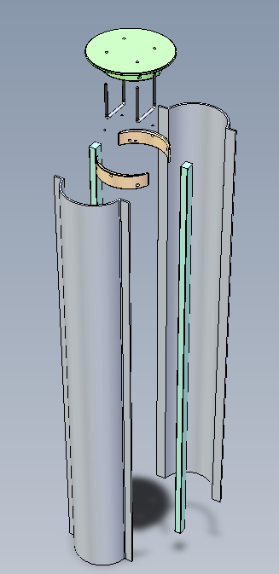
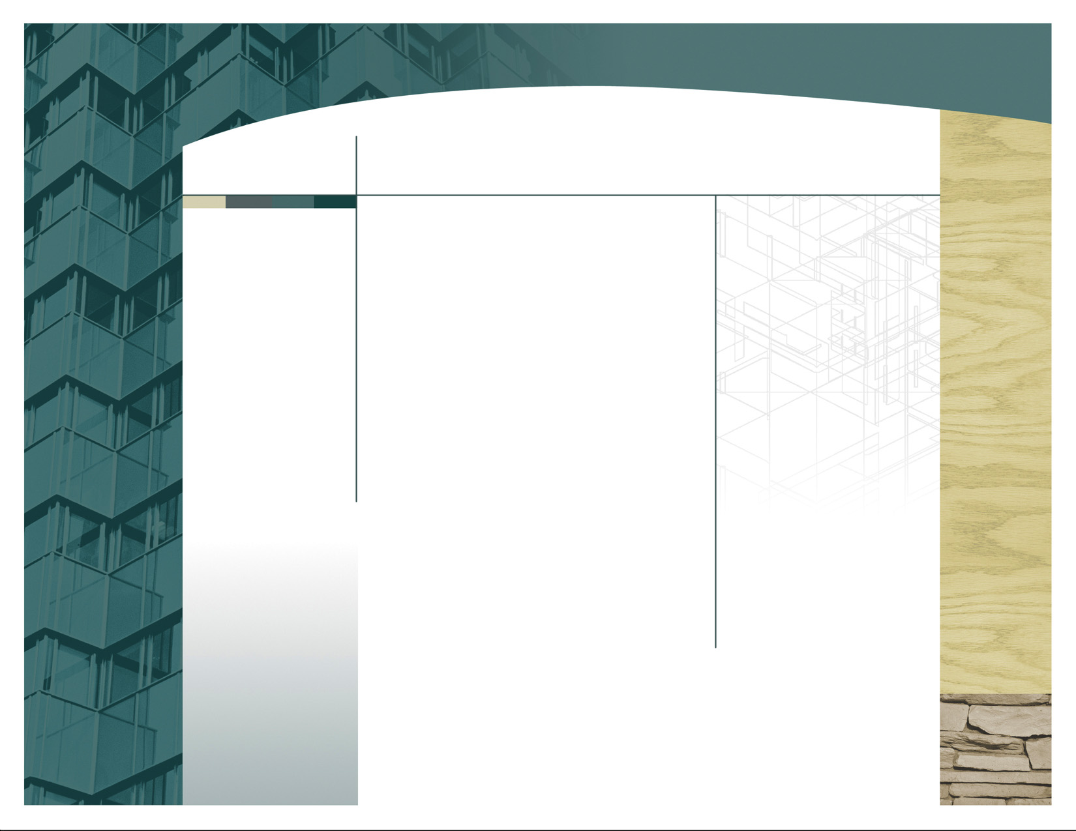
PO Box 20707,
Lehigh Valley, PA 18002-0090
T. 610. 813.2170 │ F. 610.317.0255
Email: sales@compositestructural.com
www.compositestructural.com

General Performance Standards, Notes and Guidance:
- General Performance Standards:
  - Vertical loading (vertical compression) 90 Kips
  - Bending moment 65 ft-Kips
  - Shear (lateral forces) 10 Kips.
  - Alignment/plumpness correction 6 Deg.
- This document and information provided is the property of CSS and shall not be altered, used or referenced by any third party without the expressed written permission of CSS.
- The User of this system is advised that they should obtain services of a design professional for the use of this product. CSS only represents that our product will withstand loading as documented in our specifications. The design professional shall evaluate the loading conditions and determine if the loading conditions fall within the parameters of the Collar system. Additionally, the user should employ the design professional to inspect the Pilings to ensure they are acceptable for use.
- Local Permitting may be required for use of this product. Consult with your local code official prior to use.
- The User of this system should employ installation contractors that have adequate skills for the required work. CSS does not and cannot attest to any skill set or quality of work of any installer.
- The written instructions for installation must be followed. Failure to do so could result in failure of the system.
Our Patented Piling system has been designed to withstand the corrosive environment of beach communities. The salt water and windblown sand corrodes unprotected materials, and yes, even stainless steel. Our system utilizes a high strength carbon fiber material that is corrosion proof from salt water and UV proof. The system will not erode, decay or loose strength over time. The system has three installation conditions, for raising a house on existing pilings, repairing damaged pilings, and for connecting new pilings to floor joists in new construction. The three options are generally described below:

RAISING A STRUCTURE
A house on pilings can be raised by disconnecting the house from the pilings, raise the house to create a work area, cut all of the piles to a preset elevation, and install the Collar on the piling. The Collar is connected to the piling by six galvanized lag bolts and is glued with a high strength adhesive and all gaps are filled with flowable epoxy fill and fiber. The Collar extends above the piling to the bottom of the home's joists to the preset height, up to 6'-6", or higher when lateral supports are considered. Once the Collar is set on the home, it is filled with concrete to transfer the load of the house from the floor joists directly to the top of the piling, the concrete provides the compressive strength, while the Collar provides tensile and shear strength. A Collar Cap is then installed with two galvanized steel u-bolts which extend into the floor joists for the installer to connect to the joists.

PILING REPAIRS AND EXTENSIONS
A 36" section of Collar can be installed onto an existing piling and a new section of piling can be placed on top, with 18" of the Collar covering the top of the existing and 18" covering the bottom of the new piling. Generally, the minimum length of the new piling needs to be 6 feet to ensure the piling length is not too short, which could lead to reduced piling loading capacity. This option generally requires lateral support of the pilings. Consult with your design professional

NEW CONSTRUCTION
The standard practice for connecting pilings to floor joists is to notch the pilings and bolt the joists to the pilings. This method dramatically reduces the strength of the piling due to reduced cross sectional area at the connection point. Additionally, this connection method exposes more surface area of the piling allowing for additional potential for dry rot. A 12" Collar section with a Collar Cap can be used to connect directly to the top of the new piling providing a connection that will outlast the piling by literally thousands of years.
Our System includes:

- Collar cut to customer length in sizes ranging from 12” to 144”.
- Collar Cap with galvanized steel u-bolts to connect to the structure.
- Collar spacers to allow for variations in Piling diameter
- Collar Cap spacers to allow for variations in Piling diameter.
- Tubes of high strength adhesive glue to connect the Piling to the Collar and for the Collar flange and to fill gaps between the Piling and the Collar due to the nature of irregular Pilings.
- Detailed installation manual providing guidance to the installation contractor.
- Detailed written specifications provided in paper format and available in word format upon request.

Flexibility:
Our system has been designed to accommodate piles ranging in diameter from 8” to 12”. The system can also correct vertical alignments by up to 6 degrees.

