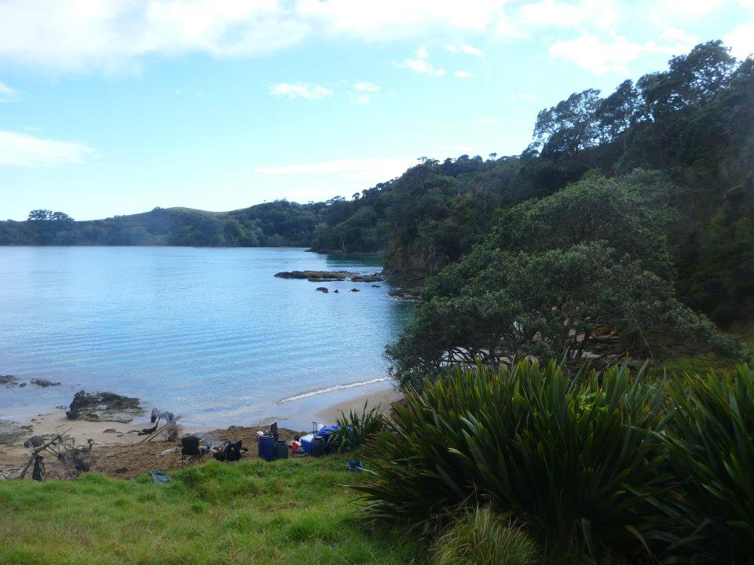
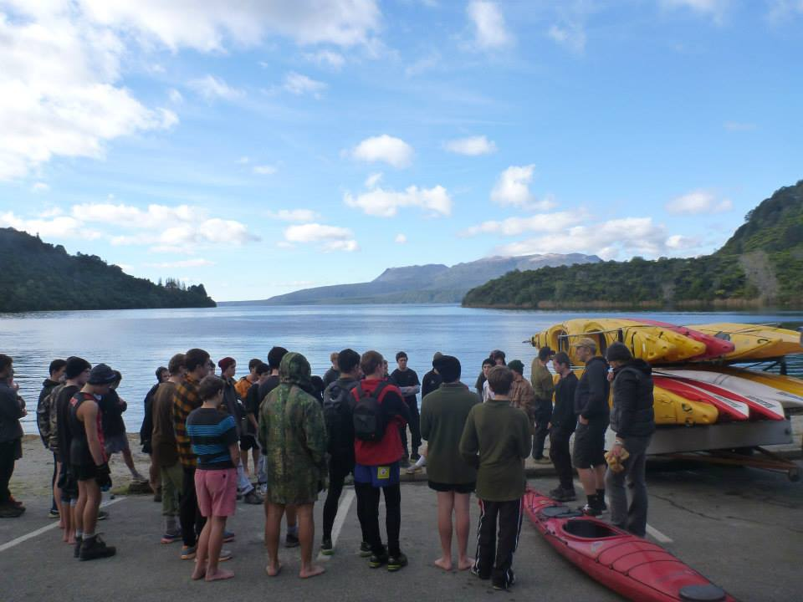
‘Take the path less travelled’
(This is our mission statement)

- Love the outdoors?

- Want some better stories about your NZ exchange?

- Check us out!!

Our tours offer a platform for foreign students to …

- Build confidence
- Create positive relationships
- Experience new cultures
- Solve problems in an unfamiliar and challenging outdoor environment

Our tours have many great popular NZ tourist activities but more importantly go where no other similar tours go. We create our own path less travelled!!!

We also aim to keep driving/travel to a minumum. Through experience we know this means more time having fun ; )

Sound good?...Check out our new Tours on Offer……..

We are the only adventure tour organization providing exciting experiences on and off the beaten track
New Zealand
We are all about making your story in NZ one worth telling. Here at …………..Tours we pride ourselves in providing the most memorable and exciting adventure based tours for students JUST LIKE YOU. We don’t just take you to some of New Zealand’s world-class adventure activities, we also take you deeper into the real New Zealand other tours don’t touch.

Our guides are addicted to adventure and the outdoors. We are ready to have some fun and share with you our knowledge of our beautiful country. Come and get into it!
Still no name for business

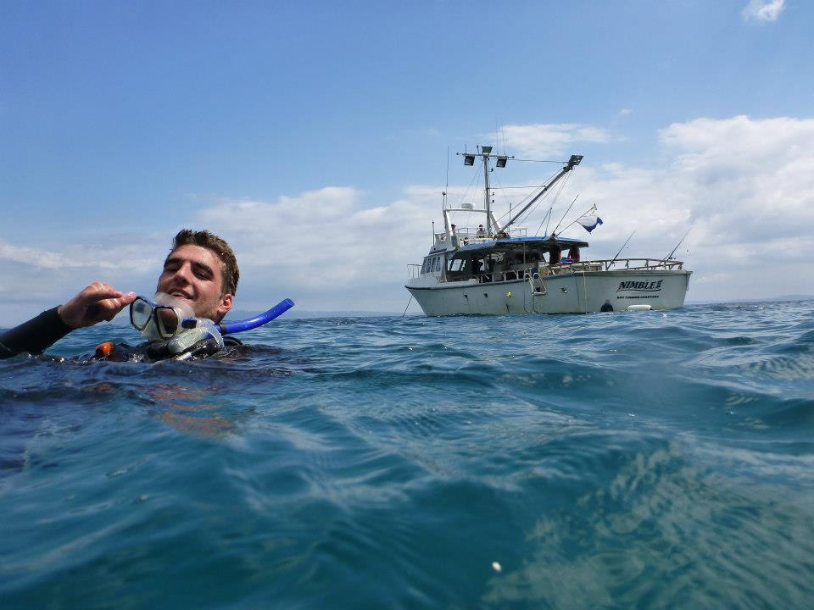
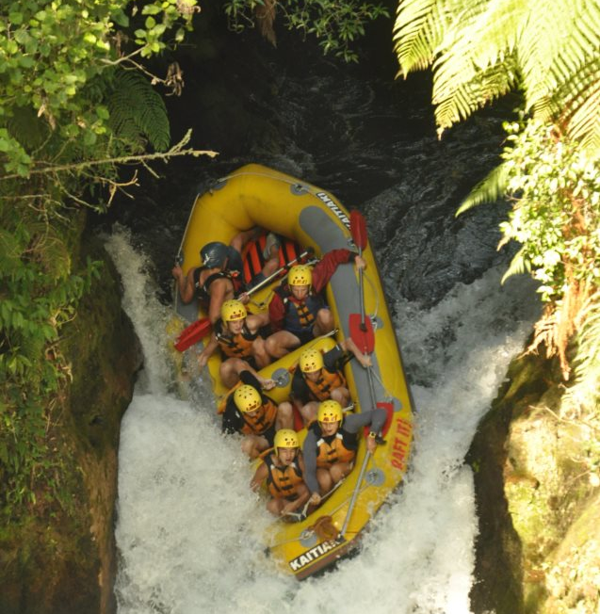
Maui’s Fish Tour

Maui’s Fish Tour takes you on a Journey to the golden beaches, crystal clear waters and lush native NZ bush of the Coromandel. We then make our way to New Zealands best adventure destinations Rotorua. Through to Taupo and the central plateau where we
Activities we have included in the Tour are:
- Rafting
- Mountain Biking
- Luge/Thrill Rides
- Sea Kayaking Cathedral Cove
- Tramping
- Glass Bottom Boat
- Bungy
- Snorkeling
- Fishing
- High Ropes Course
- Hot Pools
- Sight seeing
- Cultural Experience

Included in the costs
- Food
- All transport
- Cost of all activities and guides

All of this and 7days of fun with other international students for $1455pp

Day 1 – Waikato high ropes course and travel to Papa Aroha Coromandel for some kiwi camping

Day 2 – Travel to Whitianga and go on the ‘Glass Bottom Boat’ and Snorkeling in the Marine reserve

Day 3 – Kayak Tours to Cathedral Cove and dig a spa at hotwater beach with fish and chips on the beach

Day 4 – Travel to the Rotorua luge and skyrides. Later hit the geothermal hot pools and ‘Cultural Night’
Day 5 – Raft the Kaituna River and Mountain Biking Redwood forests and BBQ night

Day 6 – Travel to Taupo where you have the option to bungy jump and then we go to the mysterious ‘Craters of the Moon’

Day 7 – Huka Falls, natural hot springs and miniputt

Day 8 – Travel and farewells

Tour Dates:

Jan 24th – 31st

Limited to 30 spaces

Contact details –
To make a booking contact either

Hemi Coates
coateshemi@gmail.com 0226381956

Daniel Meade
meadedan@hotmail.com 0211586984

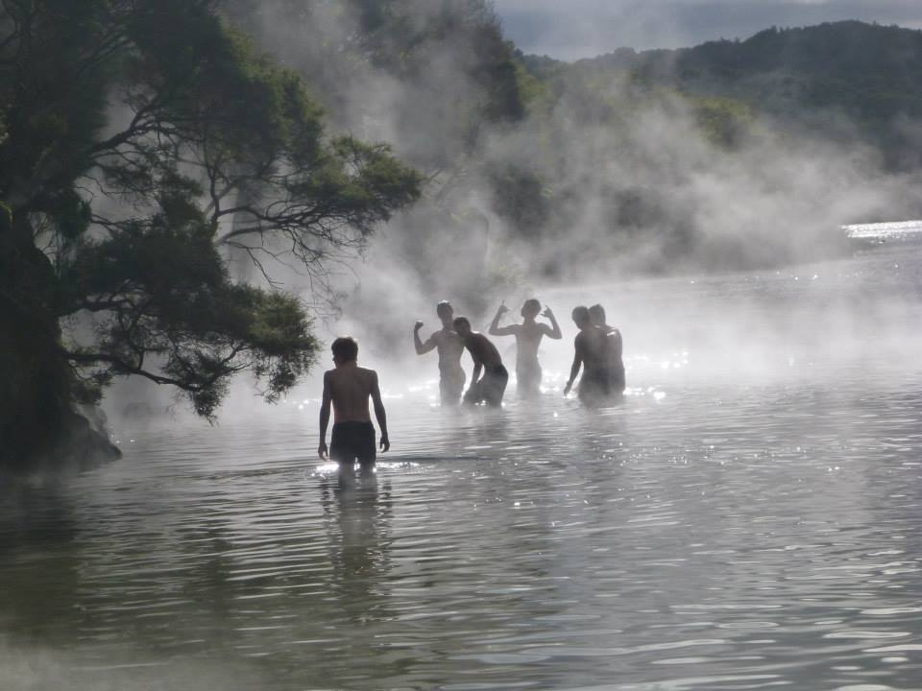
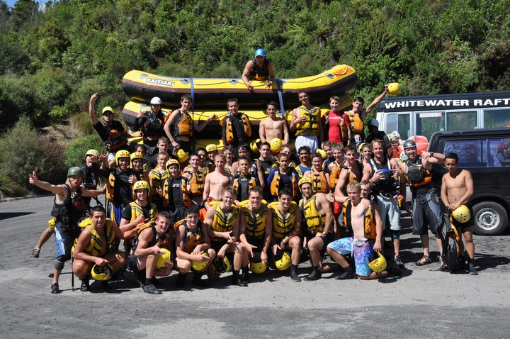
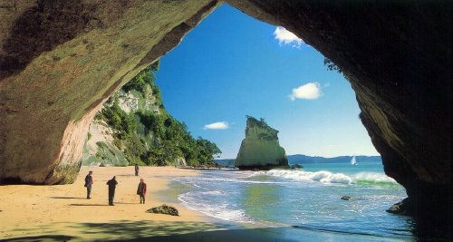
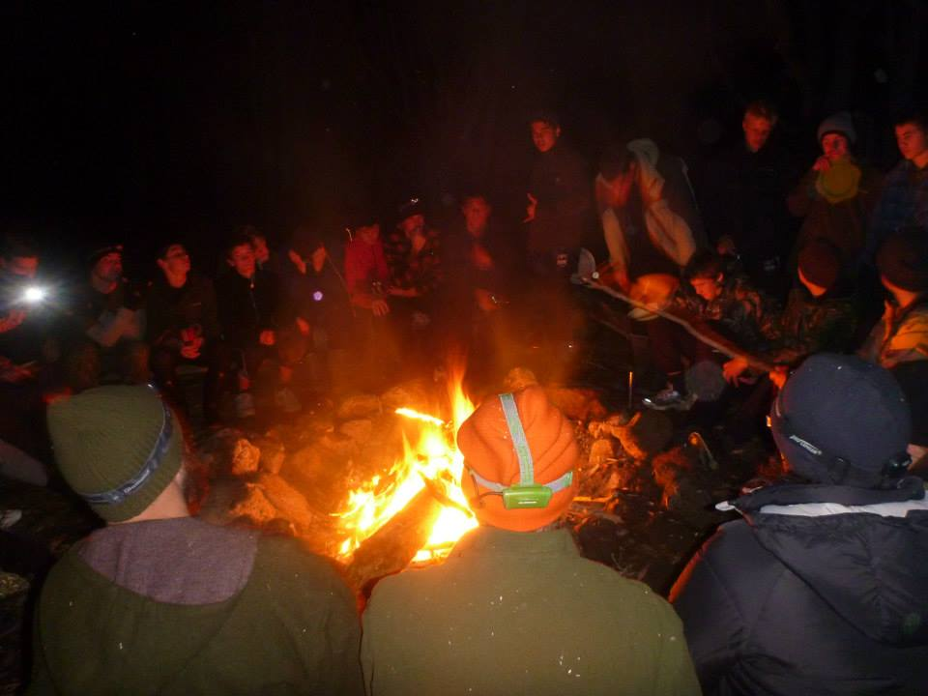
Tour dates : Dec 15th -22nd Limited to 30 spaces
The Homeland Tour is one of our most exciting adventure tours. We travel from the heart of the Waikato, home of the beautiful limestone caves, to Raglan the capital of NZ surfing on the west coast. We then make our way east to the adventure tourism playground of New Zealand, Rotorua! From there we hit the golden sands of Mt Maunganui. This culturally rich central Bay of Plenty region is home to some of our most exciting and beautiful rivers, mountains, forests and walks. Onto New Zealand’s best kept secret the Coromandel!
Activities we have lined up for you:
- Rafting
- Mountain Biking
- Surfing
- Caving
- Luge/Thrill Rides
- Sea Kayaking
- Tramping
- High Ropes Course
- Hot Pools
- Tramping/Sight seeing
- Cultural Experience

Included in the costs
- Food
- All transport
- Cost of all activities and guides

The Homeland tour

All of this, 8 days of fun and making memories with other international students for $1455pp

Day 1 – Waikato high ropes course and Karamu/Waitomo Caving

Day 2 – Raglan camping surfing and Kayak Tours in the Whaingaroa Harbor

Day 3 - Travel to Rotorua Luge and Skyrides, tramp in Kaingaroa Forest/Whakarewarewa Thermal Village and Hot Pools

Day 4 – Rafting the famous Kaituna River and Mountain Bike the world-renowned Red Wood forests, cultural night

Day 5 – Travel to the Bay of Plenty and Climb the Mount Maunganui (Mauao), shopping and Harbour tour

Day 6 – Travel to Coromandle Cathedral Cove kayak tours and Hotwater Beach

Day 7 - Pinnalces tramp in Coromandle, Whangamata beach day

Day 8 - Back to Waikato, Hot pools in Te Aroha in the morning and farewells

