Born To Be Man Logo Design
Brief:
To create 2 logos for Born To Be Man (BTBM) brand.
Logo 1 will be pictorial. Ideally, this will be a simple logo that is memorable, and can be instantly associated with our brand.
Key elements of the logo:
- Manly. This logo has to be instantly recognizable as masculine. It has to be an action/pose/figure that is instantly associated with men
Below examples should not be followed EXACTLY. They are merely for reference:
- Muscular man
- Man standing up to pee
- Man holding weapons
- Simple. Silhouette based logo is an avenue that can be explored, as it is a single colour block, and can be recognized instantly.
-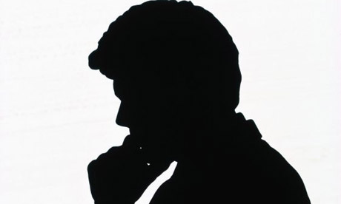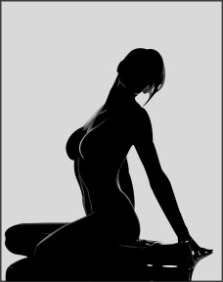
Logo 2 will be the words “BTBM”.
- This logo is purely word based, and should be flat. Basically, it should evoke brand association as well.
- The logo should be easily recognized, and can be used for printing ease.
- 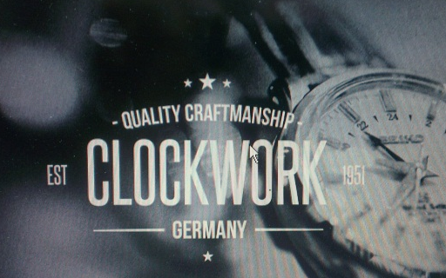

A fine example of having an instantly identifiable pictorial logo & word logo is Nike:
Nike is famous for its “Swoosh” logo along with its NIKE (word) logo. Ideally, BTBM would be the same, with an instantly recognizable picture logo, and another simple take on the BTBM letters.
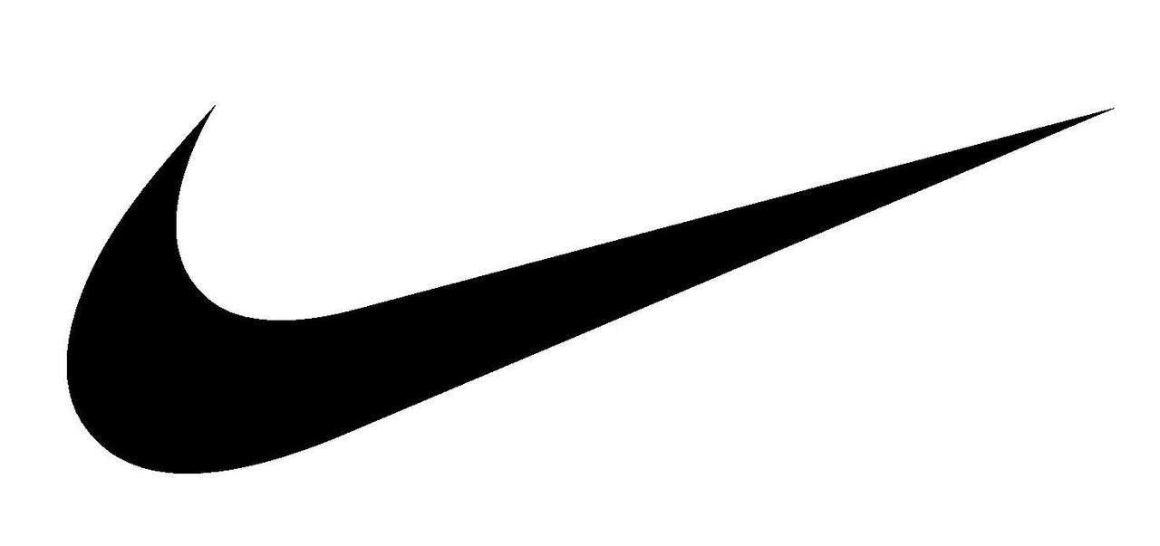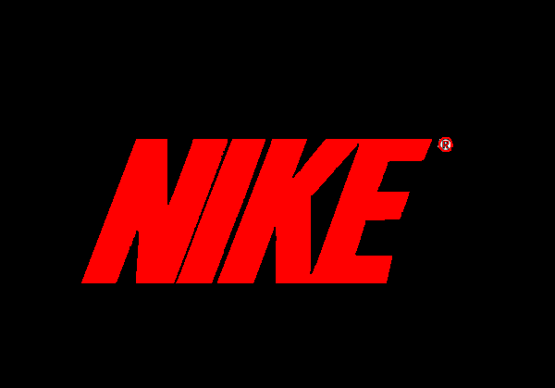
Target Audience:
- Young males from 15 – 30 years old
- Internet Savvy
- Possess disposable income
- Preferably have access to credit cards for purchase
Message Objectives:
- Shouting to the audience that we are an unashamedly male-orientated brand
- Buy our products, and you will be seen as a man
Do’s & Don’ts:
- DO – be willing to have a design that is “OUT THERE” to establish a personality
- DO – be shamelessly masculine
- DO – be classy at the same time
- DON’T – Try to please everyone. We are aiming for a niche
- DON’T – Be feminine at all
- DON’T – Overcomplicate the designs

