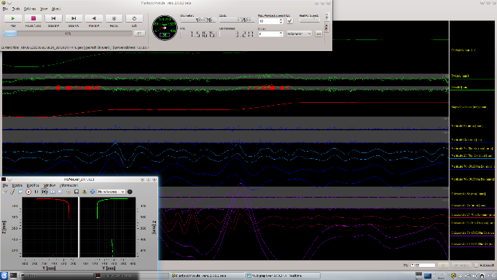
Accurate & Reliable
for Railway Maintenance
TGMS
Track Geometry Measurement System

Easy to install on almost every bogie, thanks to the compact dimensions.
Base system measures only the rail top and gauge side - optional modules allowing measurement of the field side also can be added.
Versions for extreme cold or hot environments.
Automatic window cleaning system.

Unattended operation.

DMA engineers have expertise across the full range of technical disciplines necessary for developing and continually improving a state-of-the-art track measurement system.
TGMS
Track Geometry Measurement System
DMA Accurate & Reliable for railway Monitoring

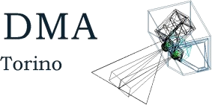

Being a 100% in-house developed system, DMA possess the full set of skills to easily support the product for the entire life cycle.
Availability, maintenance, accuracy over time: all are components of the life cycle cost to evaluate carefully.
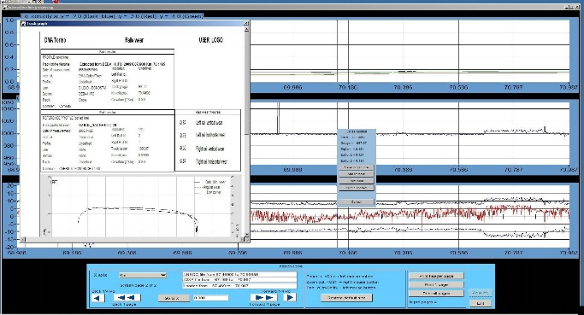

TGMS Output Measurements
The track geometry is defined by:
- Gauge
- Cross-level
- Alignment
- Longitudinal level
- Twist
- Track curvature
- Cant
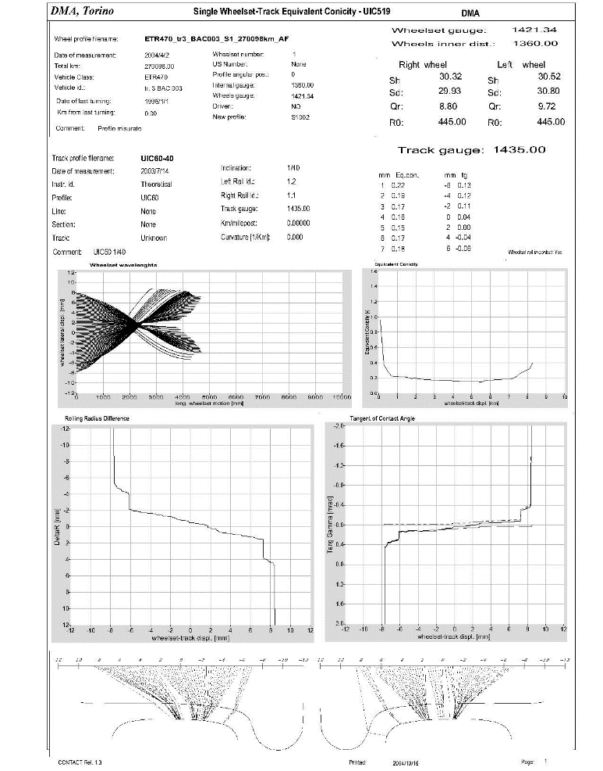
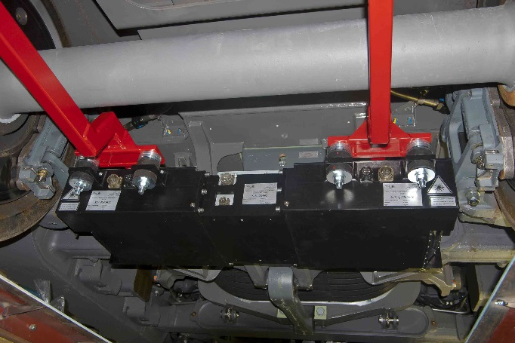
TGMS Technical Features
Main features:
- Maximum measuring speed up to 400 Km/h
- Very low minimum speed; optional zero speed measurement
- High accuracy even on long wavelengths (D3: 150-200 m for high speed lines).
TGMS measuring the track geometry is composed by two profile measurement instruments (left and right) and one inertial pack. All these instruments are installed on a single rigid rod, mounted on a bogie. A number of cables connect these instruments to the electronics racks, installed in the car body (a compact 19” rack, 18 U high). Video displays and printers are installed according to the requirements for the real time display and printing of data.
TGMS is so compact and easy to install that it can also be mounted on trains in regular revenue service. No moving parts or mechanical transducers ensure high reliability and long life.
TGMS
Track Geometry Measurement System
DMA Accurate & Reliable for railway Monitoring

Main Advantages/Benefit for the User
Main applications include the measurement of:
- Rail wear
- Wheel-rail contact parameters (UIC 519)
- Track geometry (EN 13848 - Track Geometry Quality Standard)

One standard PC is all you need to control the instruments and receive the data. More PCs can be installed if heavy real time processing of the data is required (e.g. computing the contact points and the equivalent conicity).
DMA provides a comprehensive suite of software to archive and process the rail profile data.

