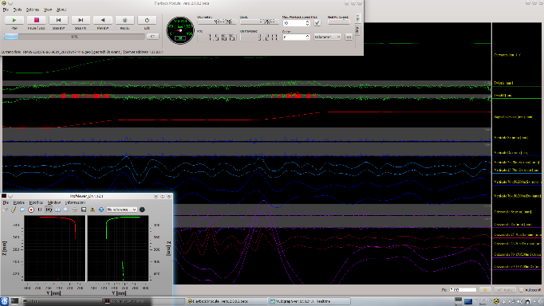
Accurate & Reliable
for Railway Maintenance
ORPMS
Optical Rail Profile Measurement System

The Optical Rail Profile Measurement System was developed for high accuracy measurement of tracks profile. It is also used by personnel dealing with high-speed trains, sensitive to running dynamics.
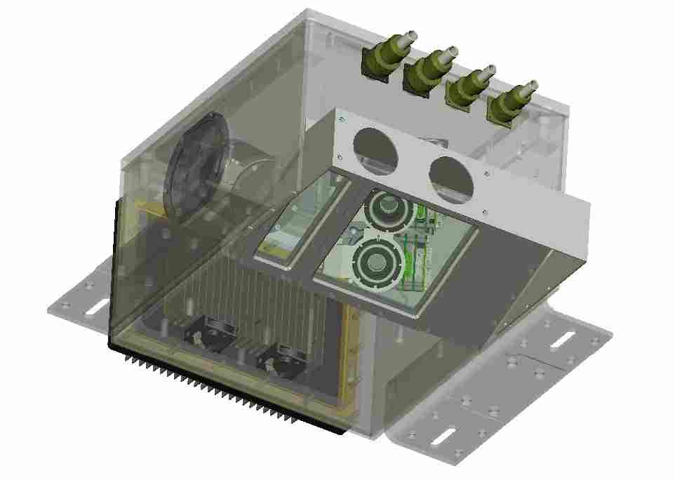
DMA engineers have expertise across the full range of technical disciplines necessary for developing and continually improving a state-of-the-art track measurement system.

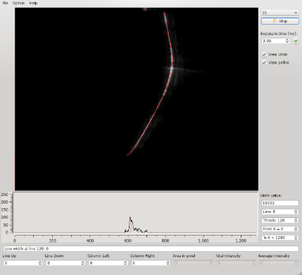

Being a 100% in-house developed system, DMA possess the full set of skills to easily support the product for the entire life cycle.
Availability, maintenance, accuracy over time: all are components of the life cycle cost to evaluate carefully.

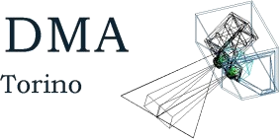
ORPMS Output Measurements
- Right rail profile coordinates
- Left rail profile coordinates
- Gauge calculation
- Curvature
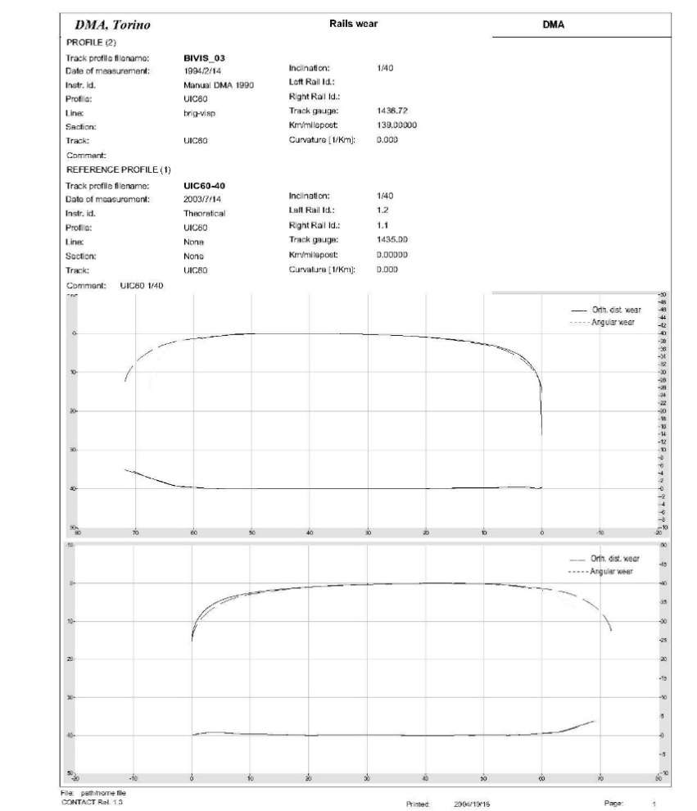

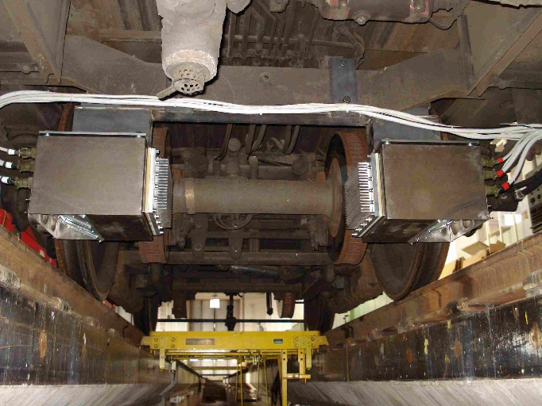

Main Advantages/Benefit for the User
The instrument design is very modular. Different versions exist to meet a wide range of requirements. The parameters to be specified to choose the right version are the following:
ORPMS Technical Features
ORPMS
Optical Rail Profile Measurement System
DMA Accurate & Reliable for railway Monitoring
- Maximum number of points (512 camera lines analyzed; average 250-300 good points, depending on the lenses): at 180 Km/h: 1 profile every 1 m; at 300 Km/h 1 profile every 2 m.
- At reduced number of points (256 camera lines analyzed; average 120-160 good points, depending on the lenses): 300 Km/h 1 profile every 1 m.
- Post processing including linearization and filtering.
- Accuracy up to +/- 0.05 mm
- Average number of points measured on the profile up to 300 depending on measurement speed
- Real time acquisition of the profiles and gauge with an accuracy good enough to compute the equivalent conicity according to the UIC519
- Real time computing of the equivalent conicity according to the UIC519 every 50-100 m, depending upon the train speed
- Compute the equivalent conicity according to the UIC519 for intervals down to 0.5 m, in post processing
- Degree of protection: IP63
- Accuracy (specified as sigma of the error of the estimated position of the point on the profile: +/-0.2 to +/-0.05 mm)
- Measurement range (rail displacement around the center position)
- Temperature range
- Data output (Profile only, Vertical and horizontal alignment only, Both)

