Back
Pistol Labs logo (spot UV, black on black)
Front
Shrimp graphic (maybe?)
Font: Open sans
Colours: Black, white, electric blue #00ADEF (only use small amounts of this colour, if at all)
Dummy details to use:
Michael Parry
Marketing Director
Drink order: G&T with cucumber

Level 3, 45 Bertie St
West Adelaide NSW 5000
0433 333 454
03 9663 5999
mparry@pistollabs.com
@mparry78
facebook.com/PistolLabs

Inspiration Images
Below are 8 images of cards that we like, you can use these to form ideas.
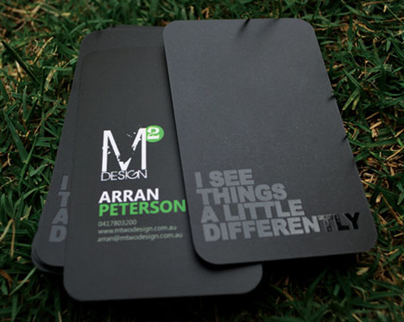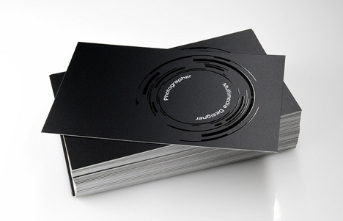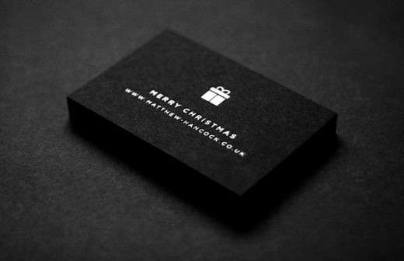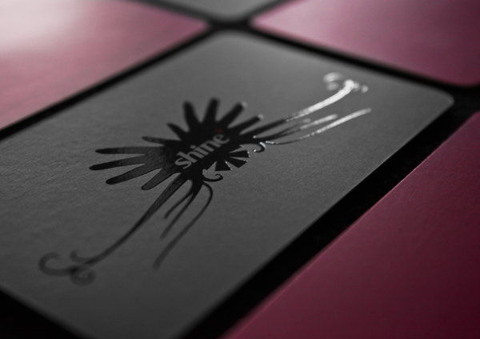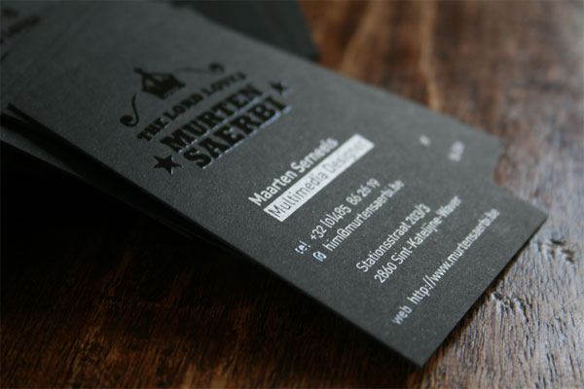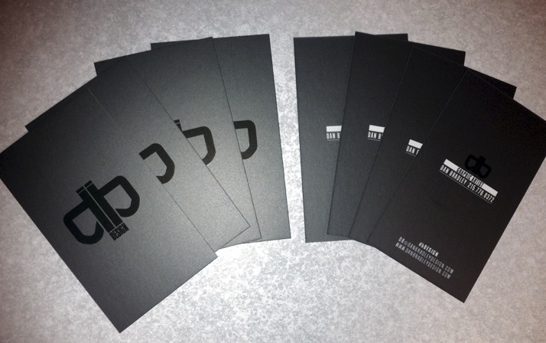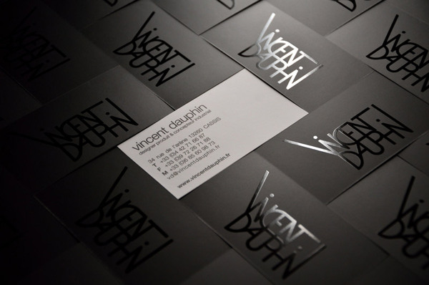
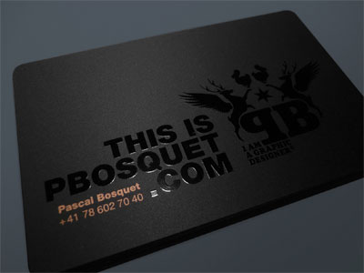
Inspiration Images (version 2)
