

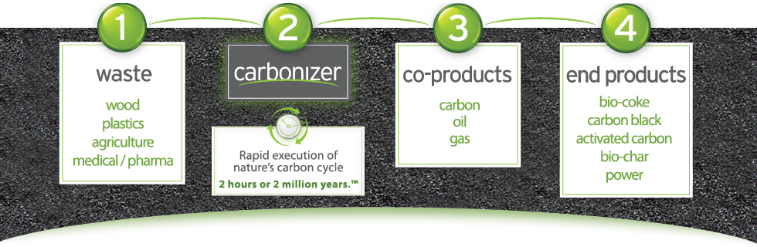

Raving Fans
Cleanest people in waste
Crisp
Bulletproof reliability
Passion for cost and production efficiency
W³
Outstanding people
Speak the truth
Cash flow
Keep things simple
Irresistible offers
Value added marketing
Serve others
Turning problems into profits
You get what you focus on
Strength based
Powerful alliances
Play to win vs. Play to participate
Protecting the environment
Give back
Direct communication
Courage
Resourcefulness
Relentless passion
Care, connect and communicate
Be real
Insanely persistent yet flexible in approach
Model after people far greater

