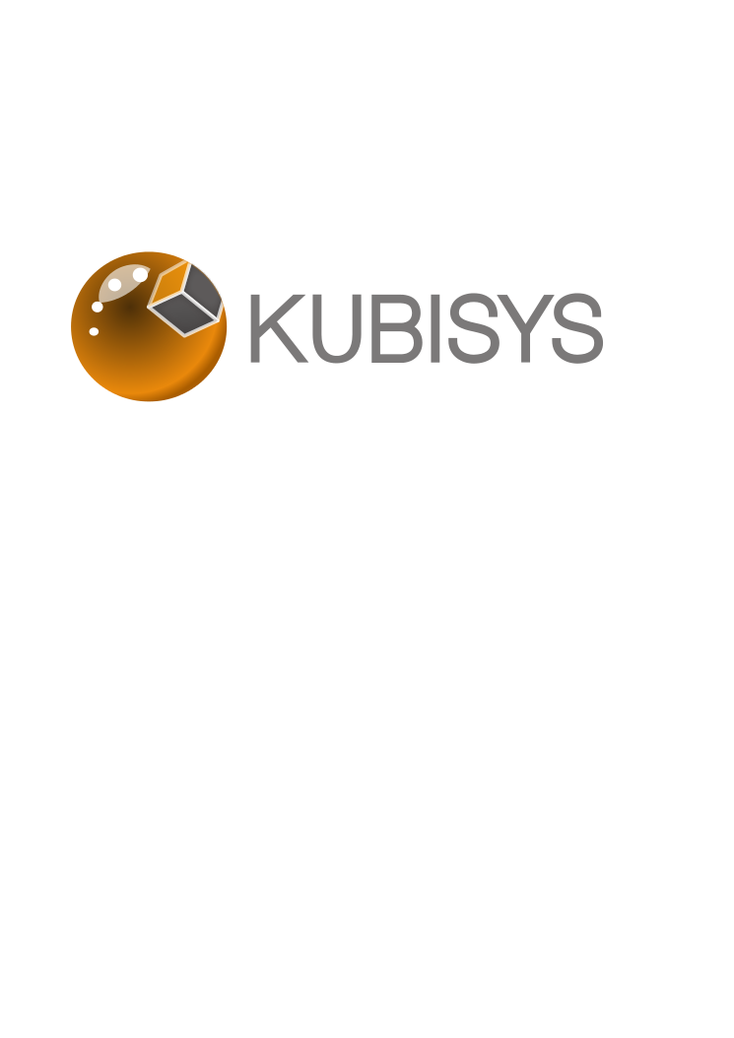
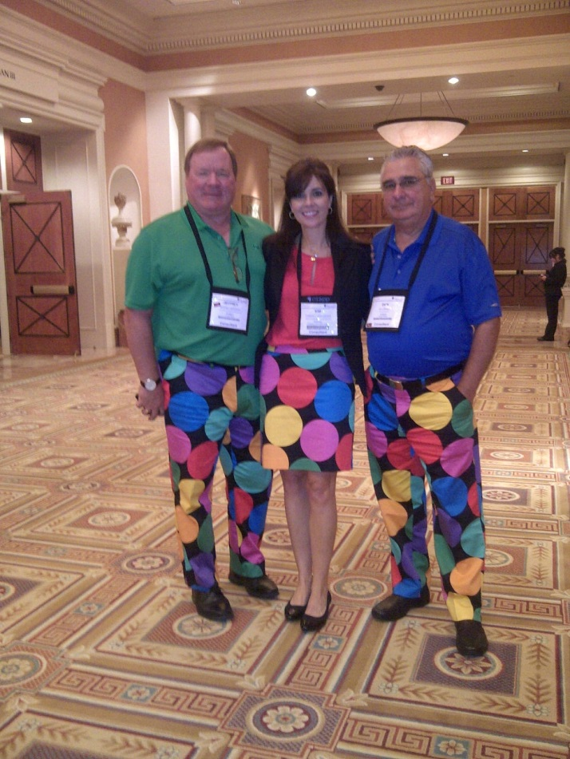

Did you have the chance to meet with us at the ILTA Catalyst in Vegas?

If the answer is no, then you’re in luck!
Team Kubisys stands ready to introduce our award-winning Thin Capture solution to your organization.
Imagine for a moment… accurate and complete test environments that can be created in minutes so you can test against production.
Developing and maintaining accurate test and staging environments is a costly and technical challenge.

SharePoint continues to be a challenging application to provision dev sandboxes, testing/QA and staging environments for.

Safe software deployments such as changes and upgrades are important but rarely implemented.
KUBISYS THIN CAPTURE CAN BE YOUR 2014 SOLUTION
2014 budget planning is upon us. The Kubisys team can work with you to identify your business case and help document the ROI and expected productivity gains.
To schedule an introductory Kubisys Thin Capture presentation and learn more about our proof of concept trials, contact Kim@kubisys.com, or sign up at Kubisys.com/get-a-demo/

