E-Liquid
E-liquid is made up of 3 or 4 primary ingredients: Water, Propylene Glycol (or Glycerin) Nicotine (or no Nicotine), and flavoring. It comes in a wide range of flavors, sizes, & strengths. If you wish to get off nicotine all together there are a number of effective methods. The liquid ranges from 0-24 mg of nicotine. E-liquid does not contain any carcinogens and nicotine is not linked to cancer.
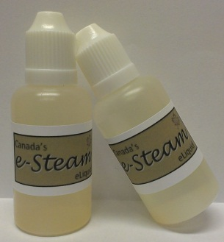

Cost
A complete switch to electronic cigarettes from smoking half to a full pack a day can result in a starter kit paying for itself in as little as 7 to 20 days.
Full Complete Kits start at $59.99

Try vaping for 2 weeks, if you’re not satisfied; return your purchase for a full refund. (Original receipt required)

e-Steam™ is an authorize Joyetech Distributor and all products are manufactured by ISO Audited manufacturers.
e-Steam™ is a registered trademark of VenLyn Group
We encourage the reproduction of this brochure in its entirety.

e-Steam™ Locations

OTTAWA EAST – e-Steam Gloucester
Gloucester Shopping Center
1980 Ogilvie Rd (In Front of CIBC Bank)
Gloucester, ON, K1J 9L3
613-983-8273

OTTAWA EAST – e-Steam Orleans
Opening Nov 1^{st,} 2013
Orleans
3022 St. Joseph Blvd (Across from Place D’Orleans)
Ottawa, ON
K1E 1E2

OTTAWA WEST e-Steam Kanata
Hazeldean Mall
300 Eagleson Rd (In Front of the Source)
Kanata, ON, K2M 1C9
613-854-8273

OTTAWA SOUTH WEST - e-Steam Merivale
Merivale Mall
1642 Merivale Rd (In front of Carleton Cards)
Ottawa, ON, K2G 4A1
613-727-8273

OTTAWA CENTRAL - e-Steam Ottawa
Varette Building
130 Albert St (Basement Level)
Ottawa, ON, K1P 5G4
613-567-8273

ARNPRIOR - e-Steam Arnprior
Arnprior Shopping Center
375 Daniel St S (Near TD Bank)
Arnprior, ON, K7S 3G8
613-622-1622

Pembroke - e-Steam Pembroke
Pembroke Mall
1100 Pembroke St East (In front of Coles Books)
Pembroke, ON, K8A 6Y7
613-732-1822

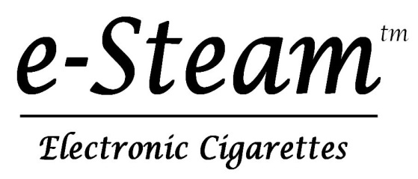

why quit?
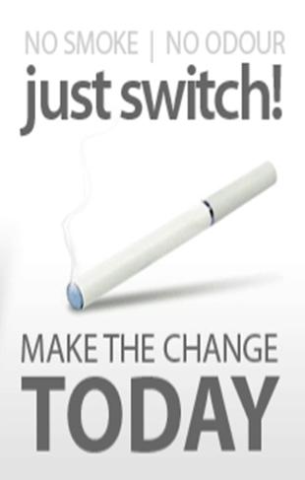

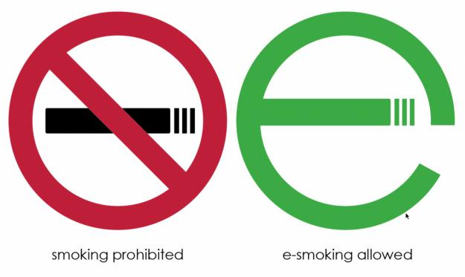
VISIT CANADA’S LARGEST RETAIL SOURCE FOR SMOKING ALTERNATIVES

www.esteamcanada.com

www.facebook.com/eSteamCanada
WHAT ARE ELECTRONIC CIGARETTES?

How smoking works
Smoking creates a reaction of instant satisfaction that makes people feel good, even mildly euphoric. While there are 4000+ unwanted chemicals, including cyanide and benzene, one - nicotine, produces all the good feelings that draw people back for another cigarette. As the tobacco burns, the smoke produced contains small amounts of nicotine which is rapidly absorbed into the bloodstream. It is the slow burning of organic materials that give off tar which sticks to your lungs and slowly releases cancer causing carcinogens.

How steaming works
By switching from combustion to steaming you eliminate the tar. When you inhale steam from your e-cigarette, nicotine (if used) is released in the same manner as it was with smoke. Instead of using smoke as the delivery method, water vapour is used. This means a vast majority of toxic chemicals from smoke have been removed. You get a similar sensation as many physical aspects of smoking remain. E-cigarettes provide a viable and satisfying alternative to traditional smoking.

Electronic Cigarettes (or E-Cigs) perform similarly to traditional smoking yet look, feel and taste similar to real cigarettes by delivering all the pleasures of smoking, without all the problems. This technology has been successfully designed to mimic the feeling and the look of traditional cigarettes.

The secret to what makes the E-Cigarette better than traditional smoking is a revolutionary modern microelectronic technology. The E-Cigarette is an integrated structure made up of a cartridge, an atomization chamber, a smart chip controller and a built in lithium battery. On the device is a mode indicator that lights up when you use it, a bit like a real cigarette. The most interesting part of the E-Cigarette is the atomization chamber. This part of the device is responsible for creating the steam which looks like smoke, very much like a real cigarette.

The steam exhaled is 98% water and looks very similar to smoke yet dissipates within seconds and leaves only a slight sweet scent.

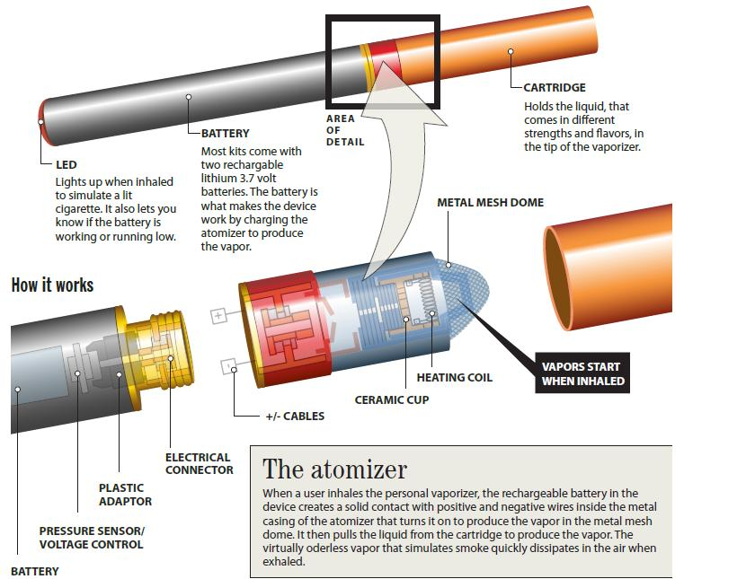

This holds the liquid, which comes in different strengths and flavours in the tip of the atomizer.
Most kits come with two rechargeable lithium 3.7 volt batteries. The battery is what makes the device work by charging the atomizer to produce the steam.
Lights up when inhaled to simulate a lit cigarette and also lets you know if the battery is working or running low.

Steam Created when exhaled

The Atomizer
When a user inhales the personal steamer, the rechargeable battery in the device creates a solid contact with positive and negative wires inside the metal casing of the atomizer which turns it on to produce the steam in the metal mesh dome. It then pulls the liquid from the cartridge to produce steam. The virtually odourless steam, which simulates smoke, quickly dissipates when exhaled.
PLEASE NOTE
Electronic Cigarettes are not meant as a quit smoking product, but rather an alternative to smoking tobacco. An e-cigarette does not treat, cure or diagnose any disease or condition. This is a device that may look like a cigarette and mimics tobacco smoking using steam.

