Have you tried Rely®?

Find out why ActivStyle customers
choose Rely® more than any other brand.

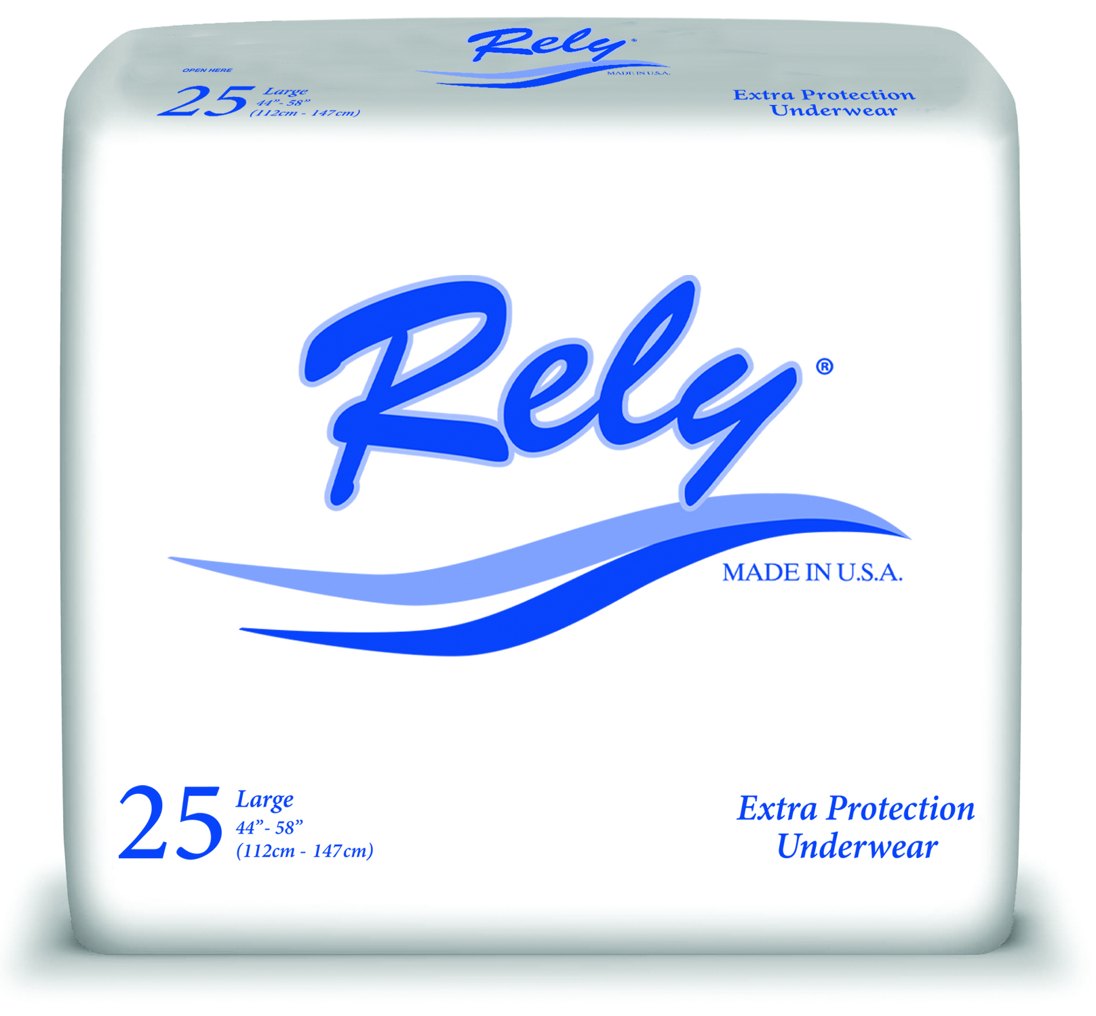

Rely® Bladder Control Pads

Rely® Breathable Briefs

Rely® Extra Protection Underwear

Rely® Maximum Protection Underwear
with Leak Guards

Call ActivStyle today for a free sample.
