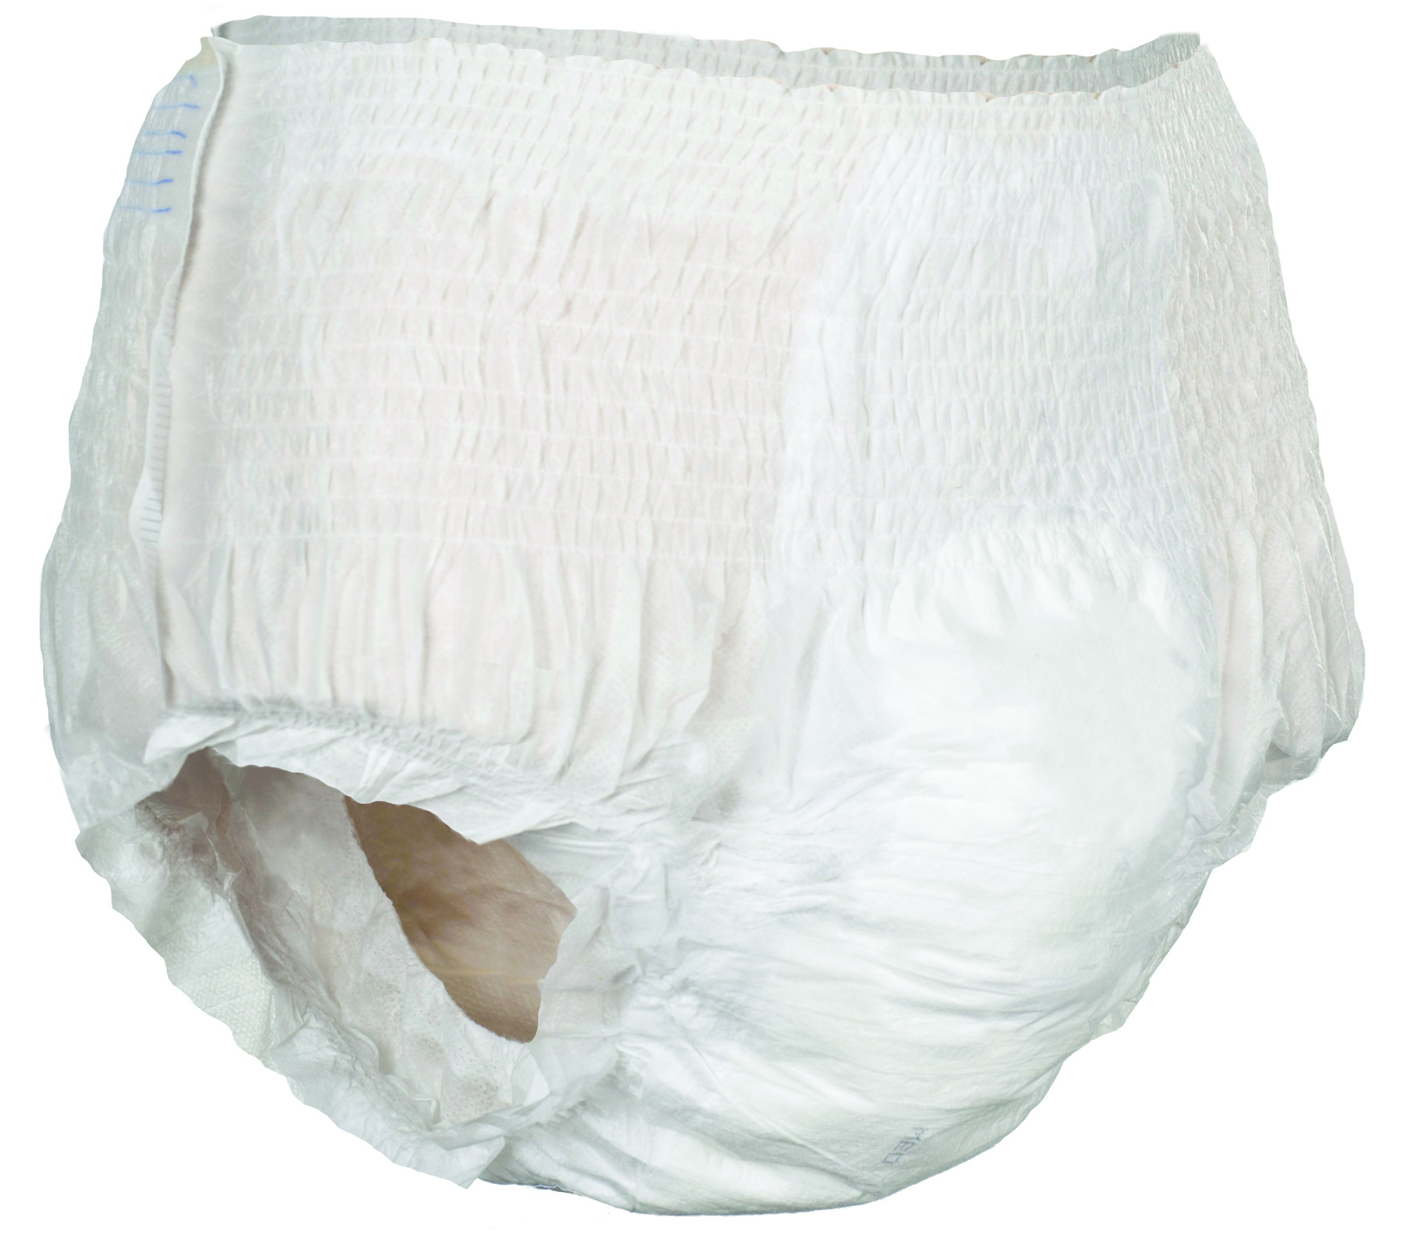

Soft, cloth-like cover

Color stitching indicates back of product

Tear away sides for easy removal

Stretchy waist/belly panels provide comfortable and discreet fit

Acquisition layer and super absorbent polymer channel and lock wetness away in core for skin dryness and odor prevention

Protection Underwear
Easy pull-on and pull-off design like regular underwear
Product Size | Hip Size | Item #
Small | 20” – 32” | RLY-B100
Medium | 32” – 44” | RLY-B110
Large | 44” – 58” | RLY-B120
X-Large | 58” – 63” | RLY-B130
Bladder Control Pads

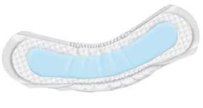
 | Size | Item
Rely® Ultra Plus | 12.5” x 3” | RLY R126PDUP
Rely® Extra Plus | 10.5” x 2.5” | RLY R144PXP
Rely® Extra | 9.5” x 2.5” | RLY R180PX

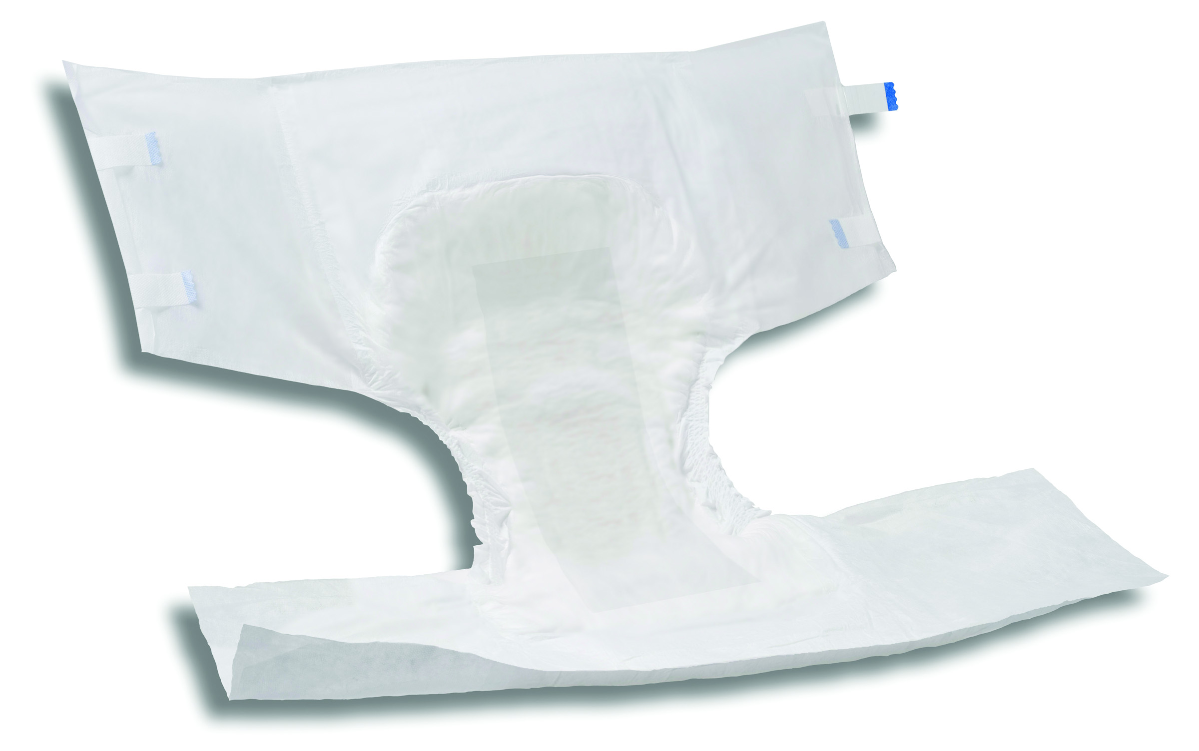

Breathable Briefs
Provides maximum leakage protection and wearer comfort.

Air-comfort breathable side panels for healthy skin

Soft and flexible fastening tabs adhere anywhere for precise fit

Cloth-like product is soft and quiet for discreet wear

Acquisition layer and super absorbent polymer, channel and lock wetness away in core preventing odor

Wetness indicator to assist with product changing

Product Size | Hip Size: | Item #
Medium | 34” – 44” | RLY-PUW110
Large | 44” – 58” | RLY-PUW120
X-Large | 58” – 68” | RLY-PUW130

Product Size | Hip Size: | Item #
Medium | 34” – 44” | RLY-PUW210
Large | 44” – 58” | RLY-PUW220
X-Large | 58” – 68” | RLY-PUW230

Moderate Absorbency
Less bulky, more discreet under clothing

Maximum Absorbency
Inner leak guard leg cuffs for the ultimate defense against leakage

Maximum Protection Underwear with Leak Guards

Extra Protection Underwear

