The web pages are divided up into different word pages below with the heading clearly shown. Anything in BLACK will be actual website content and anything in RED is just a helpful description for you or a weblink. The full size photos have been uploaded separately and are only used as a guide on this word doc.

Homepage

Commercial Hotel Dorrigo (very basic logo/heading)

Welcome to the Commercial Hotel in Dorrigo.
Enjoy the wonders of Dorrigo from only $70 per night.

Rooms from only $70 (this will be an icon/link to the booking page)

(these photos will be sliding banner/background. These full sized images have been uploaded attachments)
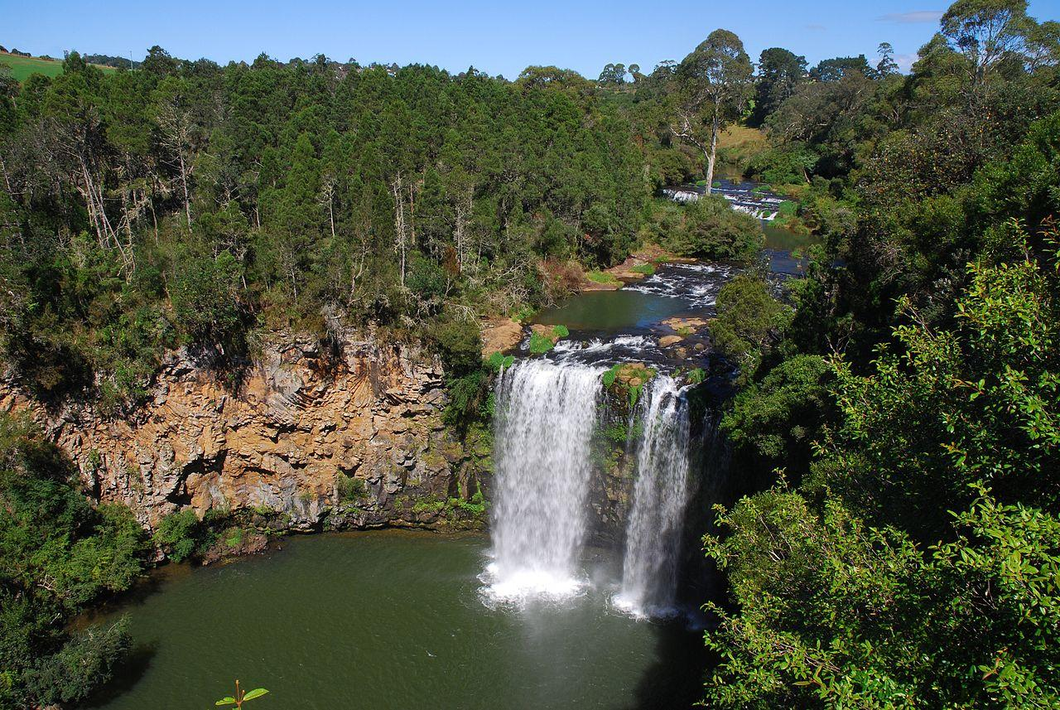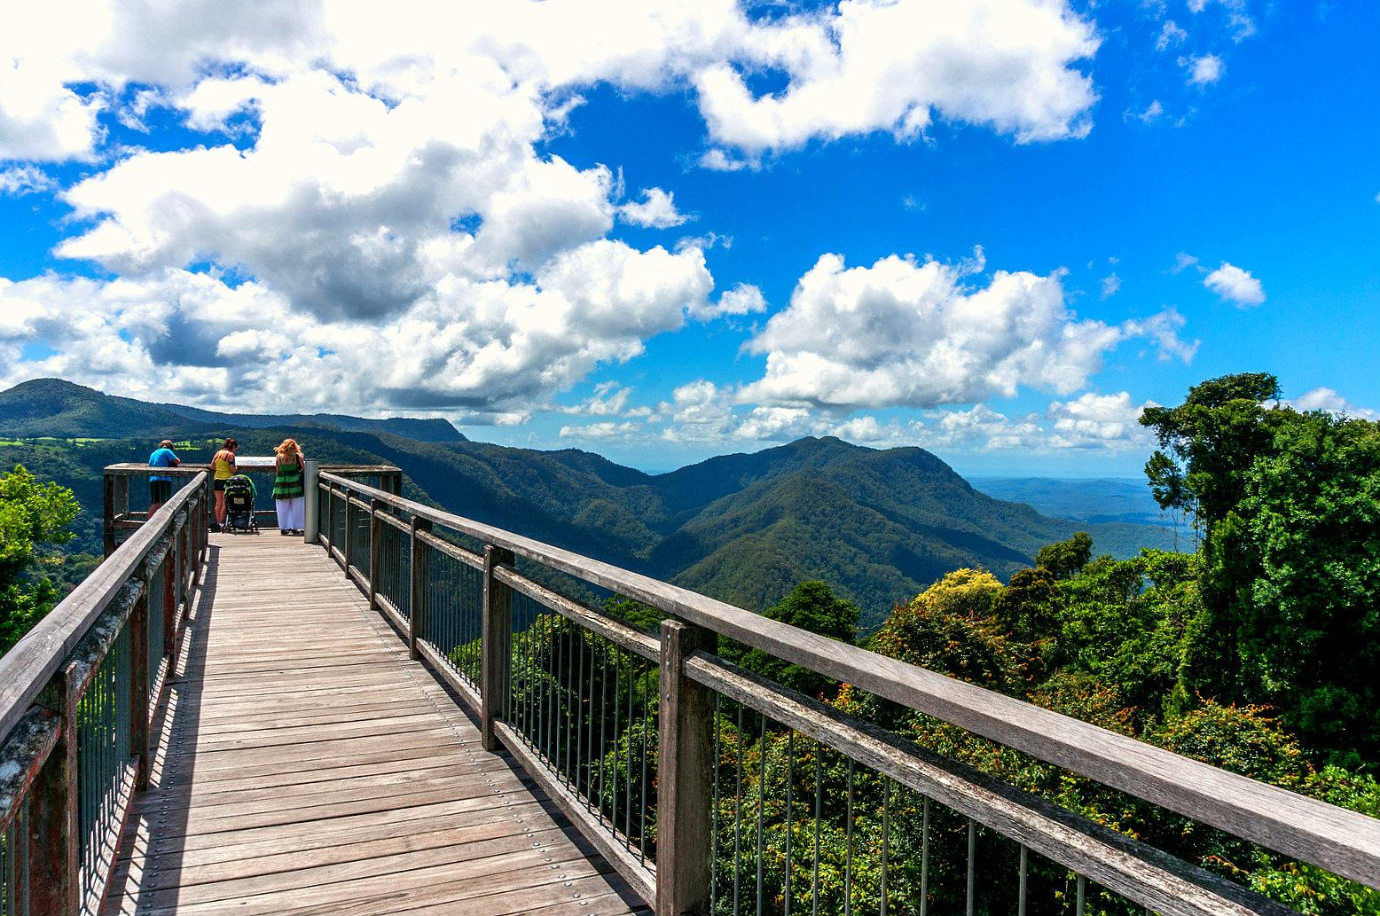
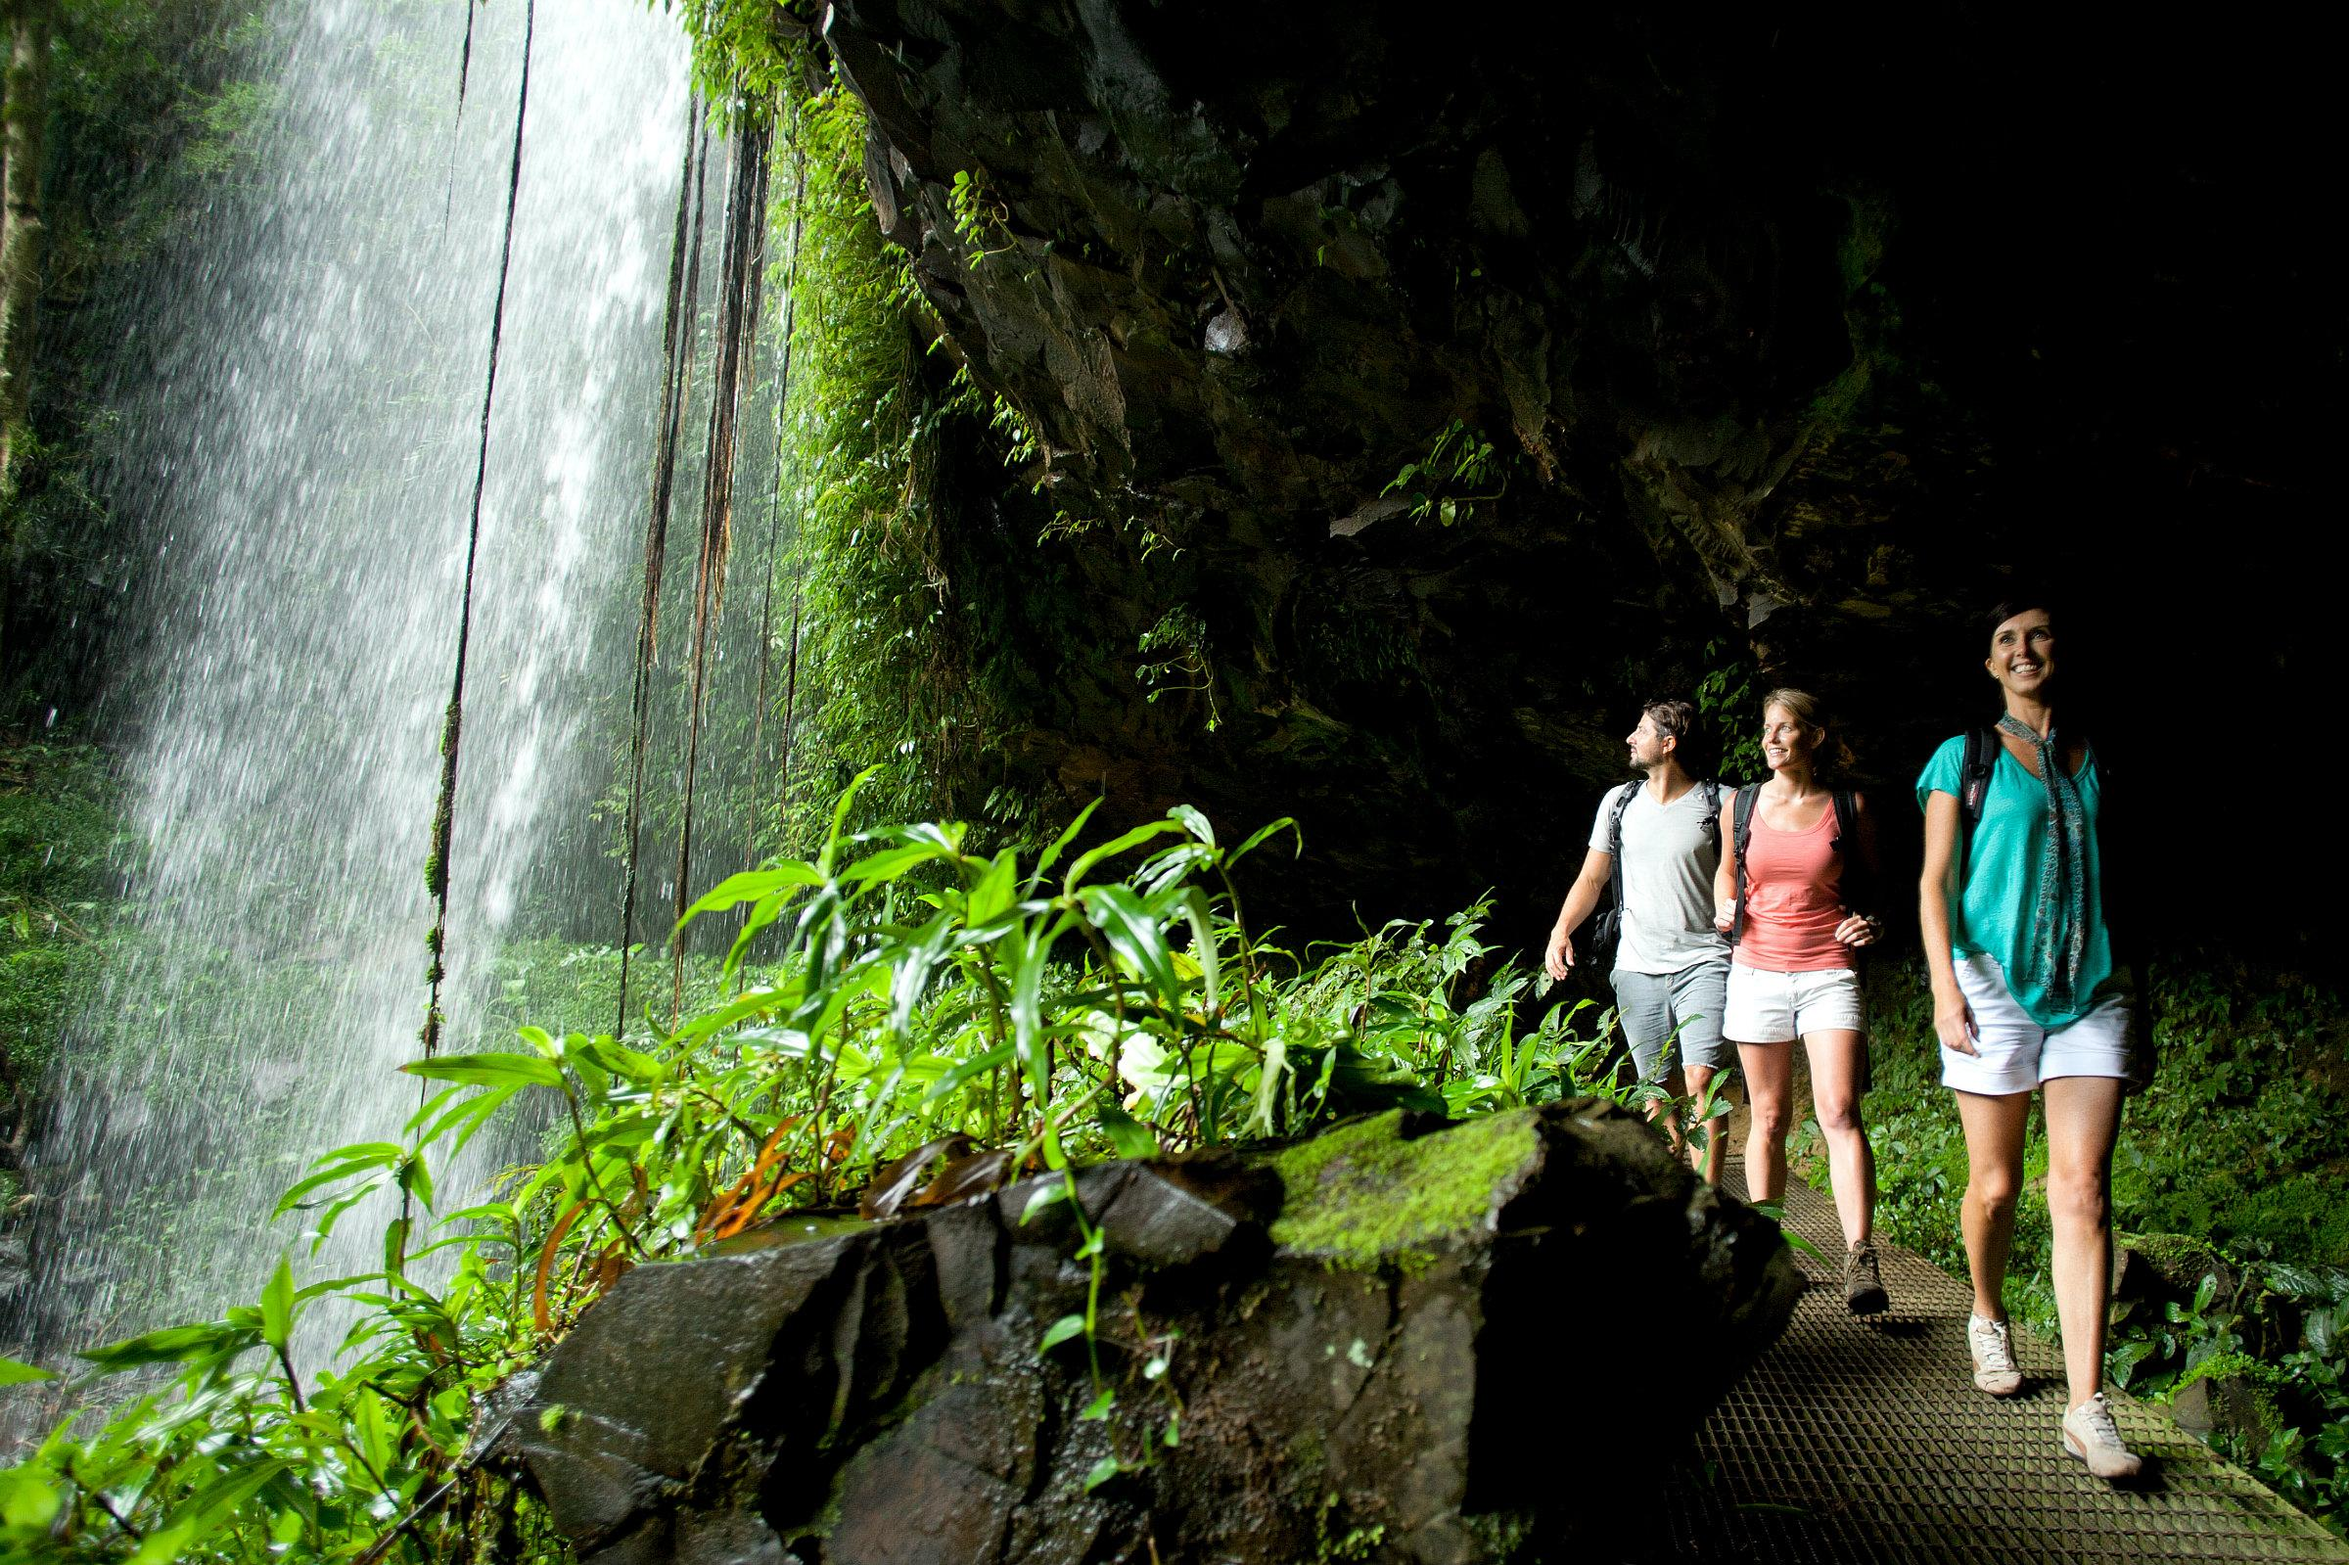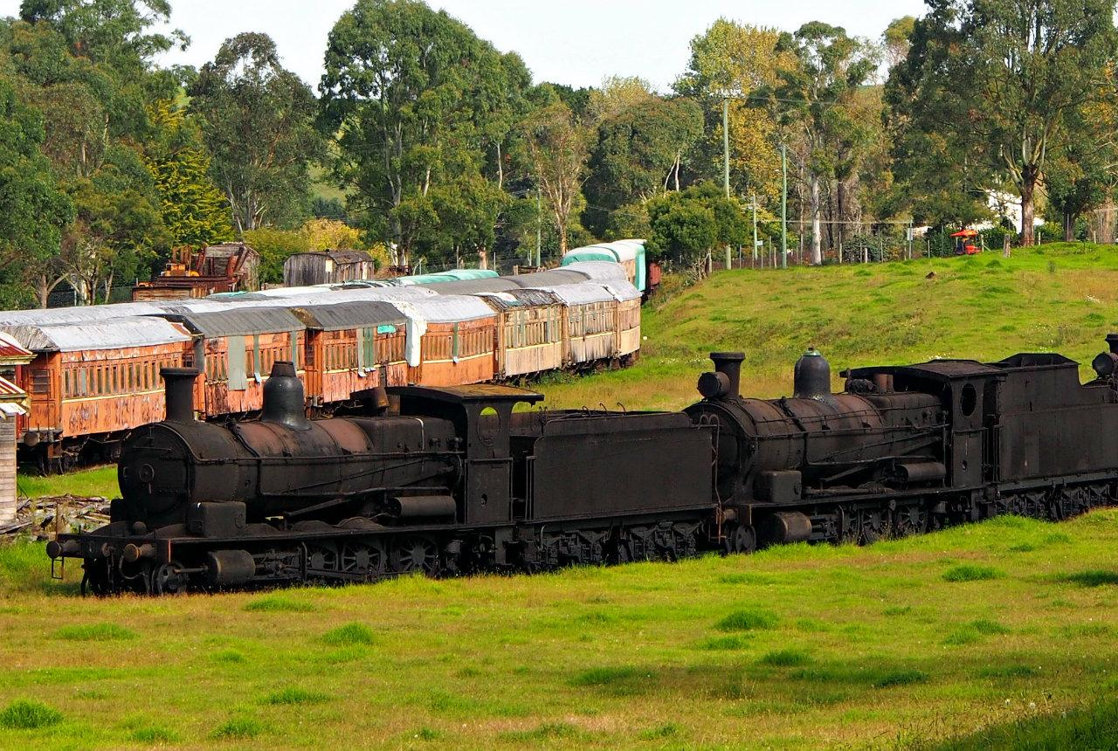

(these photos will be smaller and stationary on the homepage. These full sized images have been uploaded attachments)
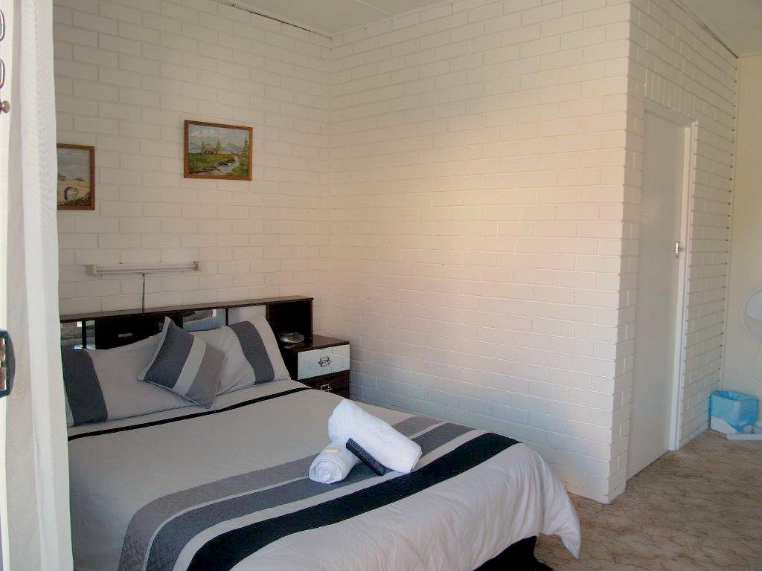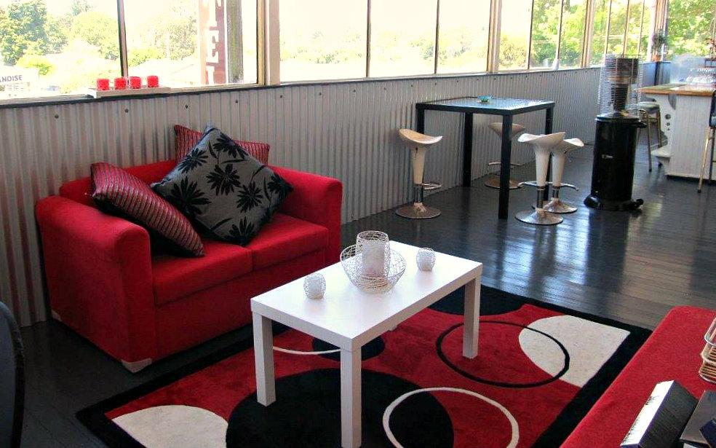

(this is the code for a small booking display)
<iframe src="https://secured.sirvoy.com/book.php?id=521d85de7ae6c&language=en&miniBox" width="300" height="400" frameborder="0"></iframe>

Accommodation & Rates

Room rates:

- 1-2 people - $70.00
- 3 people - $95.00
- Family 2+2 - $110.00

You can choose from our double and twin bedrooms. All of our rooms include:

- Ensuite bathroom
- TV
- Heater
- Internet on request
- Electric blankets
- Microwave,
- Toaster,
- Fridge,
- Tea & coffee making facilities,
- Suitcase rack

**Lunches can be made for workers who are staying through the week**

(these photos will be small and stationary on the accomodation page. These full sized images have been uploaded attachments)

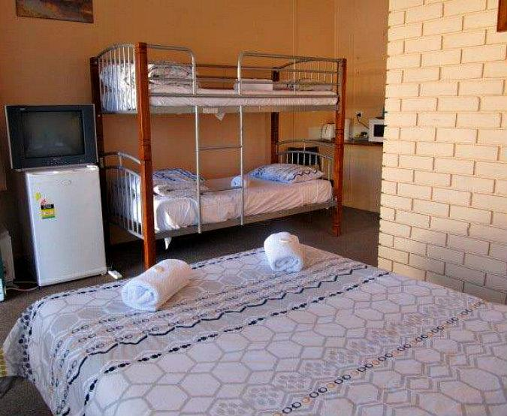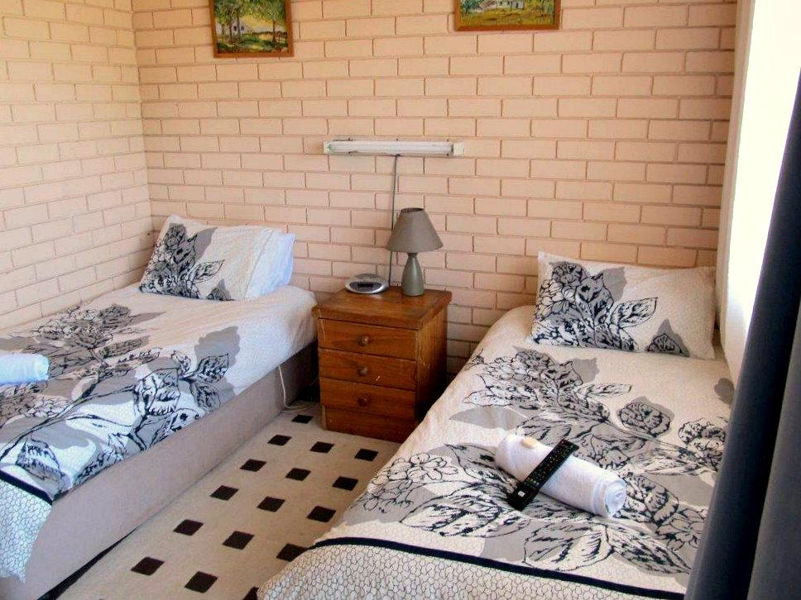

Facilities

Food
We have an extensive Chinese menu, with great $7 lunchtime specials (eat in or takeaway)
Australian meals are also available, including chargrilled steaks from $18.

Bar
One of the last great horseshoe bars with pool table and big screen TV for sports.
TAB & KENO are available. We also have a covered breakout area with uncovered seating for the sun lovers.

Our verandah dining area has views over a picturesque landscape.

(these photos will be small and stationary on the facilities page. These full sized images have been uploaded attachments)
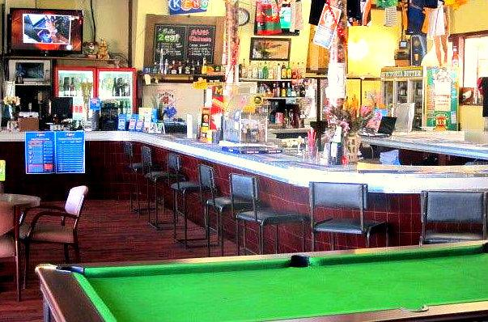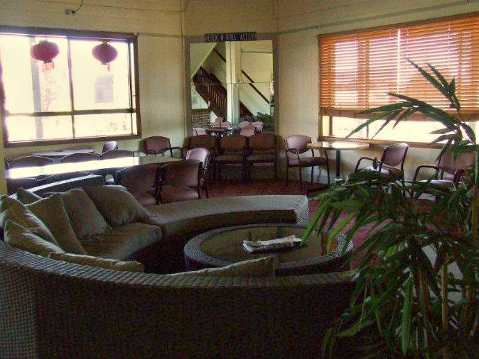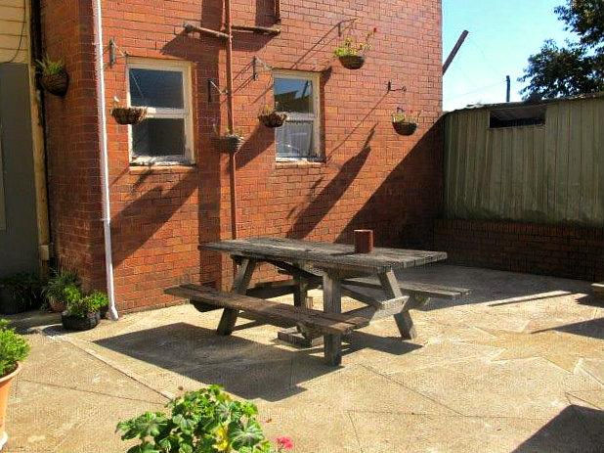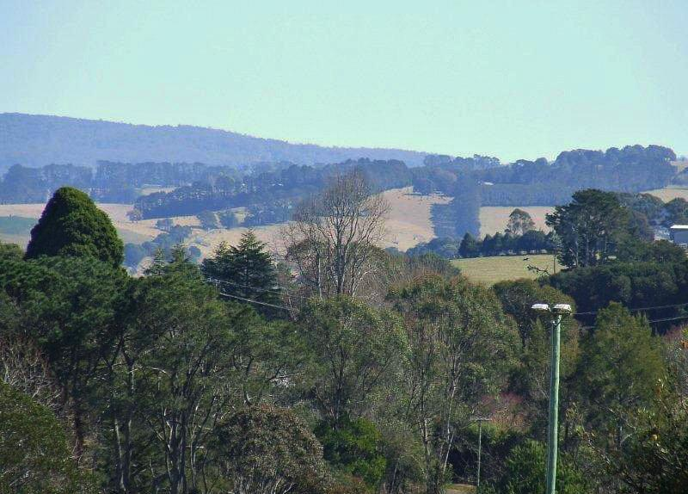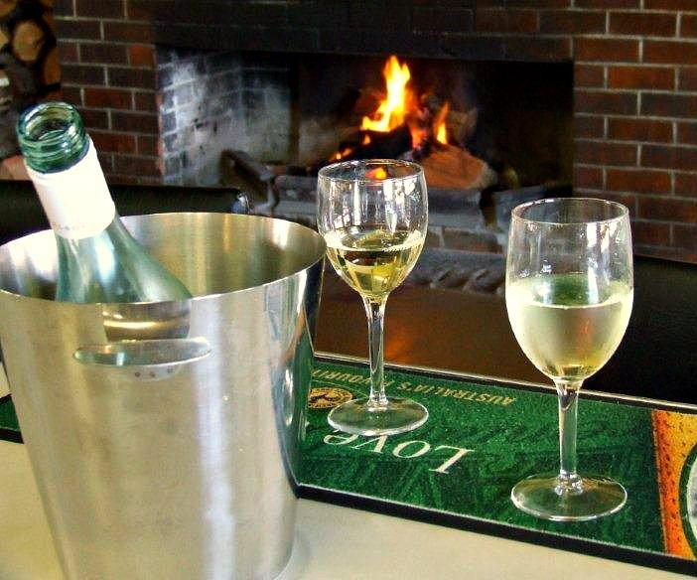

Attractions
Here are just some of many local attractions and activities:

- Dangar Falls (http://en.wikipedia.org/wiki/Dangar_Falls)
- Dorrigo Steam Railway and Museum (http://www.dsrm.org.au/)
- World Heritage Dorrigo National Park (http://www.nationalparks.nsw.gov.au/dorrigo-national-park)
- Golf (http://www.dorrigorslgolf.com.au/)
- Dorrigo Markets (http://www.dorrigo.com/community/culture-society/256-dorrigo-community-markets.html)
- Canoeing (http://www.canoeadventures.com.au/)
- White water rafting (http://www.adrenalin.com.au/white-water-rafting/nsw-north-coast/water/12621)
- 12 nearby National Parks (http://www.nationalparks.nsw.gov.au/)
- Local Art Galleries and Craft Shops (http://www.pinnata.com.au/)
- Tennis and bowls (http://www.sportscourts.com.au/dorrigo/tennis/don-dorrigo-tennis-club-inc/o2097)
- Skate board park (http://www.skateboard.com.au/v2/index.cfm?smithgrind=view&id=1994
- Community swimming pool (http://www.dorrigoswimcentre.websyte.com.au/)
- Go Go Karting at Raleigh International Raceway (http://www.raleighraceway.com.au/)
- Stream fishing
- 4 wheel driving

(these photos will be small and stationary on the accomodation page. These full sized images have been uploaded attachments)

Bookings
Phone 02 66572003
Address 6-10 Cudgery St, DORRIGO, NSW 2453
Email - commercialhoteldorrigo@hotmail.com

(here will have a booking form which can be accessed through a wordpress plugin from sirvoy hotel reservation, which can be downloaded from here….)

https://sirvoy.s3.amazonaws.com/wordpress_plugin/sirvoy-hotel-booking-engine.zip

Contact Us
Phone 02 66572003
Address 6-10 Cudgery St, DORRIGO, NSW 2453
Email - commercialhoteldorrigo@hotmail.com
ABN 55122404755

(Here there will be a google map window with our location)

