Dear Doctor,

Are you thinking about selling your dental practice?
Southeast Transitions is now expanding to the Midwest!
Welcome Ohio, Michigan and Indiana!

Who is SET?
To learn about the history of Southeast Transitions, we must first begin with the story of our founder. Bill Adams, DDS worked as a dentist for over 25 years before starting his own dental transition company. Before completely transitioning out of actively treating patients, Dr. Adams worked with two different partners and three associates. Dr. Adams also owned his own dental lab and transitioned its ownership over a period of five years. Thanks to years of practical experience, he understands firsthand the business of partnerships, associate relationships, and what it takes to make them successful. He also understands
the feeling that many dentists experience once their practice has sold.

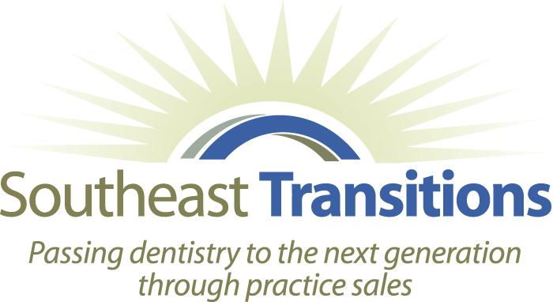
Dr. Adams decided to help other dentists with the dental practice transitions process. Since forming Southeast Transitions in 1998, Dr. Adams refined the methods for locating the right buyers who are qualified both clinically and financially to replace or work alongside the current dentist/owner; in fact, this has always been the top criteria for putting a transition together. A dental practice is a very unique business and is a direct reflection of the personality, methodology, and philosophy of the dentist. Personality and practice philosophy in particular play a very large role in brokering a successful transition of ownership that meets all parties’ expectations.

How is SET different from other dental brokers?
What sets our company apart from other dental practice transitions brokers is our dedication to matching the philosophies of both the seller and buyer. This allows the seller to feel confident that his or her clients will be taken care of, while ensuring the buyer takes over a practice that easily transfers because it is in line with his or her goals.
Many dental brokers treat all of their clients as though they are the same. However, Southeast Transitions understands each practice has its own unique characteristics—a fact that is reflected in the way we handle dental practice transitions and dental practices for sale. This is partly because our president and many of our brokers are dentists themselves!

Southeast Transitions is expanding to the Midwest with Regional Transition Advisor
Dr. Tammi Schaeferle:
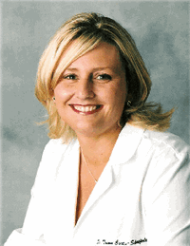

Tammi Schaeferle DDS MBA FAGD is the CEO of Dentakeeping, LLC a professional bookkeeping company for dental offices and co-owner of three Ohio dental offices. Dr. Schaeferle has over 16 years’ experience managing multiple dental offices. She personally has been through 8 transitions of buying and selling dental offices. Dr. Schaeferle is highly experienced with insurance audits, dental embezzlement, dental software reports, practice analyses and dental practice management (MBA).
Her company posts over $30 million dollars of insurance payments (eobs) for dental offices a year and they provide bookkeeping (accounts payable) for numerous dental offices. Dr. Schaeferle’s company also consults and assists new buyers with the transition of a new practice. Having a broker who is a DDS/MBA with such extensive knowledge not only on the clinical side of dentistry but with business component is what sets Southeastern Transitions apart from other brokerage firms.

Selling your practice is one of the most important professional decisions you will ever make. If you want it to be a great experience with people who understand not all dental practices are the same then contact Southeast Transitions for expert guidance during this exciting transition period.
Call us at 678-482-7305

4411 Suwanne Dam Rd., Suite 260
Suwanee, GA 30024
678-482-7305
www.southeasttransitions.com

