A unique offering to Business Owners

Why conduct A Divestment Readiness Assessment?

70% of owners of small and medium businesses will seek to exit their business over the next 10 years.

Approximately 80% of Australian businesses are owned by baby boomers, who tend to have most of their wealth locked in their business. As baby boomers enter their 60s and 70s over the coming decade most will need to exit their businesses to unlock funds for retirement.

As a result, more than two-thirds of all Australian SMEs will seek to exit within a single decade, flooding the market with businesses for sale – creating what is being referred to as the “Baby Boomer Tsunami”.

With so many businesses for sale on the market, many owners will be unable to exit - or sell for fair value, leaving them with significantly reduced funds for retirement.

To unlock the maximum value within what is in most cases, their largest asset, owners must ensure their businesses are exceptionally well prepared and ready for sale. Given that 75% of business owners have no exit strategy, Australian private companies will need to act to avert a crisis.

What is A Divestment Readiness Assessment?

The Divestment Readiness Assessment (DRA) provides an independent assessment of the readiness of a business for sale and where appropriate, identifies the specific initiatives that would optimise the sale outcome for the business owner.

The DRA is conducted by consulting professionals and is supported by M&A Specialists. It provides the business owner with the following:
- The overall preparedness of their business for sale in the short-term. This considers 2 dimensions:  - The relative ease with which the business can be sold based on its current structure in the current market, and  - The relative financial performance of the business compared with its potential. | 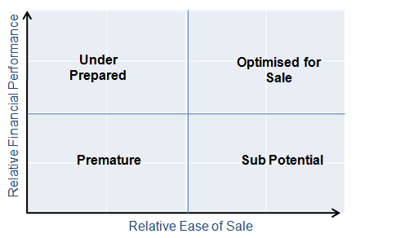
- An appraisal that provides the assessed value range of the business in its current state if presented to market in the short-term. The appraisal considers the attractiveness of the business to a variety of buyers such as financial investors and industry acquirers.
- The high priority initiatives that would make the business more saleable and/or substantially improve the anticipated sale price of the business.  The Divestment Readiness Assessment is focused on identifying those initiatives that will substantially enhance the sale outcome for the owner – as opposed to general business improvement. | 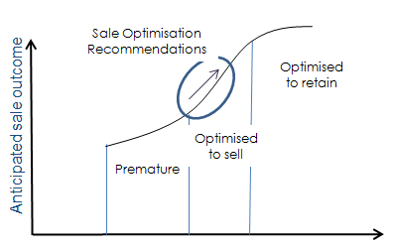
- An example of their business’ investment highlights as would be presented to the market if they wish to progress to a sale.

Additionally, if the client has an interest in understanding more of the process that would be applied to sell their business, the consultant will facilitate a session with an M&A Specialist which will include:
- An overview of the sale process
- Indicative target acquirers for the client’s business
- Marketing approach and channels that are applicable to the client’s business
- Responses to frequently asked questions such as “how does the M&A Specialist maintain the confidentiality of a business during the sale process?”

Benefits to the Client

The Divestment Readiness Assessment is intended to be an ideal interim phase for any client that wishes to assess and/or optimise their business for sale – whether or not they intend to sell in the short-term.

The Divestment Readiness Assessment is a consulting engagement designed to provide a client with independent advice regarding their exit options and the readiness of their business for sale. At no stage during the Divestment Readiness Assessment is there an expectation that a client will proceed to a sale.

The Divestment Readiness Assessment is designed to deliver the following benefits to a client:
- Provide independent advice that is in the best interests of the client
- Greatly assist the client to decide whether they should proceed with a sale in the short-term
- Identify specific actions that are expected to substantially improve the client’s sale outcome
- Enable the client to understand the likely value they will achieve at exit
- Provide the client with an understanding of the sale process
- Serve as a “stepping-stone” for client who wish to consider selling in the future
- Capture key information that would “kick-start” the client’s Information Memorandum and disclosure documentation should the client wish to proceed to sale

Divestment Readiness Assessment Process

Unlike generalist consulting reviews, the Divestment Readiness Assessment is a specialist activity focused on assessing and optimising the potential business sale outcome

The Divestment Readiness Assessment is conducted as follows:
- Introduction: the consultant provides an overview of the DRA process and outlines key information that is required to support the Review
- Onsite review: the consultant will meet the client and tour the client’s business if applicable. The consultant will work through the review with the client (typically half a day to a full day)
- Analysis: the consultant will work with the M&A Specialist to analyse the information, assess the readiness of the business for sale and to complete the current market value range of the business.
- Sale Optimisation Recommendations: the consultant will work with the M&A Specialist to determine whether there are any high priority initiatives that would likely substantially improve the sale outcome for the client.
- Presentation of outcomes: the consultant will then meet with the client to present the outcomes of the Divestment Readiness Assessment. The consultant will provide the client with the complete Divestment Readiness Report at that meeting and will schedule a follow-up meeting. The presentation will typically take 2 hours.
- Follow-up: typically within 2 -4 weeks of presenting the Divestment Readiness Report, the consultant will meet with the client to answer any specific questions and to discuss next steps (if applicable).
- Optional session with the M&A Specialist: should the client wish to learn more of the M&A process, the consultant will facilitate a session with the M&A Specialist to provide an overview of the sales process and to respond to any questions the client may have.
- Optional implementation support: should the client have an interest in gaining assistance to implement some or all of the recommendations, the consultant will develop a proposal tailored to the client’s needs.

High Quality Process

The Divestment Readiness Assessment draws on over 26 years of business sale expertise

The Divestment Readiness Assessment is designed to provide a client with highly qualified, independent advice that is in the best interests of the client:
- The Divestment Readiness Assessment is conducted by an experienced professional that is well informed in the M&A process for small to medium businesses  - The consultant’s analysis is reviewed and endorsed by the M&A Specialist  - The Divestment Readiness Assessment is based on the established “5 Pillars” framework which considers the key assessment criteria of buyers that are common across various industries | 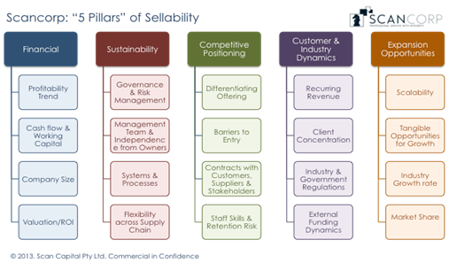
- Preservation of the client’s confidentiality during the process is of paramount importance to the consultant. The Divestment Readiness Assessment includes appropriate measures to support the client’s confidentiality. For example, the consultant will allocate a unique reference identifier to the client so the identity of the client is not revealed to the M&A Specialist, nor is it disclosed on any documentation developed by the consultant.

