‘Supercharged for Singletrack’ engine t shirt concept:


FOR
TRACK
SINGLE

SUPERCHARGED

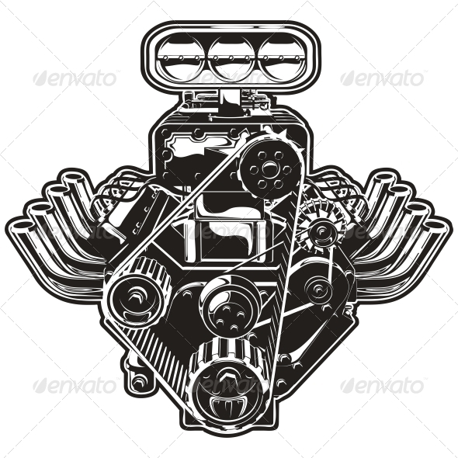
Haven’t got the right software to make the engine image above the text something better, like the image below:

