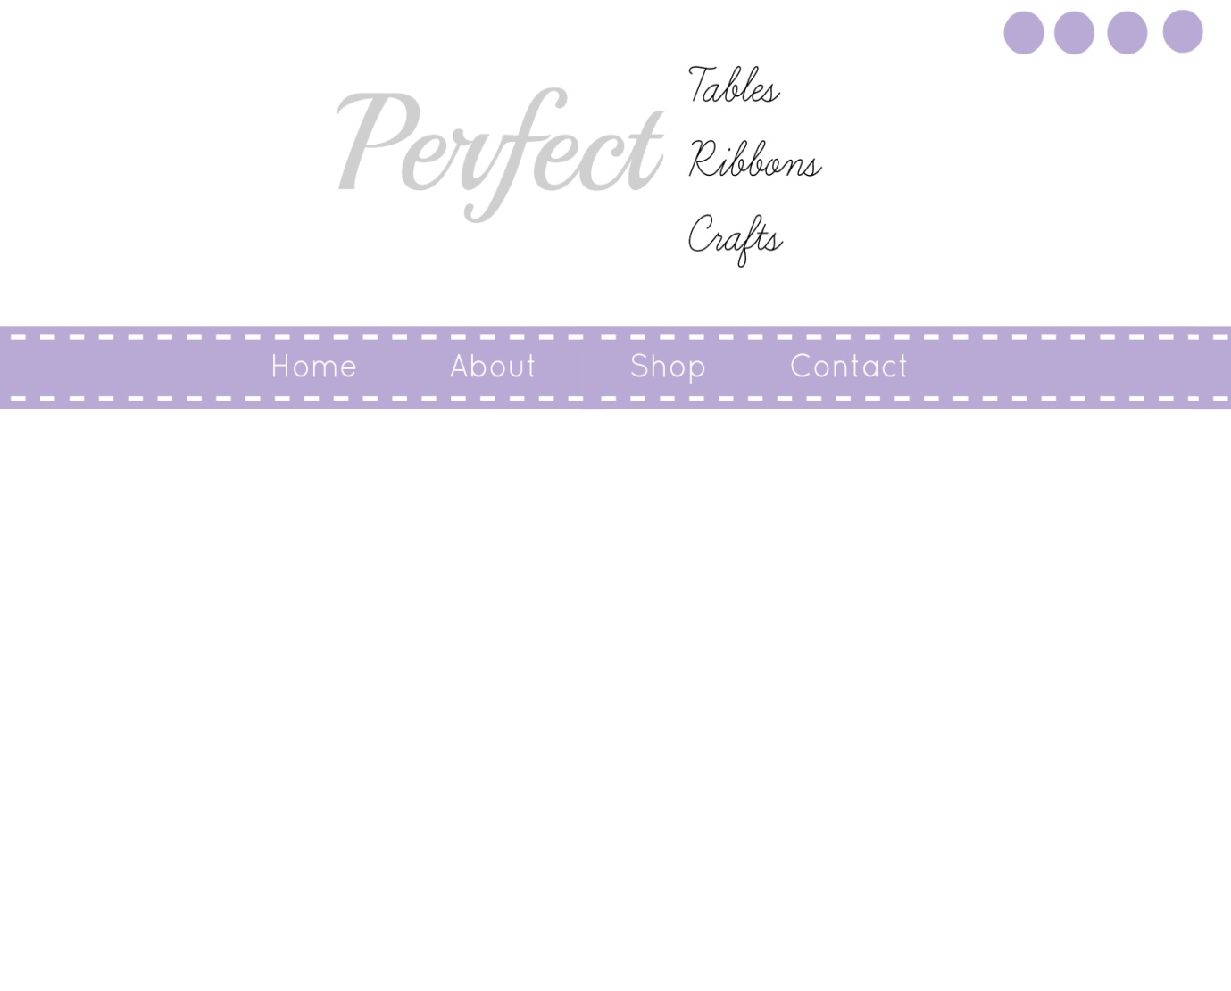Quite like above simple logo but font not quite right love the colour of the navigation bar
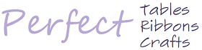
Love above colours
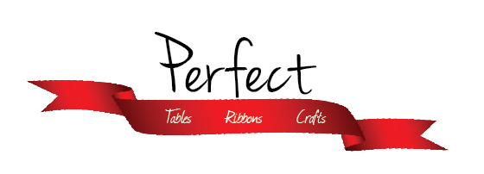
Quite like font on Perfect idea to have rest in ribbon but ribbon wrong colour
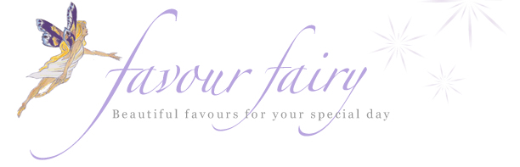
Like the sparkle in this logo

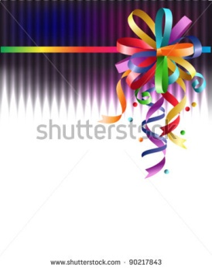
Perhaps adding some sort of bow into the logo like the idea of this bow showing a range of colours but not sure if a simple ribbon bow would be more sophisticated

http://sewingmakingbaking.com/
like colours writing on logo

