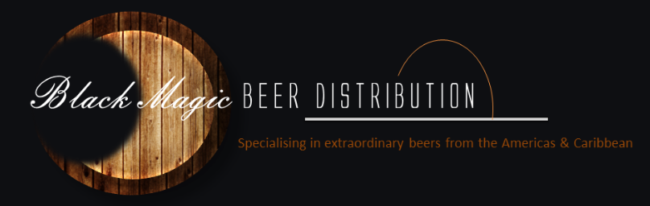
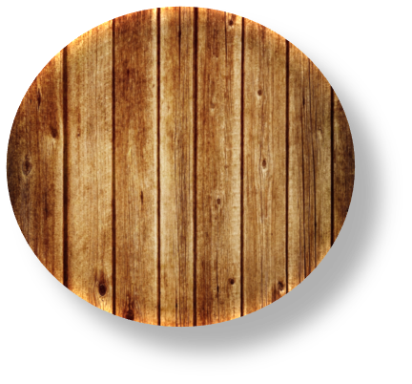
MEXICO
MEXICO
MEXICO
MEXICO
Golden, very low carbonation, pale larger with a whole chilli in the bottle. Brewed for 18 years in the USA before moving to Mexico. For those that like a ‘bite’. Lime is strictly forbidden with this beer.

This brew is bright, deep golden yellow in colour with the aroma of sweet malt, lightly floral and hoppy. The flavour of Mexicali Original reflects its hop bitterness; slightly sweet and just a perfect balance of two row barley malt, Chinook, Mt Hood and peerless hops that culminate to a very clean and semi-dry finish.
Mexicali Dark offers a colour that is bright, clear and dark brown. The aroma is lightly sweet, pleasant toasted malt with a slight coffee background and the flavour is a wonderful balance of roasted malt with a bit of sweetness, nice bitterness from the hops. This medium bodied dark beer has great carbonation and finishes with strength and a great after taste.
A specialty craft brew. Bright and deep red copper in colour, this ale is very aromatic, intensely floral hoppy, lightly sweet and malty. Red Pig Ale is full-bodied offering a very pleasant high bitterness, with smooth sweet malt character, creamy head with good carbonation.

Costa
Rica
MEXICO
MEXICO
MEXICO
MEXICO
Barrilito is a lager beer made with high quality ingredients. Because of its transparent and bright gold colour, good body, clean aroma and refreshing flavour, it is an excellent pilsner beer. Barrilito is Grupo Modelo's fourth most popular brand in Mexico.
A smooth preimum tasting, thirst quenching Central American style beer.
An outstanding rich, complex preimum dark beer .
A superb lager that has been around for over 80 years. The Costa Ricans have made this the beer of choice. The brewery is situated on a natural spring water source resulting in a delicious tasting, perfectly balanced beer.
Tecate was the worlds first beer brand to encourage its drinkers to add a wedge of lime to a can of beer. The brewery introduced this innovation in 1950 and due to Tecate’s popularity in Mexico and the fact lime worked so well with the beer, it became the accepted way to serve all Mexican beers.
Pacifico is a Mexican Pilsner style beer. It was first brewed in 1900 when three Germans opened a brewery, the Cerveceria del Pacifico in Mazatlan. It is argued that is Mexicos most favorite beer.
Rio Bravo is an incredibly popular, well priced, mid strength beer. It pours a bright, light golden colour with great clarity. Plenty of malts on the nose, biscuits and light fruits. A good tantalising finish.
MEXICO
MEXICO
Corinita means ‘little corona’ in Spanish and that is literally what a Corinita is. A little corona.
MEXICO
MEXICO
MEXICO
Negra Modelo is one of the richest tasting, most robust beers in Mexico. A complex beer, redolent with caramel and chocolate flavors from the malt, the beer is perfectly balanced with a bit of spiciness and ruthless in the hop aspects of its flavor profile. The beer is brewed by the famous Grupo Modelo.
This beer is in its own category. 12% alcohol, 500ml can. Fiery yet cold. Uncanny yet bold. Strong yet smooth. Not for the faint of heart.

