Arboritec Commercial/UVElite Catalog (Larger than 8.5*11 so a pocket page can hold normal sized documents).
COVER: ARBORITEC LOGO
Title: COMMERCIAL FLOORING FINISHES
Cover Image: Image Representing Commercial Flooring Space (Something like a glass highrise, or large commercial space showing lots of foot traffic/activity for example. We would like the image to extend across the cover and back of the catalog.)

PAGE 2: Arboritec Story and Positioning
- Welcome to Arboritec. Let’s Cure Flooring.
  - Our goal is simple: to reinvent the way commercial floors are finished and refinished. Our success stems from close colaboration with our partners and customers. We understand your need to create the safest and most beautiful space for your employees and customers as efficiently as possible.

We understand your floors need the most durable protection available. We provide durability through unrivaled material sciences. We understand you can’t afford to wait days for your floors to be refinished. We offer instant cure finishes to eliminate downtime. We recognize your need to meet strict environmental standards and health regulations. Our finishes exceed the strictest regulations, allowing you to breathe easily and spec our finishes with confidence.

Image representing collarboration or working together. Something like people shaking hands, but we are looking for something a little more creative and out of the box if possible. Possible image of group of architects/engineers/designers gathered around spec documents.

- Ceramic Fortified Nanotechnology
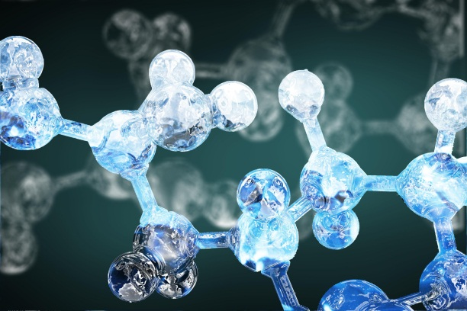
Image of molecules somewhere in some form, such as...

Something really graphical and organic looking. Not something that looks like a plastic molecule model. Could be made to look like tree bark or something.

  - Arboritec finishes are built around two principle pillars – Nantechnology and Ceramic Silica. We are the market leader in these technologies. Our finishes are the result of years of advanced material science develoment. It’s engineered into every product we offer.

    - Arboritec finishes set the standard for:
Durability and Protection
Flow and Levelling
Dry and Cure Times
Eco-Friendly Finishing

Nanotechnology is the science of creating materials at the ultra-small scale, down to 1/100,000 the size of a single human hair. When compared with conventional finishes, it’s clear why nanotechnology is so beneficial. At an atomic level, every finish is like a sponge. They have tiny voids and gaps within them which limit their durability. Arboritec’s nanoparticles are small enough to consistently fill these voids, allowing the finish to better handle stress, wear evenly, and deliver superior durability.

”It’s the smallest things that make the biggest difference” (More featured and pronounced)

We would like to create or find a graphic that would represent the nanotechnology portion of the copy. Maybe an image of a sponge (or generic material) from a bit of a distance, with a zoom ”bubble” coming off of it. From a distance it looks solid, but the soom bubble would show a close up view that really shows the voids and holes. This is just an idea.

PAGE 3: Setting the Standard for Waterborne Finishes
Arboritec finishes raise the bar for what you should expect out of your floor finish. Don’t settle for the status quo. Your floors and business deserve the very best. Symbols for each one, such as:

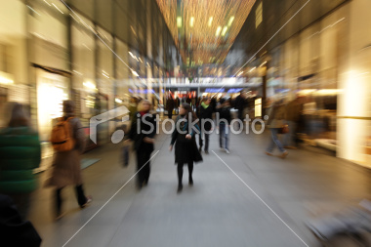
…..for Nanoceramic Fortification. All symbols in same style. Leaf for “Environmentally”, clock face for “Operational Downtime”, simple smily face for “Customer Service”, generic document for “spec with confidence”. Something along those lines.

We would also like to find a way to incorporate heavy traffic retail shots on wood floors into the catalog. This could be as a background image on a page if the content can still be easily read and not create too much clutter. Or a strip of photos across a page maybe, top thrid of a page, something like that.

- Environmentally Responsible: Architects, contractors, engineers and retail chains worldwide confidently choose our finishes. All Arboritec finishes are created with the health of the environment, floor owner, and contractor as a priority. Our commercial grade finishes seemlessly integrate into your building plans, easily meeting the strictest environmental standards.

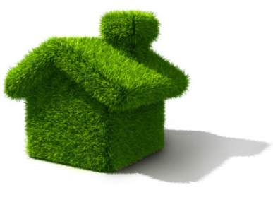
Some sort of ”green” building/construction graphic. Such as the image to the left for example.

LEED
CalGreen
OTC
SQAMD
AIM

- Nanoceramic Fortified Protection: Arboritec finishes lead the industry in strength and durability, giving your floors sophisticated beauty under demanding use. Our strength comes from advanced integration of ceramic particles. Ceramic compounds are harder than most metals, and often used in bullet proof vests. Only diamond displays superior strength. Now that’s protection.
Image of mineral hardness (Mohs) comparison, such as diamond/cermic silica/aluminum Oxide/titanium. For example, images as follows but in a much better presentation.
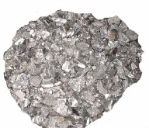
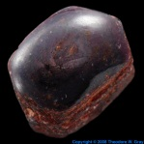
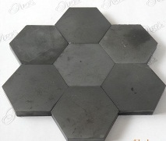
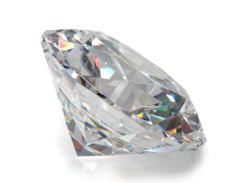

Titanium (6.5)

Diamond (10)

Aluminum Oxide (9.0)

Ceramic Silica (9.5)

- Reduced Operational Downtime: Traditionally, finishing a wood floor can lead to costly operational downtime. Because Arboritec finishes cure faster than conventional waterborne finishes, you will be back in business faster than ever before.

GRAPHICAL REPRESENTATION:
Product Cure Time
Arboritec UVElite Instant
Arboritec Waterborne 3-5 Days
Other Waterborne 7-15 Days
Solvent based 24-28 Days

- Commited Customer Service: The Arboritec Advantage comes from our technology and our people. We have the technical expertise to help you make the ideal decision regarding your floors, and are happy to help. We are focused on providing practical solutions to the real challenges raised by our commercial customers.

Another colaboritve image, such as a handshake?

PAGE 4: Arboritec Commercial Ceramic Fortified Waterborne Finishes
If Possible, use stock type photos of people on wood floors for the background? Something simple and clean, but visual. This is just a suggestion, and we are open to any idea one can think of!
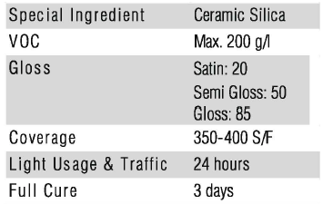
- Avenue (JUG IMAGE) – The flagship of all conventional waterborne wood floor finishes. Exceptional adhesion on all surfaces: new, resanded, and engineered.

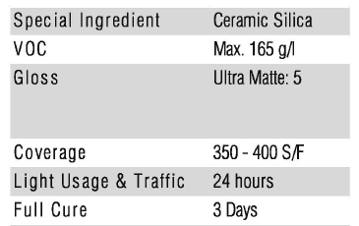
- Genuine (JUG IMAGE) – Arboritec’s ultra low matte premium finish. Genuine emphasizes the natural beauty of any wood, and is ideal for both residential and commercial applications.

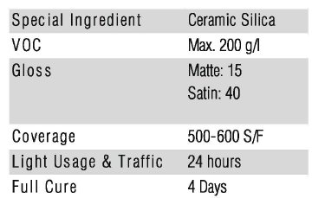
- Elite (JUG IMAGE) – The highest performing one component waterborne finish on the market. Designed for commercial applications, this one component finish offers less waste and less hassle without sacrificing durability.

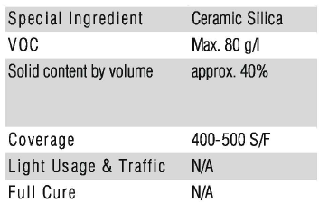
- First Coat (JUG IMAGE) – The ideal pre-finishing prep. This waterborne sealer dries harder, penetrates deeper, and has the highest solid content on the market.

Technical data needs to be represented for each product, in some format. Presentation innovation encouraged!
PAGE 5-6 Spread: UVELITE
- Meet UVElite. It’s stronger, faster, and cleaner.
Instantly cured floors are the next revolution for the flooring industry. Based on five years of intensive development and testing, UVElite is Arboritec’s instant cure solution.

- UVElite takes waterborne finishes to the next level. It’s the Arboritec finish you know and love, with the inclusion of photoinitiators. This cutting edge technology allows UVElite to cure instantly. By coupling this advancement with our unparalled nanoceramic technology, UVElite is quickly becoming the premiere waterborne finish on the market, in more ways than one. With UVElite, you really can have it all.
Graphical representation of UVElite pillars: (1) Nanotechnoloy, (2) Ceramic and (3) Photoinitiators. For example, a stool. It can only stand up with the three pillars, all working together to give ultimate performance. Creativity encouraged.
- Features & Benefits
  - Instant Cure: A UVElite job can be completed from sanding to cured in less than a day. This means reduced operational downtime for businesses, and satisfied customers.
  - Reduced Early Damage: 90% of floor damage occurs during the curing period, when the finish is most vulnerable. UVElite is fully cured when the contractor finishes the job. The floor can withstand full use immediately, without risk of early use damage.
  - Unrivaled Durability: Compared to traditional two component finishes, UVElite is the toughest, most durable waterborne finish on the market. In testing, floors cured with UVElite even match or surpass the durability of factory prefinished flooring.
  - Better for Floor Owners and the Environment: UVElite is the flagship of green finishes, performing above and beyond even the strictest environmental standards in the industry. (Passes DIBt Standard, Passes CA 01350; NMP Free; Solvent Free)
  - User Friendly Simplicity: UVElite only needs to be cured once. Other ultraviolet finishes need to be cured once per coat. Using UVElite saves you time and effort.

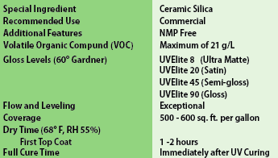
- UVElite (JUG IMAGE) – Premium instant cure commercial finish. UVElite provides world class protection, and allows immediate return to business activities.

- Curing UVElite
UVElite is as easy to apply as all other Arboritec waterborne finishes, and extremely safe when applied appropriately. Once applied, the finish is exposed to and instantly cured by ultraviolet light from a portable UV machine. It doesn’t get any faster than that.
Pics of machines and curing Images
Corner curing image with caption.
”Crate and Barrell Tyson’s Corner employees replacing fixtures while instant curing still underway.”
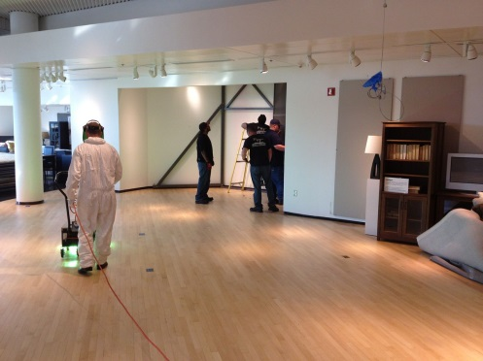

PAGE 7: Pocket Page
This page just needs to be a photo/design of somesort. The pocket will be used to hold more targeted and specific one-sheet materials to include in the catalog.

PAGE 8: Contact Information Introduce a standard visual element to the contact information for consistent use across arboritec materials. We would like ideas how to visually layout out information in a visually compelling way.

- Arboritec Logo
- Futureproof your Commercial Floors
- Cover Image: Image Representing Commercial Flooring Space (Something like a glass highrise, or large commercial space showing lots of foot traffic/activity for example. We would like the image to extend across the cover and back of the catalog.)
- Available from block – Distributor Stamp
- Arboritec USA, Inc.
6200 S. Syracuse Way, Suite 125
Greenwood Village, CO 80111

www.arboritec.com
usa@arboritec.com
(877) 416-5972

Look for us on Facebook, Twitter, Pinterest (use symbols, bottom of page)

