Nurses’ Manifesto
Nurse with open hands, hearts and minds.
Look after yourself and value your health as much as you value the health of others.
Delight your clients and colleagues by exceeding their expectations.
Deliver care skillfully.
Respect the limits of people’s knowledge and share your knowledge generously.
Support your colleagues and champion their purpose.
Learn something new each day.
Trust your knowledge and seek advice only from respected sources.
Be a lifelong learner.
Celebrate, respect and value the diversity of Australian culture.
Smile and infect others with your happiness and have fun!
Always do the right thing without exception.
You are unique, revel in your individuality.
Always be solution focused.
Seek success firstly from within.
Only follow exceptional leaders.
If there is no one left to follow, then lead!
Always lead with purpose, passion and commitment.
Respond to complex situations innovatively, creatively and safely within the scope of your practice.
Adopt a ‘can do’ attitude to everything that comes your way.
Choose your thoughts wisely, they create your reality.
Live your dream.

Sample 1
Sample 2
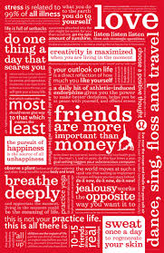

Sample 3
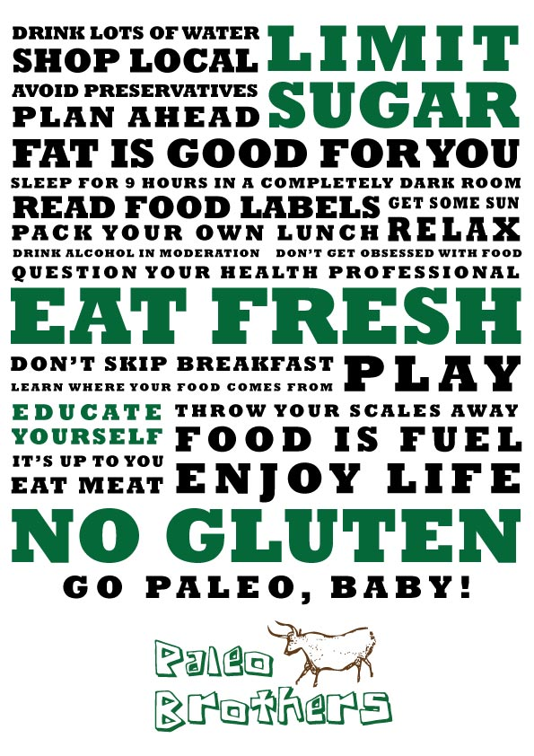

Sample 4
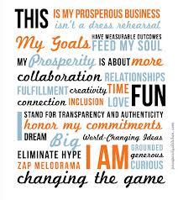

Sample 5


Our attempt 1
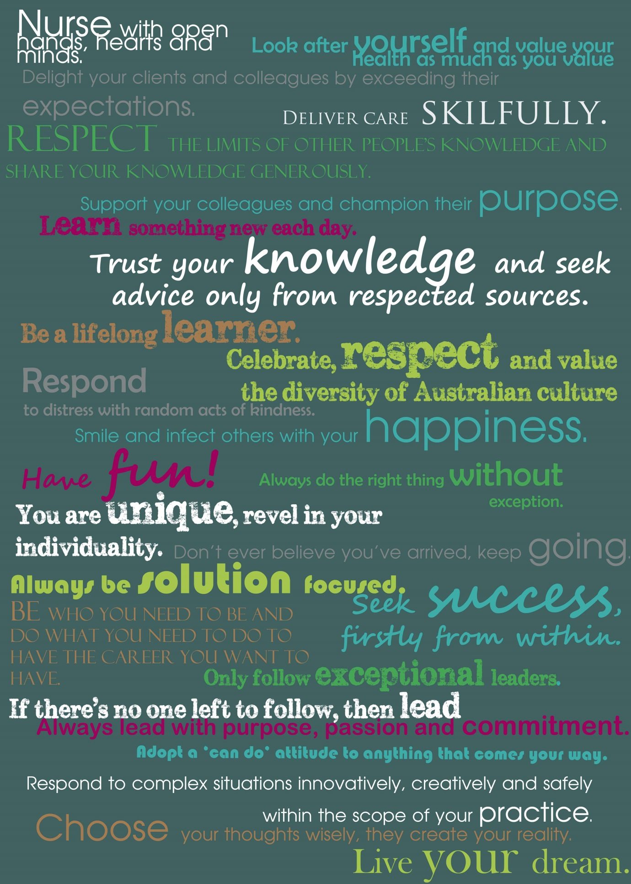
Our attempt 2
Nurse with open hands, hearts and minds.
 Look after yourself and value your health as much as you value the health of others. Delight your clients and colleagues by exceeding their expectations. Deliver care skilfully. Respect the limits of other people’s knowledge and share your knowledge generously. Support your colleagues and champion their purpose. Learn something new each day. Trust your knowledge and seek advice only from respected sources. Be a lifelong learner. Celebrate, respect and value the diversity of your culture. Respond to distress with random acts of kindness. Smile and infect others with your happiness. Have fun! Always do the right thing without exception. You are unique, revel in your individuality. Don’t ever believe you’ve arrived, keep going. Always be solution focused. Seek success, firstly from within. Be who you need to be and do what you need to do to have the career you want to have. Only follow exceptional leaders. If there’s no one left to follow, then lead! Always lead with purpose, passion and commitment. Respond to complex situations innovatively, creatively and safely within the scope of your practice. Adopt a ‘can do’ attitude to anything that comes your way. Choose your thoughts wisely, they create your reality.
Live your dream.

Our attempt 3
Look after yourself and value your health as much as you value the health of others. Delight your clients and colleagues by exceeding their expectations. Deliver care skilfully. Respect the limits of other people’s knowledge and share your knowledge generously.
open hands

Nurse with

hearts & minds

Support your colleagues and champion their purpose. Learn something new each day. Trust your knowledge and seek advice only from respected sources. Be a lifelong learner. Celebrate, respect and value the diversity of your culture. Respond to distress with random acts of kindness.
- Always do the right thing without exception.
- You are unique, revel in your individuality. Don’t ever believe you’ve arrived, keep going. Always be solution focused. Seek success, firstly from within. Be who you need to be and do what you need to do to have the career you want to have. Only follow exceptional leaders. If there’s no one left to follow, then lead Always lead with purpose, passion and commitment.
Have

fun!

Respond to complex situations innovatively, creatively and safely within the scope of your practice. Adopt a ‘can do’ attitude to anything that comes your way. Choose your thoughts wisely, they create your reality.
Live your dream. 

