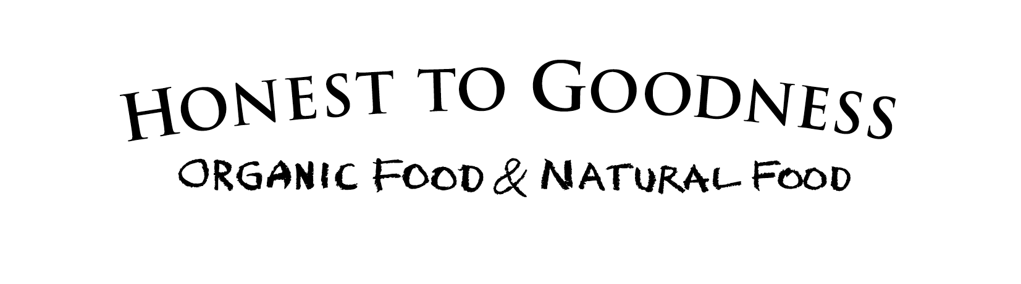
Brand Identity
About us
Honest to Goodness is a Sydney-based online retailer, wholesaler and distributor of certified organic and natural food products that has been in the industry since 2002. We are the first and best choice for; the environmentally responsible consumer, the conscious business owner or the family nurturer; who no longer want to accept compromises regarding their nutrition or the environment. Our high quality & nutritious wholefoods are taken straight from nature and passed on in the way its intended. That is our philosophy...real food that loves you back!

Originally founded with the ideal of providing pure and simple food that has nothing weird or nasty in it to an affordable price, we now follow through with this promise: Our healthy, delicious and environmentally sustainable goods can be purchased via health and organic food stores, pharmacies and markets as well as our online shop and our showroom in Artarmon.

The business has 3 main focuses:
- Ingredient supplier to manufacturers – bulk supplies
- Wholesale supplier to health food shops, independent retailers & food co-ops.
- HTG Retail Range - direct to customers via online shop, showroom & growers markets in Sydney

Our Range
We have a fabulous and diverse range of organic food and natural food products, both bulk and retail, which we distribute throughout Australia.
Our range of pantry staples includes over 700 products from nuts, seeds, dried fruits, cereals, grains, snacks + more, to stock up your pantry with healthy and tasty wholefoods!
The 'No Nasties' splashed across the bottom of our retail range says quite a lot about what we do. Quite simply you will find nothing weird or nasty in anything within our range. No artificial colours, flavours, preservatives, sweeteners, hydrogenated fats or GMOs. We call this food 'Honest' food. It is nutritious, wholesome and full of 'goodness'.

Organic Foods (green writing on black) – certified organic foodstuffs
Natural Foods (purple writing on black) – including no artificial preservative foods, unrefined foods, as natural and healthy as possible foods, gluten free products.

Our Positioning...
We value integrity, respect and clarity in all that we do. We are about “Real Food that loves you back” and here’s why;
- Real Food – You may find it is what is NOT in our food that makes us different. Our range is nutritious and healthy, devoid of cheap fillers and nasty additives (No Nasties!), ethically sourced and carefully prepared. We remain forever conscious that the foods we sell go into people’s bodies and become part of them.
- Nothing to hide – we believe value in pricing comes from providing our customers with as much information as possible about the product they are purchasing.
- Organic Certification - Our warehouse and production facility are organically certified and therefore never fumigated. We follow strict food handling guidelines and have a quality management system in place to ensure the best possible quality and handling of our products.
- Contribute not exploit – at the top of our “bucket list” is that we be remembered for our contribution. We strive to lead, innovate, inform and thrive. Where possible we favour Fair Trade suppliers which support our belief in fairness and sustainable trading conditions.
- Environmental responsibilities – we actively support organic & biodynamic farming through our commitment to sustainable agriculture, by expanding the market for organic products. We respect our environment and consciously reuse, recycle and refuse in our day to day operations.
- Social responsibilities – as a leader in our field, we believe we carry a responsibility for setting an example of how a business can and should be run. We operate tight guidelines relating to ethical and responsible sourcing, nutritional nature and quality of the products we sell, efficient supply chains and community involvement.

Business Name - Honest to Goodness
Our brand is representative of what we do, and this includes honesty and transparency about the food we sell and honesty and integrity in our dealings. Goodness is about the food itself, our food is of high quality and provides essential nutrition.

The way we talk...
Our Personality is
Australian
Honest but not blunt
Friendly and knowledgeable
A wise head on young shoulders
Confident but willing to learn & listen
Healthy
Sociable, fun
Relaxed, informal
Nurturing
Respectful
Thoughtful
Quirky

Our Audience is
The internal team at Honest to Goodness
Those already buying organic products
The socially & environmentally responsible consumer
The health conscious consumer
The consumer with specific dietary needs i.e. gluten free
he consumer with specific dietary wants i.e. vegan/raw
The unpretentious foodie

Ages 25 +
Both genders
The Cook. The family Nurturer
Families

Example of language – Honest to Goodness:
hŏ’nėst (ŏ’-) a. 1. (of gain) got by fair means. 2. (of thing) simple, unpretentious and unadulterated. 3. truthful and sincere.
goo’dnėss n. 1. virtue; comparative excellence. 2. the nutritious element of food.

Call to Action Samples

Want to be our friend? For the whole Honest to Goodness story, our newsletter, recipes and serving ideas, visit us online at www.goodness.com.au

Honesty is a good policy. If you don’t love this product, call and tell us why on 02 8310 1800

Overall Tone of Voice Qualities
The tone of voice should be clear, clean and simple.

Many Audiences, One Tone of Voice
The tone of voice should always relate to any other elements used to represent the brand.
This tone is characterised by its seamless linking of facts and fun.
It is designed to allow for both formal and informal communications.
There is room within the tone of voice for quotations.

The way we write...
1. Fonts
HTG Logos
The Font used is Helvetica Neue (not to be confused with regular Helvetica or Arial even though it looks similar.) You can buy these fonts for PC via Fontshop.com for a reasonable price.
Helvetica Neue 45 light
Helvetica Neue 75 Bold
Website - Verdana

Marketing Materials/Flyers etc - Verdana

Emails
Body Copy: Calibri size 11
Signature - Verdana size 10

Internal and External Word documents
Headings and website: Verdana size 10
Body Copy: Calibri size 11

Showroom promotional signs
Headings and website: Verdana size 10
Body Copy: Calibri size 11

2. Colours
Are PMS 2655 (Purple) – for the NATURAL RANGE (#9b6dc6) 9b6dc6
PMS 368 (Green) – for the ORGANIC RANGE (#5bbf21) 5bbf21

3. Our Tone
Do not use numbered lists / Do use bullet points.
Do not preach / Do be informative.
Do not be patronising / Do make good use of brand equity.
Do not have more than six words in a headline
Do keep sentences less than a dozen words.
Do not use too many words | Do use fonts and punctuation instead.
Do speak from the core philosophy of Honest to Goodness

H2G Key words:
- Goodness
- Real Food
- Nutritious
- Honest
- No Nasties
- Goodies
- Real food that loves you back

Our Brand...
Tagline
‘Organic food and Natural food’ this again is truly representative of what we sell both ‘organic’ and ‘natural’ foods. This tagline logo is at the top of our letterheads used for any press releases or formal letters. Any marketing material will include this logo at or near the top.

b. ‘Real food that loves you back’ – this is the message about what we do – the emotional attachment to our brand & a reason for purchase. It is at the top of our retail packets & is meant to appear as a message written on a chalkboard that could change over time. This logo is included in most marketing materials & business cards as a logo or philosophy catchline.

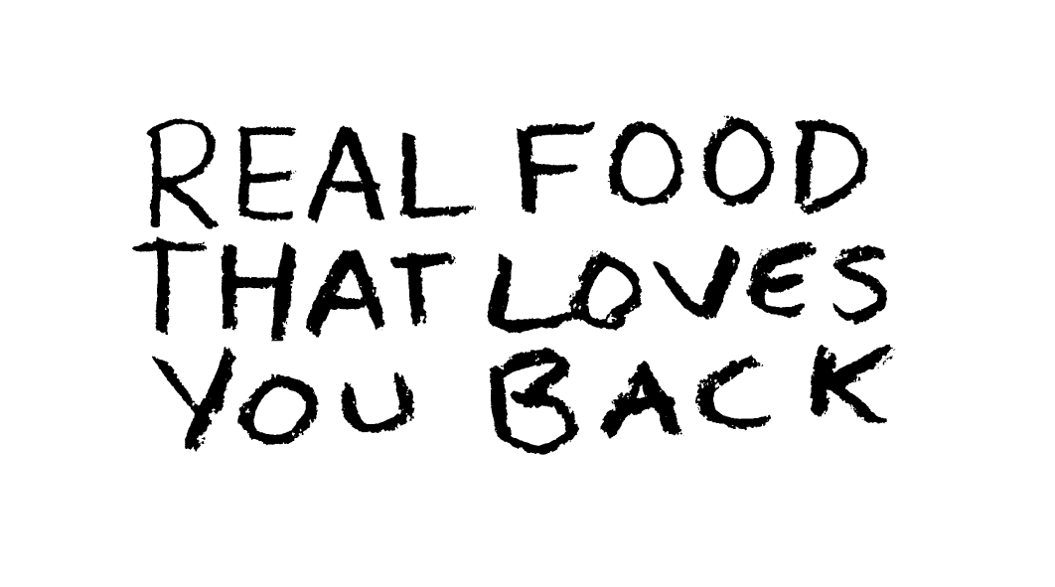
c. ‘No nasties added’ … this appears on the front - bottom of all of our retail packs. It is about what is not in the food they are looking at.
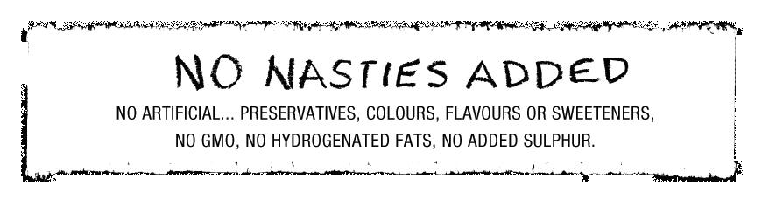

The Organic Consumer...
More than 70% of organic consumers are aged between 25 & 44. I imagine the other potential consumers are in a similar age group. This is our target market.
Organic consumers come from a wide spectrum of income groups. A survey conducted in 2005 showed that 27% of organic consumers had a household income of over $100 000 but 35% have an annual household income of between $30 000 and $60 000. I imagine ‘value’ would be important to this last group.
Organic consumers come from all walks of life and socio-demographic backgrounds. Research has failed to identify them as sharing one particular profile. Nevertheless, different analyses showed agreement when ascribing the organic consumer to one or more of the following characteristics:
- Female (which also stems from the fact that women are still primarily responsible for the food sourcing and preparation)
- Higher education
- Higher personal disposable income
- Between 25 to 44 years (most likely in their 30s)
- In favour of domestic products
- Health-conscious
- Less price-conscious
- With children
- Conditional eaters (lactose intolerant consumers etc.)
Where consumers shop for organic food depends upon their level of commitment to purchasing organic. The majority of new organic consumers start at the supermarket and as they become more committed move their way to the distribution channels that H2G focuses on, as health and organic food shops, organic markets and online shops.
The main reasons for consumers to purchase organic food are health, concern for the environment and superior taste. These motivational factors can be seen in two terms-use values with the first and last one being private good attributes that are enjoyed by actually consuming the product and the second one being a public good value. Committed in contrast to new organic consumers are much more interested in the latter and therefore demand additional product attributes beyond organic.

Barriers for purchase
- Price (it is up to the industry to communicate the reasons for the price premium on organic food)
- Availability
Most people perceive organic products as being expensive. Therefore it is no surprise that shoppers are looking for value for money and buy organic products at less expensive retailers, turn to farm shops, or even grow their own. Organic Market Report 2009 UK
Market Trends
- Health Market
- Larger of the 2
- Consumers buy organic food primarily because it is perceived to be healthier than conventional food

- Original Organic Market
- Consumers are interested in the social aspects of organic production (e.g. a clean environment, locally produced food)
- For them additional product attributes beyond organic need to be present. The Organic Food Market USA

.

