

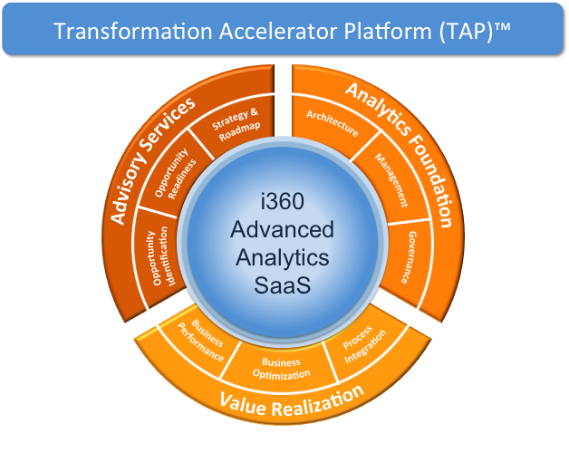
4555 Mansell Road, Suite 300 info@illuminate360.com www.illuminate360.com 1.770.521.4277
Analytics Opportunity Assessment

Maximizing the value of your information assets and accelerating your business performance through advanced analytics
Highlights
- Advanced analytics accelerates business growth through insight that is relevant, predictive, and leads to action
- Analyze potential analytics opportunities and their fit/gap against your business priorities and capabilities
- Validate opportunities with key stakeholders to ensure alignment
- Rank top opportunities and identify business case and ROI drivers through use cases
- Identify potential execution risks and mitigation strategies
Advanced analytics is helping companies accelerate their business performance and enhance their competitive edge in business growth, margin, and market share. It helps organizations generate insight from potentially massive amounts of data through variety of sources. Insight can be real-time, predictive, and is integrated into business processes and actions. Advanced analytics can lead to better customer experience, improved quality, and more clear understanding of risks in business execution.
The first steps in your accelerated journey to become more data driven are understanding the analytics opportunities available and their fit with your organizational capabilities, resources, and, most importantly, business priorities. If you are just starting to look into what advanced analytics can do for you and your organization, you may be asking:
- What are our top business priorities and how can advanced analytics help us achieve them?
- Where should I start? What are my top opportunities and use cases for deploying advanced analytics in my company?
- What business benefits can I gain through more focused investment in analytics? How does it help me address my business priorities?
- How can I accelerate my analytics initiatives to gain competitive edge?
The Value of Evaluating Analytics Opportunities
Assessing potential analytics opportunities guides your decision on where to start with your data transformation. It helps you make more informed decision on where to focus and apply your investments and resources, with highest chances of positive business impact. This enables you to ultimately:
- Undertake the transformation to become more data driven, by incorporating advanced analytics in your business processes
- Extend the reach of your existing analytics initiatives and enrich the insight across your organization
- Use data and analytics to achieve business objectives and gain true competitive edge
How can Illuminate360 Advisory Services help you?
The Analytics Opportunity Assessment is an Illuminate360 Advisory Service and can be your starting point to become more data driven. It is a short assessment that identifies your top analytics opportunities aligned with your business priorities. It also highlights competitive benefits to be gained.
This offering benefits you by:
- Highlighting areas to focus your investments and resources to start and accelerate your advanced analytics transformation.
- Validating your execution capabilities and understanding execution risks.
- Jump starting the business case for advanced analytics transformation and the resulting competitive advantages.
This offering achieves its objectives through:
- Discovery process, including interviews with key stakeholders and executives, to confirm top business priorities, understand current state of analytics including the support organization
- Identification of key performance metrics used in business decisions
- Analysis of collected information and production of deliverables using Illuminate360 Methodology & Services framework
- Stack ranking of the opportunities and highlighting key business case and ROI drivers for each

Our Advisory Services are a set of strategic services that link your business priorities with advanced analytics transformation opportunities. As a key element of TAP™, these services analyze your business priorities and transformation needs, assess your capabilities and gaps, and propose a blueprint and a roadmap to transform you into a data driven organization. A critical outcome from these services is a business case that shows the ROI on your investment and helps you track key elements of your business case during and after execution of the roadmap.

Analytics Opportunity Assessment
Offering Deliverables
- Confirmed business priorities & alignment with IT
- Map of key stakeholders and champions
- Prioritized list of analytics opportunities and uses cases aligned to top business initiatives
- High level business case for top three opportunities with metrics for measuring success and determining ROI
- Highlighted execution risks and barriers and mitigation strategies
About our Advisory Services

Why Illuminate360?
At Illuminate360, we accelerate transformation of our clients into data-driven organizations. We do that using our Transformation Accelerator Platform (TAP)™. TAP™ is primarily based on our proprietary Advanced Analytics products which, along with a combination of Advisory Services, is designed to accelerate your Advanced Analytics transformation journey. TAP™ leverages our industry expertise across Advanced Analytics, Cloud, and Risk Management to take an integrated view of your transformation needs.
Let us help you. Please contact your Illuminate360 Business Development Manager for more information.

