
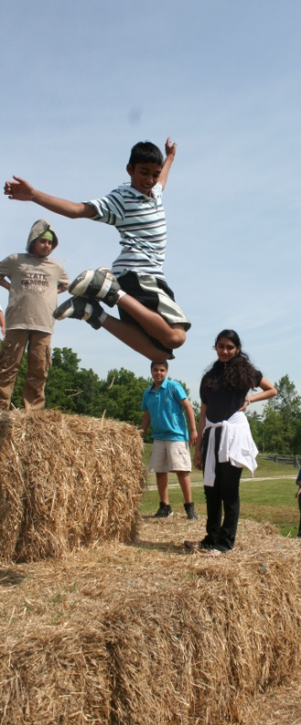
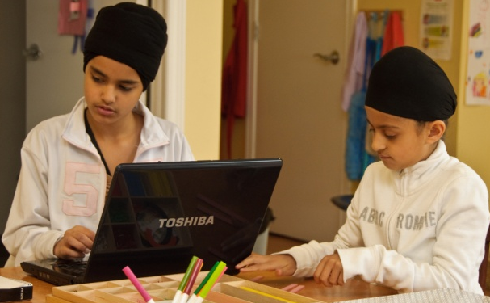
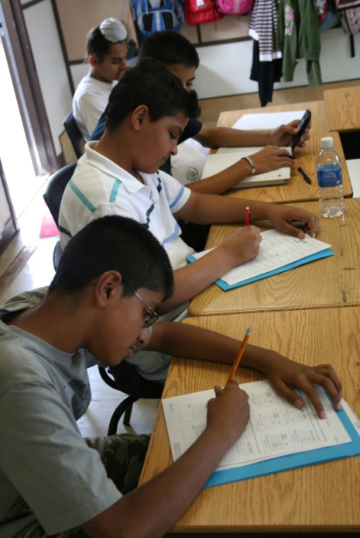
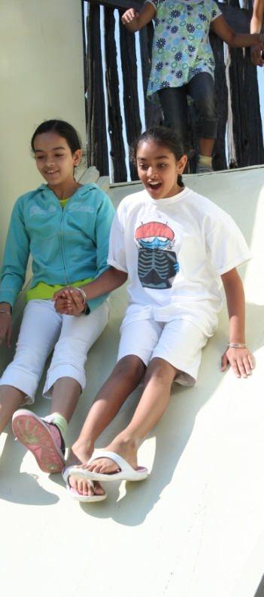
Improve Reading Skills.
Basic readings, comprehension, critical analysis, speed reading are all skills that are critical for survival in the 21st Century Information Age.

Reading Speed + Reading Comprehension = Better grades and less study time
905-913-0801
info@kmschool.org
www.kmschool.org
Jul 2 – Aug 24 @
Khalsa Montessori School
2-4535 Ebenzer Road, Brampton.

Timing
9:00 AM – 3:30 PM, Five Days a Week
Early Drop off: as early as 8:00 AM
Late Pick up: as late as 5:00 PM

Registrations
Register for any number of weeks either:
- Online at www.kmschool.org, or
- In person any day at Khalsa Montessori School
Imagine a summer where your child:
• Has FUN every day
• Improves Reading & Writing Skills
• Studies Math at next grade level
• Can Wii
• Makes Multi-Media Presentations
• Experiences Science
• Plays Sports
• Goes to Wonderland every week!
• Progresses Spiritually

“I wish school could be like this Summer Camp all year long”
KMS Summer Camp 2012
By KMSchool for Ages 3 years to 12 years (upto Grade 6)

MONTESSORI PROGRAM

For ages 3 to SK we will provide a true Montessori environment. See what Montessori can do for your child in a few weeks!


Early Registration Benefits:
- Personalized summer program designed in consultation with parents and teachers
- Lower Weekly Fees
- FREE Wonderland Pass!
TRIP Every Week to:



First 40 4-week registrants will get a Season’s Pass to the Wonderland!
905-913-0801
info@kmschool.org
www.kmschool.org

- Official Tax Receipts provided
- Certified Staff
- Low Staff to Student ratios
Montessori
Following the child, one by one, engaging them with education materials with respect, grace and courtesy, produces amazing results. Children are never bored in a Montessori classroom – it so enriching and beautiful!



Math
What’s coming up for your child in the next grade in Math? Following the Ontario Ministry of Education expectations, our teachers will introduce Math by way of fun projects and worksheets. Prepare your child for the next year.

Wii Room
This is one room that every child must have every day of summer. Besides Wii systems this room also has board games, and other fun indoor activities. Except for the field trip days, children get to spend some time every day in this room.

Gurmat/Spiritual Time
Spirituality is ignored in the school all year long. Summer is our opportunity to reconnect the children with their parental Spiritual grounding. All Faiths are welcome!

Summer Camp for ages
3 to 12 years
Cost
Starting from $160/wk. Early registration gets you the best pricing. See our website for details.

Pizza Day!
One day a week parents need not send lunch from home.

Extended hours Daycare

We are open from 8:00am till 5:00 PM

KMSchool’s Summer 2012

